Broadmayne First School Knowledge Organiser

Literacy Focus | Reading and Writing | Year 2 | Autumn Term 1

The Power of Reading |  |  |  | Guided Reading | Key Knowledge and Vocabulary
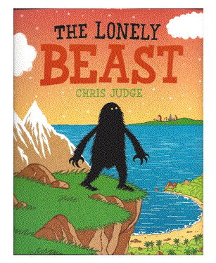 | Genre  quest story  Writing  story, character description, newspaper article, questions  Drama  Freeze frame, conscience alley |  |  | We will focus on Fiction books. We will look at the following skills:  Decoding- breaking down a word into phonemes (sounds) to be able to read it.  Prediction - saying what you think will happen next or as a result of something.  Comprehension - understanding what we have read. | Phoneme  Grapheme  Digraph  Trigraph  Segment  Blend  Tricky Word  Spelling pattern  Homophone  Noun phrase | A single unit of sound.  A letter or group of letters to correspond to each phoneme .  Two letters making one sound.  Three letters making one sound.  Break a word into phonemes  Put phonemes together.  A word that you cannot sound out.  A group of letters that make a phoneme common to lots of words  Two words that sound the same but are spelt differently eg hear/here  A phrase where an adjective is used before a noun to describe it e.g. bright blue table, cunning fox
Planned Experiences |  |  |  | Spelling, Punctuation, Grammar
* EXPLORATION: What makes good writing? Narrative?  * COMPOSITION: Creating story maps and recounts  * VISUALISATION: Creating images with words through the use of noun phrases.  * COMPARISON: Link with other quest stories and stories by the same author.  * VISUALISATION: Drama, writing in role, hot seating.  * PERFORMANCE: Drama and Role play - reenacting the journey the Beast went on.  * SKILLS: Using appropriate features from Y1 and new features as taught. Editing and improving (in some compositions) |  |  |  | We will have daily phonics and spelling sessions where we work in our groups.  Statement sentence - a sentence that tells you something. It usually ends in a .  Question sentence - a sentence that asks a question. It always ends in a ?  Comma - we use a , between objects in a list except for the last two in the list where we use ‘and.’
The Big Write |  |  |  | Handwriting
Digital literacy clips (films), music and still images are used to inspire a longer piece of independent writing. The Big Write shows how you use the literacy skills that have been taught in class and allows you to develop your writing stamina. The session includes some shared writing (the whole class creating some example sentences) The Big Write can be a story, a non fiction text, a letter, a diary entry or a poem around a specific theme. |  |  |  | Ascender: letters that have a stick that goes up above the line you are writing on (b,d,h,l,t).  Descender: letters that have a tail that go below the line you are writing on (f,g,j,p,q,y).  We will focus on curly caterpillar letters (a,c,e,d,f,q,s,o) and one armed robot letters (r,n,m,h,b)

