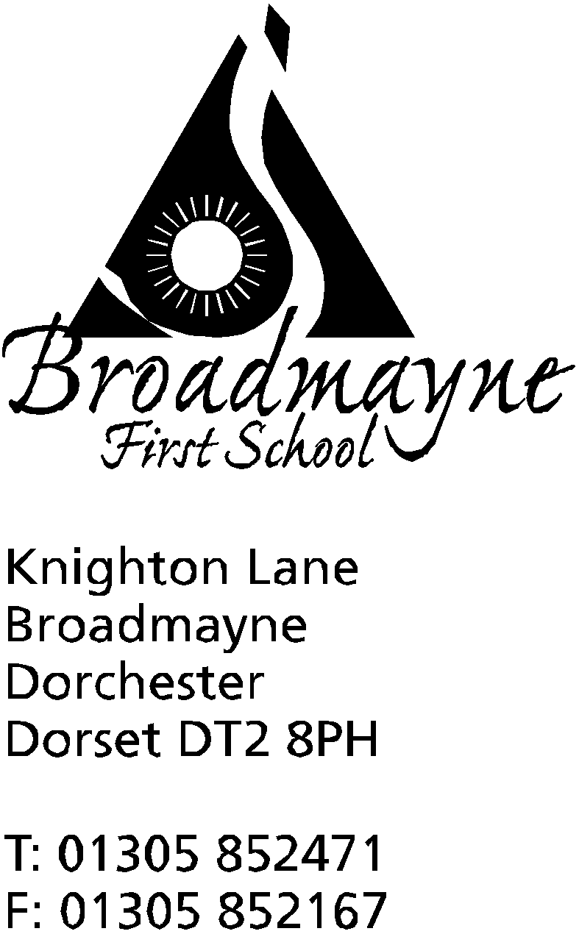

In Dorset

Headteacher
Helen Collings
Tuesday 14th April 2020

Dear Parents and Carers,

I hope you are all keeping well, and that you had the opportunity to enjoy the good weather over the bank holiday weekend. As we enter the second week of the Easter holidays, I am aware that like me, many of you may be concerned around your child’s use of the internet and the amount of screen time they are accessing.

My youngest daughter is a huge Minecraft fan, and would play all day if I let her, so this is an issue I have been really interested in. We tend to think of screen time as a daily maximum amount that’s acceptable, but I think at the present time it’s important to focus on screen quality, rather than quantity. It’s important for us to think about who uses media with the children (do they share with brothers and sisters? play with friends?), the purpose of the content (school? entertainment?), and who’s talking with them about what they are watching or playing.

All screens are not equal, and one hour of playing Minecraft does not equal one hour of watching Teen Titans (I am drawing on my own experience here!), or one hour of Facetiming a family member or friend, or one hour of following drawing tutorials on Youtube. What our children get from each is different, and satisfies different needs at the moment - and that’s OK.

One of the things the current crisis has brought to the fore is that children need social interaction, and technology can help us with that at this time. I think for all of us as carers and parents it’s worth thinking about the following points:

- don’t feel guilty - we are all living through a huge cultural shock, and it’s OK for screen minutes to be low on your list of priorities at the moment
- not all screen time is equal - some is educational, some is for fun - what we do on screens is more important than the time spent
- good content is key - choose high quality, age appropriate media. Use review sites to help you make decisions ( I often use commonsensemedia.org for this - it has reviews of apps, games and movies and is very clear about what they contain)
- be creative with screens - have children make videos, take pictures, create their own dances and film them
- keep talking - engage with children about what they’re watching and playing - join in when you can.
(I would like to say that conversations around Minecraft can go on a bit!)
- keep a balance - across the week you can look at balancing everything - more screens can be balanced against finding time to be outside, be active, eat well and engage socially with others

I think that during these times when there might be higher stress we can use technology to help our children find the right balance, and to help our family lives. Thinking about doing all we can to keep our children safe, there are some great packs for parents on the site Thinkuknow - the link is here: https://www.thinkuknow.co.uk/parents/support-tools/home-activity-worksheets?utm_source=Thinkuknow&utm_campaign=46e6250b3e-TUK_ONLINE_SAFETY_AT_HOME_07_04_20&utm_medium=email&utm_term=0_0b54505554-46e6250b3e-64791497

They also have parent and carer guides for internet use here: https://www.thinkuknow.co.uk/globalassets/thinkuknow/documents/thinkuknow/parents/pdf/thinkuknow-parents-helpsheet-primary.pdf

I, like everyone else, watch the government updates each day, to see what is happening and any implications for our school and families. We await specific updates for schools - I believe there may be one later this week and I will contact you all if anything within that affects us directly at the moment. In the meantime, the school remains open for our key worker’s children, and staff are working from home to prepare ideas for home learning starting again next week, when we will be moving towards a whole school project approach.

In the meantime, please keep yourselves and your families safe, we are thinking of you all,

Yours faithfully,

Mrs Collings

