Broadmayne First School Knowledge Organiser

Maths Focus | Addition and Subtraction | Year 2 | Autumn Term 2

Addition Vocabulary | Subtraction Vocabulary |  |  | Practical resources
add | subtract |  |  | Number line, numicon, dienes, tens and ones chart, 10p and 1p coins, place value counters, part part whole board.  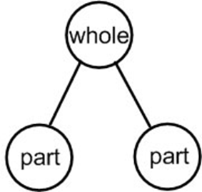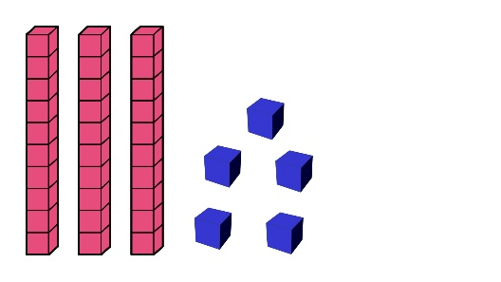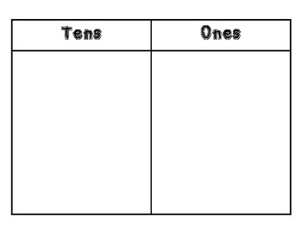  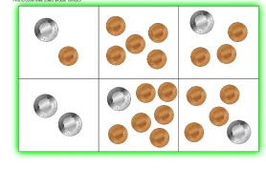
altogether | take away
sum (also known as total) | difference
plus | minus
more | less
regrouping
renaming
calculate
estimate
inverse
Number bonds to 10, 20 and 100 |  |  |  | Number families
Making 10 Making 20 Making 100  Add in an extra 10! Turns the bonds to 10 into  10s numbers!  0 + 10 =10 0 + 20 = 20 0 + 100 = 100  1 + 9 = 10 1 + 19 = 20 11 + 9 = 20 10 + 90 = 100  2 + 8 = 10 2 + 18 = 20 12 + 8 = 20 20 + 80 = 100  3 + 7 = 10 3 + 17 = 20 13 + 7 = 20 30 + 70 = 100  4 + 6 = 10 4 + 16 = 20 14 + 6 = 20 40 + 60 = 100  5 + 5 = 10 5 + 15 = 20 15 + 5 = 20 50 + 50 = 100  6 + 4 = 10 6 + 14 = 20 16 + 4 = 20 60 + 40 = 100  7 + 3 = 10 7 + 13 = 20 17 + 3 = 20 70 + 30 = 100  8 + 2 = 10 8 + 12 = 20 18 + 2 = 20 80 + 20 = 100  9 + 1 = 10 9 + 11 = 20 19 + 1 = 20 90 + 10 = 100  10 + 0 = 10 10+ 10 = 20 20 + 0 = 20 100 + 0 = 100 |  |  |  | 7 5  12  7 + 5 = 12 5 + 7 = 12  12 - 5 = 7 12 - 7 = 12  Inverse calculations  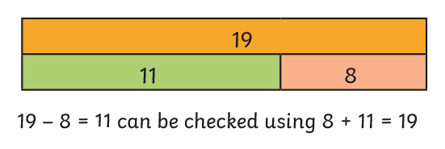
Part Part Whole Model |  |  |  | Rounding to estimate
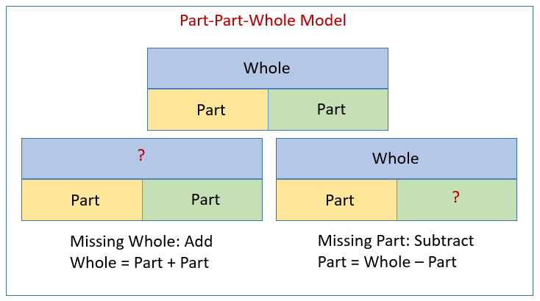 |  |  |  | If a number ends in 1, 2, 3 or 4 round down to the nearest 10.  It a number ends in 5, 6, 7, 8 or 9 round up to the nearest 10 .  32 + 26 = 58  Round to the nearest 10  30 + 30 = 60.

Key Knowledge
Addition |  |  | Subtraction
Adding a one digit number to a two digit number  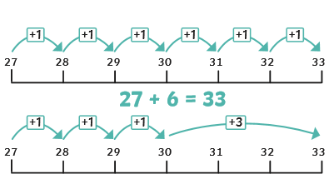 |  |  | Subtracting a one digit number from a two digit number  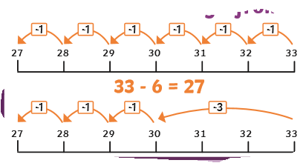
Adding a 10s digit to a two digit number  27 + 40 + 67  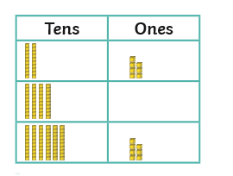 |  |  | Subtracting a tens number from a two digit number  72 - 30 = 42  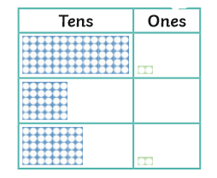
Adding 2 two digit numbers  Method 1 (no regrouping)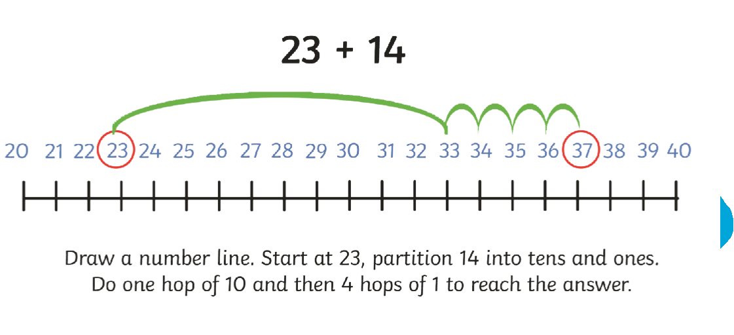  Method 2 (with regrouping)  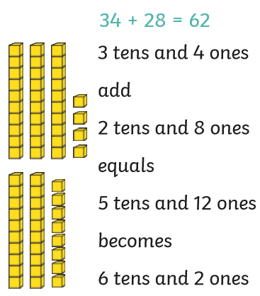 |  |  | Subtracting a two digit number from a two digit number  Method 1 (no regrouping)  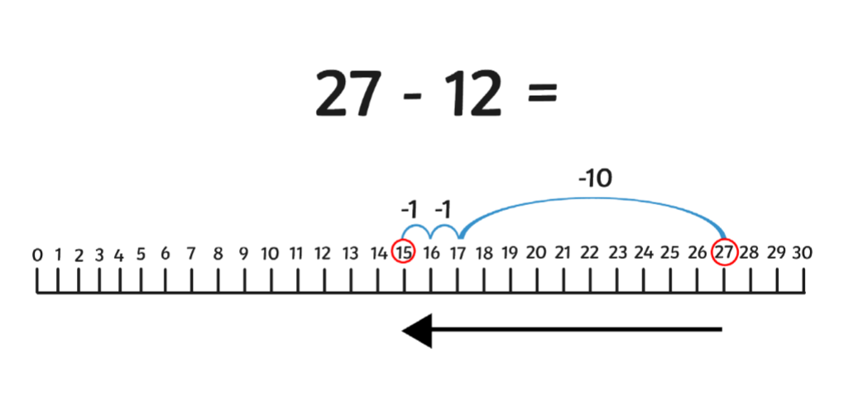  Draw a number line. Start at 27 and partition 12 into tens and ones. Do one hop of 10 then 4 hops of 1 to reach the answer.  Method 2 (with regrouping)  