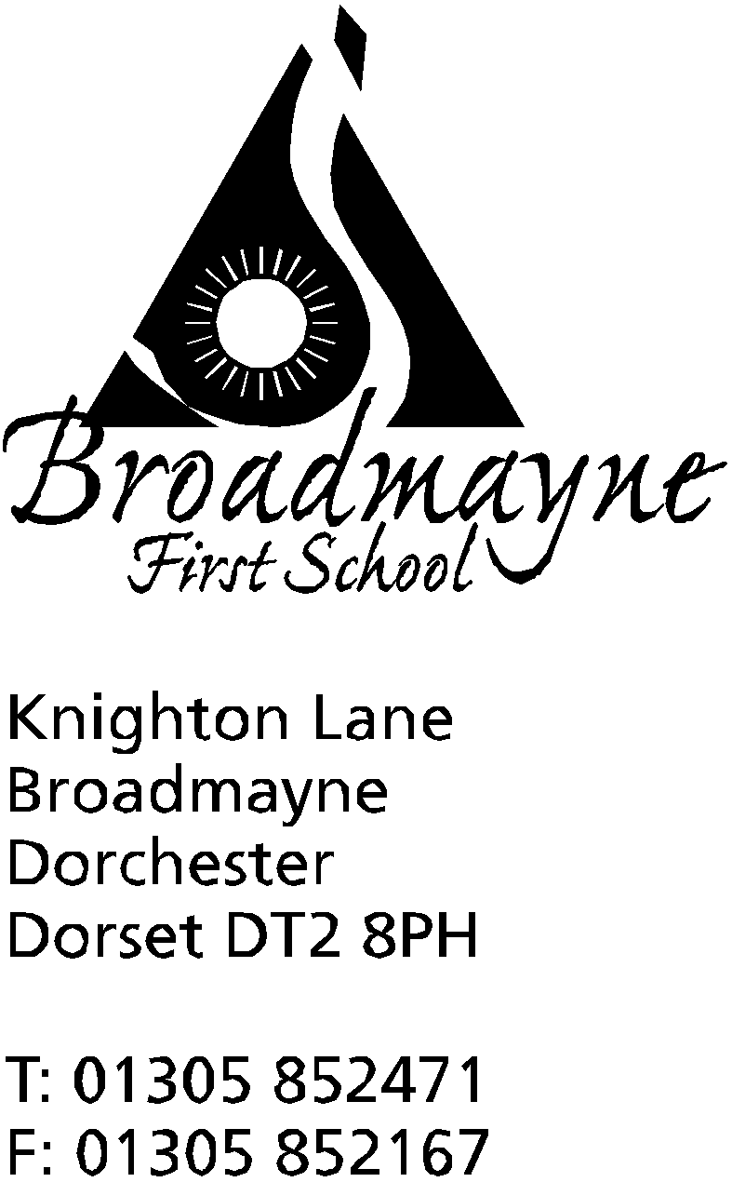

In Dorset

Headteacher
Helen Collings
Monday 6th April 2020

Dear Parents and Carers,

As we enter what would have been our Easter holidays, I just wanted to take the opportunity to touch base with you all, and to send our best wishes for the holiday period. It is tricky to really make the most of this time when we are so restricted in the ability to travel, but I have put together a list of virtual tours you might enjoy exploring with your children- if we can’t get to visit the Acropolis, then the Acropolis can come to us! The link is on the website and can be found here:
http://www.broadmayne.dorset.sch.uk/web/links_to_virtual_tours/469479

As I have said before, as this is the Easter holidays, you won’t find the staff posting lessons for the next two weeks, but these will continue after the holidays, and staff contact with you all will still continue. The BBC will also be starting a home learning service after the holidays - in the meantime you might find the resources at https://www.bbc.co.uk/teach interesting. Once again, I want everyone to know that the most important thing in the coming weeks is not keeping up with a prescribed curriculum, but keeping children engaged with learning and the idea of learning, whatever form that might take. Let’s see if we can make COVID-19 an opportunity for learning and not just an obstruction to it!

Mrs Bassindale has asked if there are families in our school community who would be interested in contributing towards a school history project for this time. In years to come this will be of enormous interest to children coming to Broadmayne, and if we had an archive of memories and artefacts we could share, it would really help with children’s understanding of our current experiences at this time. Would your family like to keep a diary? Or a scrapbook? As Mrs Bassindale says, we are living a future history lesson, and it is important that we record our thoughts and feelings at this time, to share with others.

As a school, we are beginning to notice some of the strains being placed on our families, particularly if you have issues around employment at the moment. There are people you can speak to if there are specific issues you are trying to deal with, details of some of them are below, and these can also be found on the school website. Please don’t worry about contacting the school directly if you want to talk about something, whether it is through me or another member of staff you feel comfortable talking to - we can usually point you in the right direction for support, or help in more direct ways if possible.

Children’s Advice and Duty Service - if you are concerned about the safety or well being of a young person: 01305 228866
Food bank: 07554 983 978 email: foodbank@dorchesterbc.org.uk
Samaritans: 116 123 free from any phone
Dorset Council online resources for families: https://mailchi.mp/dorsetcouncil/online-resources
Domestic Abuse Helpline for Dorset: 0800 032 5204
NSPCC: www.NSPCC.org.uk

On a lighter note, I wanted to share with you some reassurance that none of us are perfect at this new way of doing things, if such a thing as perfect even exists! In my own family, my husband is currently unable to work and so is spending time at home with our youngest - she informs me any ‘lessons’ mainly consist of art and DT (ie Lego!) - at the moment I’m just grateful to get home to find she is dressed and he has remembered to feed her lunch! I have managed the grand total of one maths session with her, and I fully appreciate the challenges of working with your own children! Mrs Bassindale says she has very little routine, and is finding it best to have one ‘learning’ focus for the day, whilst Mrs Norman and Mrs Howells appear to have been having some issues with remembering to put lids onto food blenders - clearly we are all finding challenges, one way or another!

I would like to end by saying a huge thank you to everyone for what they are contributing to our community at the moment - be it key workers who are helping with the essential work, volunteers who are helping keep our community running, staff at school keeping in touch with you all and thinking of how to make this the best possible experience for our children, and to you all as parents, carers and families, working to try and find a new ‘normal’ for the coming weeks. We are all doing the best we can, no matter what that best looks like from day to day.

Please keep safe and keep in touch, we miss you all,

Yours faithfully,

Mrs Collings

