This half term the Year 2 topic will be...
In English we will be looking at Here We Are by Oliver Jeffers for the first couple of weeks. After that we will move onto The Beast books by Chris Judge. We will describe the main character, talk about how stories are structured and sequence the main events. We will write a newspaper report and a book review. We will practise cursive letter formation, learn new spellings and continue to use our phonics every day. We will take part in guided reading sessions every week.

In Science we will learn about different materials and how their different properties make them suitable for different uses. We will sort different materials, use language to describe their properties eg flexible, make simple predictions and carry out simple investigations to test out these properties.
Journeys: How do we know where we are going?
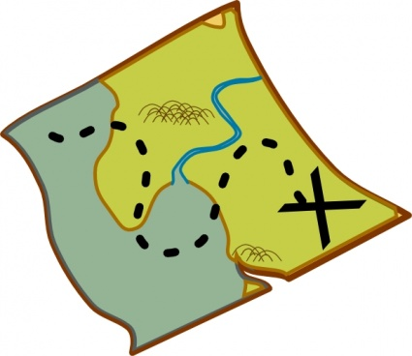

In Art we will be looking at patterns, colour mixing and printing. Where possible we will be looking to nature and the local environment for inspiration.

In Maths we will start by revisiting numbers to 20 and 50 before moving on to numbers to 100. We will order and compare numbers and look at place value in two digit numbers We will practice counting forwards and backwards in 1s, 10s, 2s and 5s.
We will also look at shape patterns and number patterns and then position, direction and turns to link with our topic.

In ICT we will be practising the skills of logging on, keyboard skills, saving and adding images to text.

In Music we will learn about volume and pitch.

In Geography we will be learning about compass directions. We will look at maps to locate different places and use simple symbols on a key when we draw our own maps. In RE we will be focussing on Christianity and our theme will be “What did Jesus Teach?”
In PE we will be taking part in multi skills sessions and Forest schools with Mr Dailey.
In PSHE our focus will be on reflecting on what has happened this year and talking about and managing our feelings.

