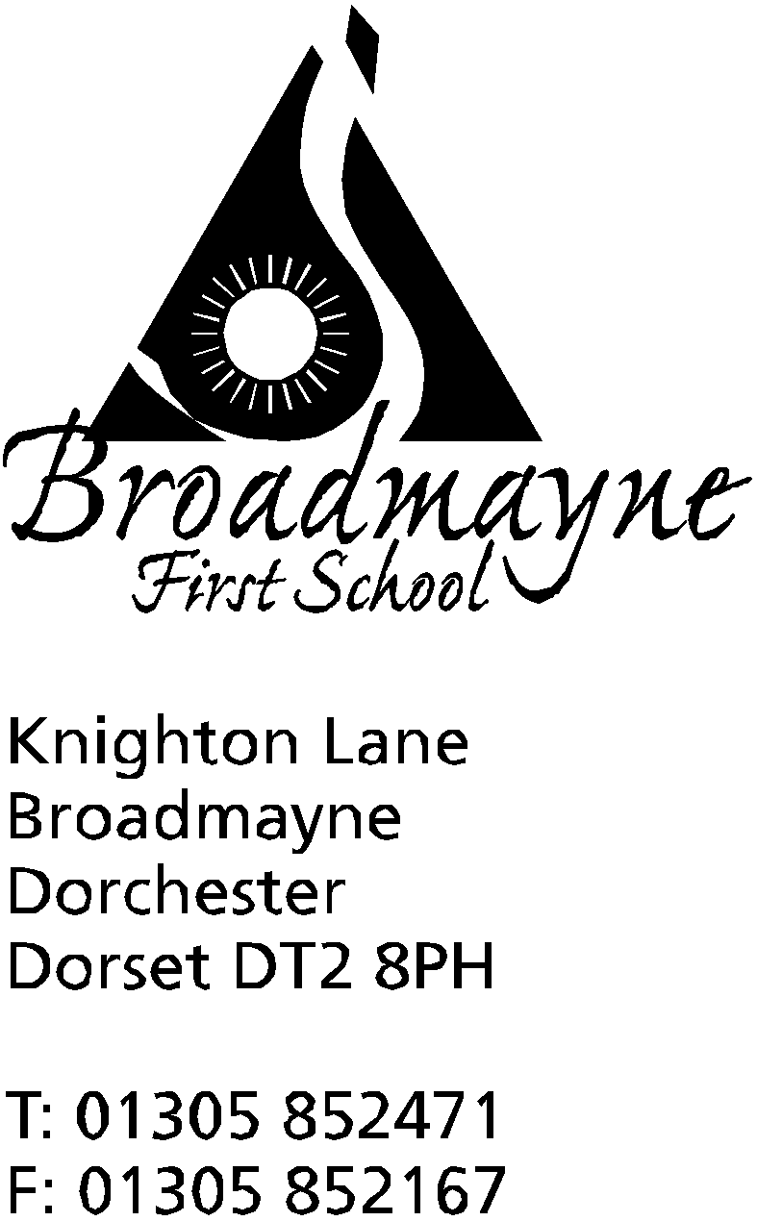

In Dorset

Headteacher
Helen Collings
Wednesday 27th May 2020

Dear Parents and Carers,

The school continues to prepare for opening to more children, in line with government guidance. This letter is to inform you of further details linked to this - these are some changes to the details contained in my previous letter, due to the fact that we have small numbers of children currently returning, and changes that have been made to the guidance we have been given - there were 41 changes to government guidance made last week!
We have planned for two bubbles, which are known as the Kingdom of the North (Reception and Year 1 children), and the Kingdom of the South (Year 2,3 and 4 children). We have planned in this way in order to be able to create a curriculum that can meet the children’s needs, whilst also taking account of our smaller numbers. All children attending full time, regardless of year group, will have the opportunity to work with their teacher at some point during the week, and we hope that by planning in this way we also have the ability to split into further groups should the need arise.
The following information applies to all children, key workers or not, who will be attending school from June:
Illness and Symptoms of Covid-19
- You must not send your child into school if they are ill in any way.
- If your child becomes ill at school, they will be placed in isolation and supported by a member of staff who will be wearing PPE equipment. We will contact you and expect you to pick your child up immediately.
- If your child or a member of your family have symptoms of Covid 19- a new persistent cough, a temperature or loss of taste or smell- you must all self-isolate for 14 days. Please inform school as soon as possible
- If we have a confirmed Covid 19 case in school, then that kingdom would need to be closed for 14 days - no staff or children from that kingdom would be able to come into school during that time. If a sibling of a child is in a different kingdom, they too would need to self isolate
- If staff sickness becomes too high, we may well have to close until staffing levels are at a safe level again

Organisation for the School Day
- If you are a key worker, the timings for the school day are from 8.30 am until 4pm - please inform the school what times you will need
- if you are not a key worker, drop off and pick up times are as follows:
Year R and 1 drop off between 9 and 9.15 am/pick up between 2.45 and 3pm
- Two metre social distancing must be maintained by all adults at all times. To drop off children, parents need to follow the following:
North Kingdom Bubble
Children dropped at Reception door-please ensure you keep 2 metres from staff
Enter through the car park gates, following social distancing guidance, and using the one way system to leave via the smaller side gate

Please pick up children following the same route and waiting in the reception playground.

South Kingdom Bubble
Enter school through the usual pedestrian gate
children dropped at the Year 4 fire door (around the side of the building)-please ensure you maintain the 2 metre social distancing rule
Following social distancing guidance, use the one way system to leave via the main playground gates

Please pick up children by following the same route and waiting outside the Y4 fire door at an appropriate distance.

All routes will be sign posted.

These drop off areas, and timings, will change if numbers increase and we have to add extra bubbles to the school.

- All communication to be via email or by telephone. Telephones will be manned from 8.15am until 4pm
- School lunches, should you wish to have them, will be packed lunches in order to free up lunch time staff.
- Packed dinners from home to be in a labelled, washable lunch box or disposable bag.
- Water bottles to be provided from home and taken home each night to be washed.
- Please check your child’s medicines are up to date - these will be kept in each kingdom.
- No book bags needed. We will not be sending reading books home to begin with as these could pose cross contamination issues.
- Children can wear own clothes suitable for outside activities, and these will need to be changed regularly as possible, ideally daily (we appreciate washing facilities are not easy for all families). Trainers/comfortable shoes to be worn. We have opted for non-uniform as realise that many of your children will have outgrown theirs and you may struggle to get new ones.
- No PE kits- we will exercise in our non-uniform clothes and trainers.
- please ensure children have sun cream already applied before they come to school, or they can apply it themselves - staff will not be able to help with this
- Children will be taught in kingdoms, with 2 key adults and will have designated facilities. These kingdoms will be self contained units and will not mix with each other. At the moment we have two kingdoms - the Kingdom of the North, for Reception and Y1 children, and the Kingdom of the South, for Years 2,3 and 4
- please ensure that at home you are adhering to all guidance around social distancing - this will reduce the risk for everyone at school

Key worker children may return to school on Monday 1st June and will drop off in the normal way at the Year 3 door. All other children, both Year R and 1 please return on Thursday 4th June- this is different to what we planned previously, and is when we will split into our new groups. As before, we are waiting for the government to give the final go ahead for the return, and we are currently being told this will be, on the 28th May. Please do not tell your child they will definitely be returning in case the date is delayed for any reason.

If your child is not attending school currently
As a school, we are happy to support whatever choice you make. If your child is not currently attending school, whether because their year group is not one of the ones asked to return, or because you have chosen not to, we will still offer support to you at home, through online home learning and our regular contact.

If your child is in Reception, Year 1 or you are a key worker and at some point you want to send your child back to school, please note we will require at least a week's notice, as this could have an impact on groups and staffing.

As always, I am available to talk to about anything you may wish to discuss on the email headteacher@broadmayne.dorset.sch.uk

I have no doubt there are many questions I have failed to address, and so I will be organising a Zoom meeting for parents at the beginning of next week, and will send further details out about this nearer the time. I will also be sending another letter containing ideas and activities you might like to use with your child to help talk about the possible transition back to school.

Keep safe and well,

Yours faithfully,

Mrs Collings

