Broadmayne First School Knowledge Organiser

Maths Focus | Place Value | Year 2 | Autumn Term 1
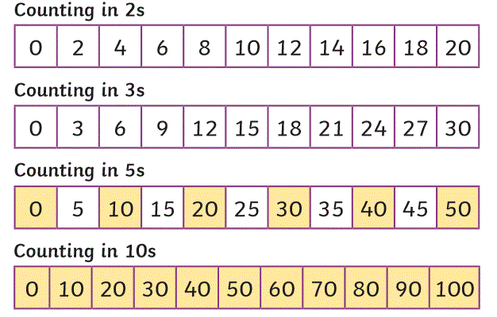
Vocabulary |  |  |  | Practical resources
ones | tens |  |  | Number line, numicon, dienes, tens and ones chart, 10p and 1p coins, place value counters, part part whole board.  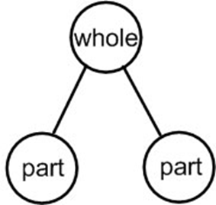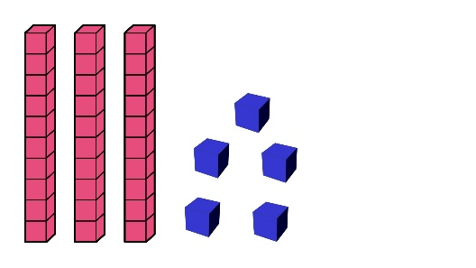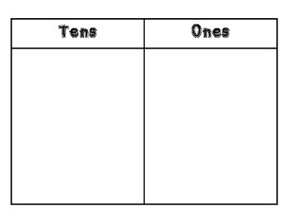  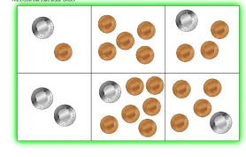  Stem sentences  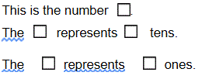
hundred | greater than
Less than | Is the same as/equals
digit | zero
partition | place value
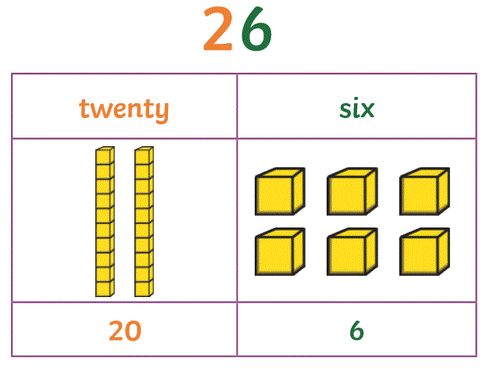
Comparing numbers |  |  |  | Ordering numbers
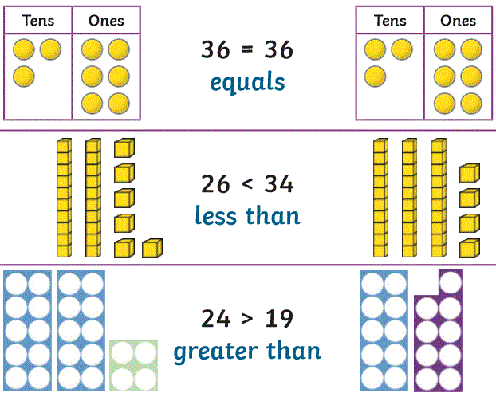 |  |  |  | 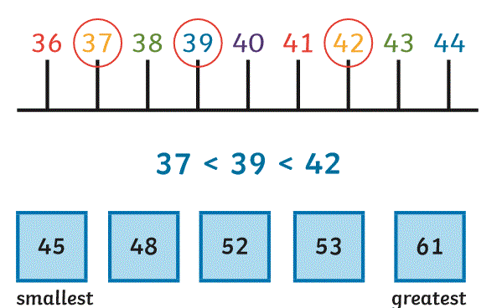  Counting in 2s, 3s, 5s and 10s

Representing numbers
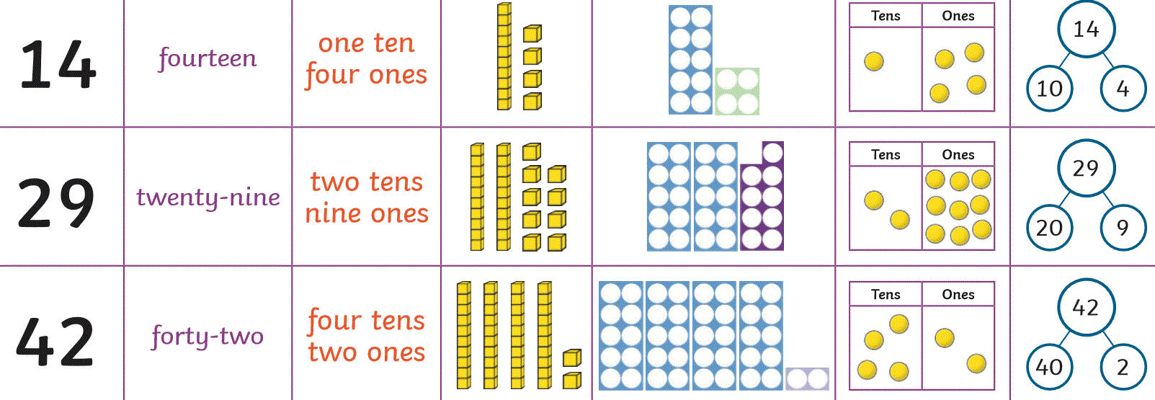

Numbers to 100
