Broadmayne First School Maths: Fractions Year 3 Spring 2

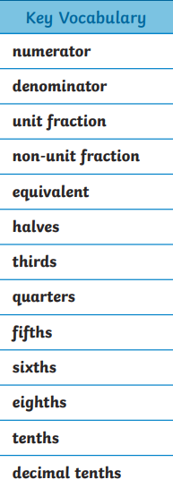  STEM sentences  If ____ is the whole then ___ is part of the whole.  The part is always smaller than the whole.  The whole has been divided into ______ equal/ unequal parts.  The parts are equal. I know this because the number of ____ in each part is the same. | Recognising Fractions  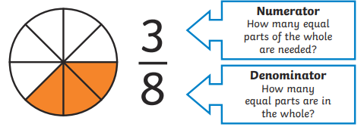  Comparing Fractions  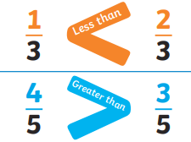 | Fractions on a number line  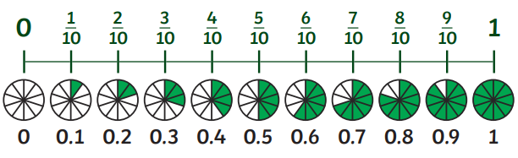
Fractions of amounts
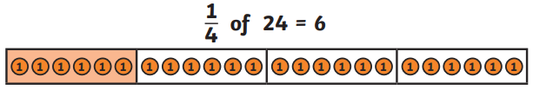
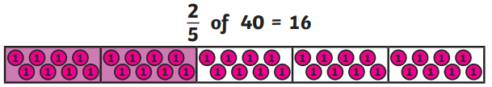
 | 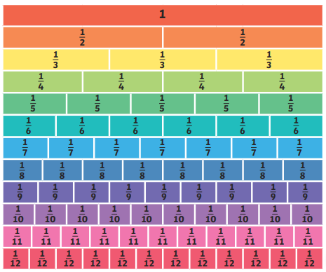 |  | Add and Subtract Fractions  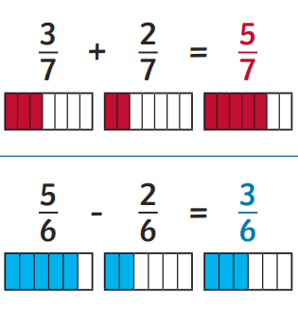 | Equivalent Fractions  