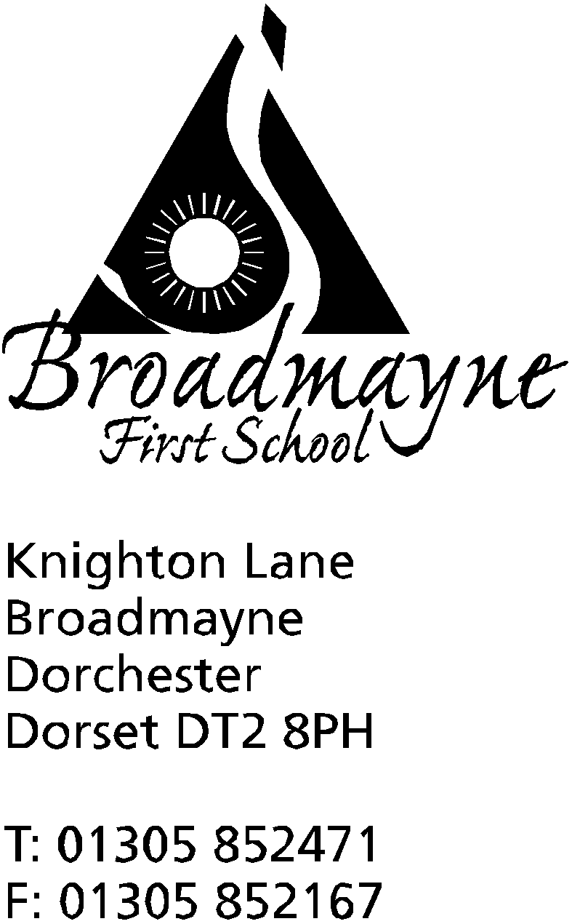

In Dorset

Headteacher
Helen Collings
Tuesday 16th June 2020

Dear Parents and Carers,

We have all been very glad to see the better weather return this week, as it has meant we have been able to get the children who are in school at the moment outside as much as possible. Our move to four kingdoms has gone well, and we are all adjusting once again to new rules and routines.

New Reception Parents
I would like to extend a warm welcome to any new reception parents reading this - although your children have not yet officially joined us, as a school we thought it might be useful for you to start receiving our newsletter and finding out about some of the things that are happening around the school. Could I ask you all to click the following link which will take you through to a short questionnaire to help us with our planning for your child’s move to the school in September: https://forms.gle/MKL6gXkCxrejrAes8

Year 4
In my last letter to you all I had hoped to have been able to write to the Year 4 parents with a plan going forward for our Year 4 children. In the light of new DfE and Local Authority guidance we are discussing how we can make something work within school and will update you as soon as we can. In the meantime, can I ask all Year 4 parents to use the following link to let us know whether they will be sending their child back into school towards the end of term for transition work if we can make it work - there are no guarantees, (but we are going to do our very best!). Your responses will aid us greatly with our planning. Please ensure all responses are in by Friday 19th June. The link is here: https://forms.gle/cyaEns8XsGJfaTTeA

Road Closure
Please don’t forget that Knighton Lane will be closed to traffic from 9am - 4pm on Wednesday 17th and Thursday 18th June. You can use Loscombe Lane to access the school during these times - please drive carefully!

The Summer Reading Challenge 2020 – Silly Squad
Last year over 8000 Dorset children aged 4-12 years participated in the Summer Reading Challenge – run nationally by libraries and The Reading Agency. This reader development promotion is designed to encourage 4-12-year olds to read for pleasure and to help maintain literacy levels over the summer holiday period. This year's Summer Reading Challenge is Silly Squad; a celebration of funny books, happiness and laughter. In light of the Covid 19 restrictions, the Challenge this year will be digital.
How Silly Squad will work (The promotion will run from June to September 2020)
- Children join the Challenge online at www.sillysquad.org.uk and set their own target for their challenge
- They read or listen to books, comics etc. that make them happy!
- Adding each completed book to their online profile will give a reward of online badges, games and videos
- When their challenge is complete children download their certificate
- Children can take part using the digital lending services, or what they have at home. When libraries reopen, they’ll be able to borrow library books.
o eBooks and audiobooks
o Digital comics
Children who are not library members can join online for instant access to digital services; they will be sent a library card when libraries reopen.
Blue Peter 6 Badges of Summer
Blue Peter is running an interactive competition to earn badges cross June and July.. Follow this link here: https://www.bbc.co.uk/cbbc/joinin/six-badges-of-summer which will take you to their page. Each badge covers a different area, such as sport or environmental issues, and work can be uploaded to be shared with others. I may be aging myself here, but when I was younger getting a Blue Peter badge was the stuff of dreams, so I’m hoping some of our children would like to have a go!

RNLI Beach Safety Campaign
This summer, the RNLI Lifeguards can’t be on every beach, meaning a heightened water safety risk to beach goers. We have been asked by them to share some important information with you. It is anticipated that once restrictions further ease and the summer weather is here, people will head to the beaches and coastline to enjoy the sun, sea and time with friends and family. In a normal year, the RNLI helps thousands of people who end up getting into difficulty in or close to the water when doing these types of activities. Due to the ongoing coronavirus outbreak they have not been able to engage with school communities as we normally would.
Instead, the RNLI are asking parents and carers to look at the following:
- Water Safety from Home resources - If you’re looking for ways to engage, educate and entertain your children at home, play the Water Safety Wednesday series – perfect for primary school-aged children.
- RNLI & MCA’s Beach Safety Campaign Beach lifeguards cannot be everywhere this summer – although they are hoping to patrol around 70 beaches later this year – it is vital every one of us takes responsibility for our own, and our families’, safety.

Countryside Code
With the relaxing of the lockdown rules, more people are accessing the countryside, and the recent fires at Wareham forest have thrown into stark relief what can happen when people do not take care. As well as practising good hand hygiene at gates and stiles, the countryside code reminds us all to:
- consider the local community and other people enjoying the outdoors
- leave gates and property as you find them and follow paths unless wider access is available
- leave no trace of your visit and take your litter home
- keep dogs under effective control
- plan ahead and be prepared
- follow advice and local signs

https://www.gov.uk/government/publications/the-countryside-code
https://www.countryfile.com/how-to/your-five-minute-guide-to-the-countryside-code/

A great video to explain the rules:
https://www.bing.com/videos/search?q=countryside+code+videos&docid=607989527111339515&mid=A8DCBB1BAF9E61D9750BA8DCBB1BAF9E61D9750B&view=detail&FORM=VIRE

Families Dorset Magazine
The digital version of the Families Dorset magazine, which until recently was sent out in print, can be found here: https://bit.ly/3di9Nfg

We still seem to be still living through very changeable times, and we are working hard to ensure the very best outcomes for our children and families. I am aware that the strain on families is generally becoming worse at this time, and the motivation to keep up with home learning is waning. As parents and carers we can only do our best, and sometimes other things take precedence. I have spoken before about the importance of prioritising mental well being above all things, and I would encourage everyone to continue to pay attention to this. If you have any concerns or worries, please do not hesitate to get in touch with us, we will always do our best to help.

Yours faithfully,

Mrs Collings

