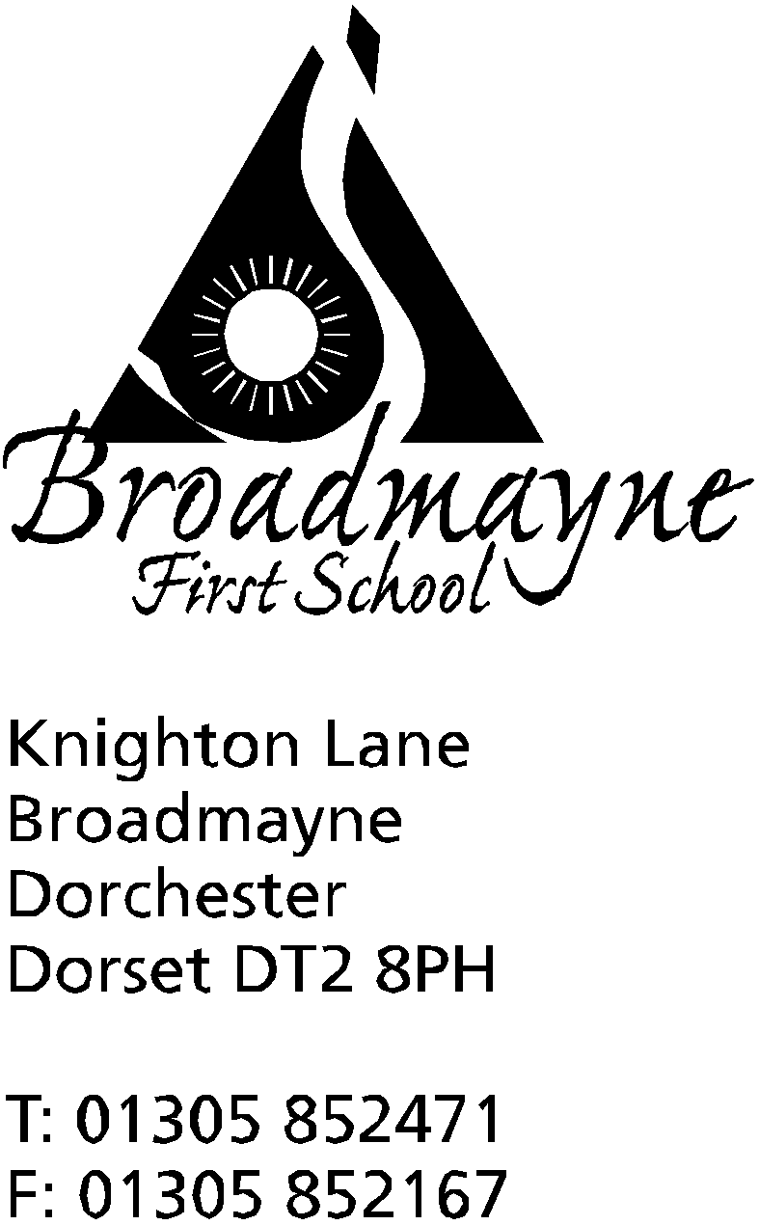

In Dorset

Headteacher
Helen Collings
Monday 1st June 2020

Dear Parents and Carers,

I hope you all had a lovely half term, and were able to make the most of the good weather we had. As I write to you today, our staff are busy discussing the curriculum as we move into the second half of the summer term, and preparing classrooms ready for our new ‘kingdoms’ to begin on Thursday 4th. We are working to create a curriculum for this half term that begins to introduce some new learning, ensuring that both children at home and at school have access to this.

Children’s Videos
My apologies at being a little later than I planned at creating a video of the photos you sent to me of the children at home - I was inundated with pictures, and on top of the new government guidance things got a little busy! I had so many photos I decided to make two videos, and they are currently available on our website here: https://broadmayne.eschools.co.uk/web/welcome/458329/cHJldmlld3x8MjAyMC0wNi0wMSAxMTozOToxNA%3D%3D

I really enjoyed looking through all the pictures, and it really made me miss the children! I hope I got every photo in - if you think I’ve missed your child please let me know.

Dorset Music Hub
Dorset Music Hub have launched an online music tuition service that may be of interest to you. Working with Dorset Music Service, they are offering a range of lessons for various instruments on a secure platform. Comprised of 20 minute 1:1 lessons, they are happy to work with pupils who already have music lessons, or who would like to start. Please email dorsetmusicservice@dorsetcouncil.gov.uk if you are interested in finding out more.

Children Returning to School
Although our key worker children are attending as normal, on Thursday of this week we will be welcoming back a small group of our Reception and Year 1 children. Just to reiterate, we are happy to support our children and families whatever decisions you make, and you will not be fined if you choose not to send your child in at this time. If your child is coming into school, please be aware we have a child with a serious nut allergy and so we continue to operate as a nut free school.
You will notice there will be some new signage on the way in to school, to help support social distancing. Please ensure you comply with this at all times, and that you follow the current timings for drop off and pick up, which are between 9am and 9.15am for drop off for Years R and 1, and 2.45 - 3pm for pick up. This enables us to limit the amount of adults accessing the school site at the beginning and end of the day.
I would like to warn everyone that all of these carefully laid plans may change in the near future, depending on the release of further government guidance or an increase in children. We will always endeavour to inform you of any changes as far in advance as possible.
If your child is not currently attending school and is in year R or year 1 and you would like them to attend school, please give us at least 1 weeks notice. Alternatively if your child is currently attending and you would like to change the days, we would also need 1 weeks notice in order to manage staffing where we can.

Online Meetings
I had intended to offer a zoom meeting to our parents, but we have had some issues with the technology over the past few days and so I am going to postpone these until I feel certain the platform can manage the meetings successfully. In the meantime I am hoping to create a ‘frequently asked questions’ section on our website - if you have a question about the current situation, no matter how small, please use this link and I will either reply directly to you and/or use it to inform the information sheet. Only school related though please- unfortunately I have no idea what the government has planned for any other areas of the country! Link is here: https://forms.gle/iuhU5a8htb99izCv7

As always, we send you all our very best wishes, particularly at this time when things seem to be getting so much busier everywhere, and we are all trying to make the best decisions for our families.

Yours faithfully

Mrs Collings

