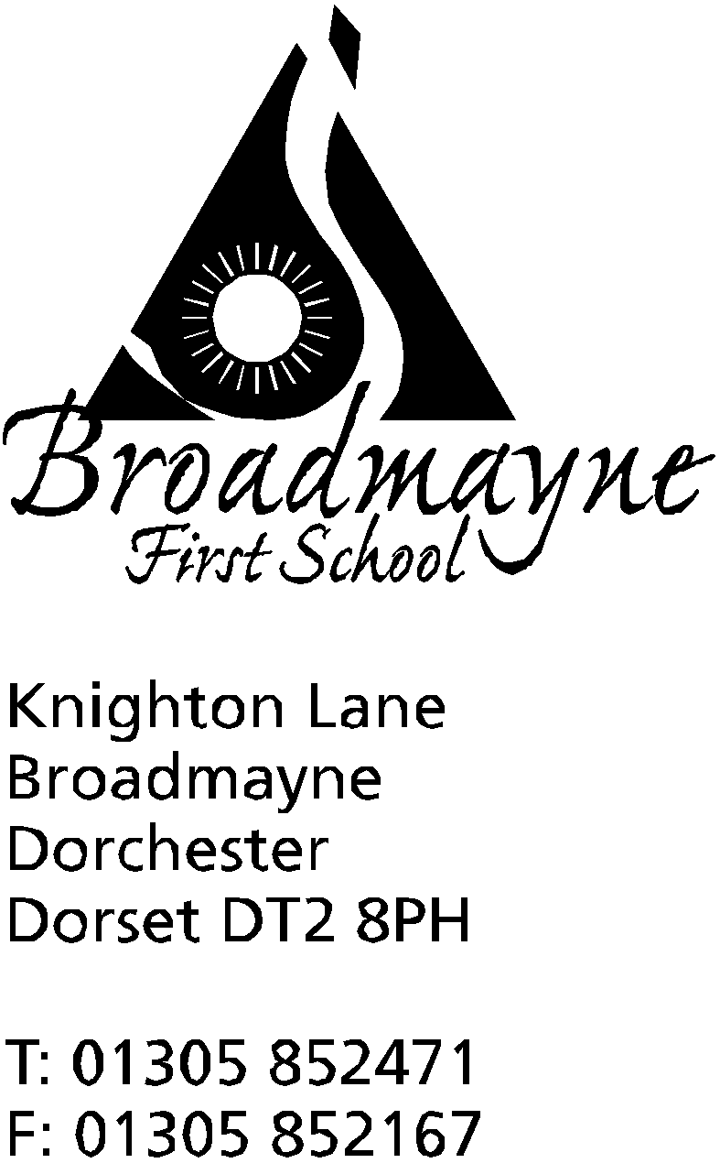

In Dorset

Headteacher
Helen Collings
Wednesday 9rd September 2020

Autumn 2020: Newsletter Number 3

Things to remember!
- Year 4 families can sign up for astronomy club (explained in last week’s newsletter) here: https://forms.gle/XiVE9iysyuRfYQqE8
- New start and end times to the school day - please see below!
- Please keep an eye on our Facebook page: https://www.facebook.com/broadmaynefirstschool

Dear Parents and Carers,

I would like to thank all of you for your fantastic support since the school reopened, and for your sensible attitude towards our approach to getting everyone safely into school. As time goes on, we will be adapting and changing our routines depending on our ongoing risk assessment and any new advice we receive from the DfE, Public Health England, or Dorset Council. Despite the continued concerns around Covid, I am happy to report that for our children, school feels very much as normal, with just a few changes to routines which they have quickly adjusted to.

New School Start and Finish Times
After careful consideration, the school has decided to change the drop off and pick up times for the children.
From Monday 14th September we will revert to our original timings for the school day. This means that from Monday the drop off time for all children will be between 8.45 and 8.55 am, and pick up time will be at 3.15pm. We believe this will help our parents to organise their days, and our staff to provide a more enriched curriculum.
In order to minimise risk, we are asking you to help us by following these rules;
- all drops offs and pick ups will be at the current doors we have been using since we returned
- please follow the one way system - this is really important for Reception parents - please ensure you do not leave the Reception playground by the car park gate, but follow the smaller gate at the side of the school
- if you have children in Year R/1 and older children, please drop the younger children off first and follow the one way system around to the older children’s doors
- we are encouraging Year 4 children in particular, and Year 3 if you feel it is appropriate, to be dropped at the school gate and to walk in on their own. If you do this please keep an eye on your child to ensure they reach the correct door. We are suggesting this to try and reduce the amount of adults accessing the site. If you or your child aren’t comfortable with this, or you have a message etc for the staff, then please do come in with your child - we will do our best to have a staff member at the top gate, but we cannot always guarantee this
- please pay attention to social distancing rules and ensure you are being safe, particularly if you are waiting for children to be released at the end of the day.
- Year R parents- please wait on the YR playground at the end of the day but please ensure you leave space for Year 1 parents to access the Secret Garden
Covid-19 Guidance for Parents in Case of Illness
We know that at the current time, if your child falls ill it can be really confusing to know what to do. Attached to this email is a handy guide we have prepared, that covers most ‘What if..?’ questions, which hopefully will be of help. The most important thing is to keep the school informed, and we will do our best to support you.

Attendance
Attached to this letter is the DASP Attendance Statement for this year, which Broadmayne, along with all the other schools in the partnership, follow.

Solar Panels
Earlier this year, the FABS were delighted to be awarded a grant of £1900 towards 12 new solar panels which were mounted on the school roof this summer. The grant from Low Carbon Dorset, funded by the European Union’s European Regional Development Fund (ERDF) and run by Dorset Council, contributed 40% of the overall costs of the project.

As you know, the FABS also takes responsibility for the running of our swimming pool - unfortunately closed this year due to COVID-19. The new panels will help reduce the running costs of the pool, which is used both by the school children, and by the general public over the summer holidays. During the winter, energy generated will also help the school reduce its carbon footprint.

Costs for panels were kept down with the help of local contractor Tincleton Solar Systems and Templegate Electrical Supplies who also donated a free Wi-fi Connection for the new system which will help the children monitor and record the energy generated by the new panels. The panels are expected to generate over 3KWh of electricity per annum saving the PTA and the school nearly £8,000 over the next 20 years! The school would like to thank everyone who has made this installation possible.
This project has been supported by:

Broadmayne and West Knighton PreSchool
The school and the preschool are beginning to work together much more closely, and we hope that over the coming months we will develop a close working partnership that will be beneficial to us both, and most importantly, to the children in our care. Unfortunately, social distancing rules may limit some of the activities we had planned, but we will keep working to find creative solutions as time goes on.

Nurf Busters Children’s Parties
This is a new venture moving into the area, which will be using our school grounds to provide children’s parties based around Nerf guns, which sounds like a brilliant idea for a party! There are posters on the school noticeboard - they can be contacted info@nurfbusters.uk or found on Facebook - the contact number is 07886 897849 or 07970 498770

Music Lessons
Music lessons will be starting over the next couple of weeks for those children who were previously having them. We will inform you if any spaces become available, should your child be interested in beginning.

Yours faithfully,

Mrs Collings

Calendar Dates- Autumn Term 2020
Date | Time | Event
SEPTEMBER 2020
Week beg. Monday 14th |  | Music lessons start
OCTOBER 2020
Monday 19th to Friday 30th |  | half term - 2 weeks
NOVEMBER 2020
Monday 2nd |  | Second half of Autumn term begins
DECEMBER 2020
Monday 21st to Friday 1st Jan |  | Christmas holidays
JANUARY 2021
Monday 4th |  | Return to school for beginning of Spring term

DASP Attendance Statement

The Dorchester Area Schools Partnership (DASP) are pleased to be able to provide some detail about our expectations for pupil attendance for the forthcoming academic year. Clearly, both families and schools are operating in challenging circumstances at present. We understand that you may have concerns for your child’s well-being and this may influence your decision for your child’s return to school. We urge you to talk to and work with us if this is the case so that we are able to work together to ensure that your child enjoys full attendance and participation in school and that you are able to be reassured for their well-being.

The Dorchester Area Schools Partnership (DASP) will remain committed to ensuring the best for all our learners and are working together with parents and carers to support children and families as schools return widely in September. All schools are working hard to promote good attendance and have common systems in place to work with families when attendance drops below an acceptable level.

You will be aware of the importance of good school attendance in improving a young person’s chance of success in life and establishing positive attitudes to life-long learning. There is clear evidence of the link between poor attendance at school and low levels of achievement. Of pupils who have less than 90% attendance, only 35% achieve five or more GCSEs at Grade 9 to 4 including Maths and English, but 73% of pupils who have attendance of 95% or more will achieve this.

If a child has an attendance level of 90% they will have missed one day a fortnight in school. Over a school year this will represent four weeks of absence. If this level of absence were maintained for a five year period it would mean half a school year would have been missed.

If DASP are concerned about a child's attendance they will talk to the parents and write to them to explain their concerns. The school will then monitor the child's attendance expecting to see an improvement. The Dorset Council (DC) School Attendance Service will be made aware of the school's concerns. If no improvement is made, the family will be invited to attend an Attendance Panel.

Here at DASP we are determined to ensure that all our students have the opportunity to achieve success and have an excellent record of attendance. Where there is cause for concern you will be contacted and attendance closely monitored. If attendance does not improve sufficiently, you will be invited to an Attendance Meeting or Panel. This meeting is an opportunity for the school, family and a representative from DC’ s School Attendance Service to meet together to discuss why your child has such a high absence rate and seek solutions to any problems.

The Panel/Meeting can recommend several outcomes, which can include; a further period of close monitoring with specified targets for attendance; issuing a £60 Penalty Notice, a Parenting Order or seeking prosecution which could result in a fine of up to £1,000.

The attendance process is designed to identify poor attendees quickly and address the issues that are affecting their attendance. When attendance improves, monitoring will continue and, if it falls, the Attendance Process will be resumed. Please be assured that whilst we will be sympathetic with families with genuine concerns over Covid – 19 it is expected that all children should regularly attend school.

All schools hope that the Attendance Meeting/ Panel will not be needed and that all pupils will have a good record of attendance, are happy and successful and benefit from their time in school.

