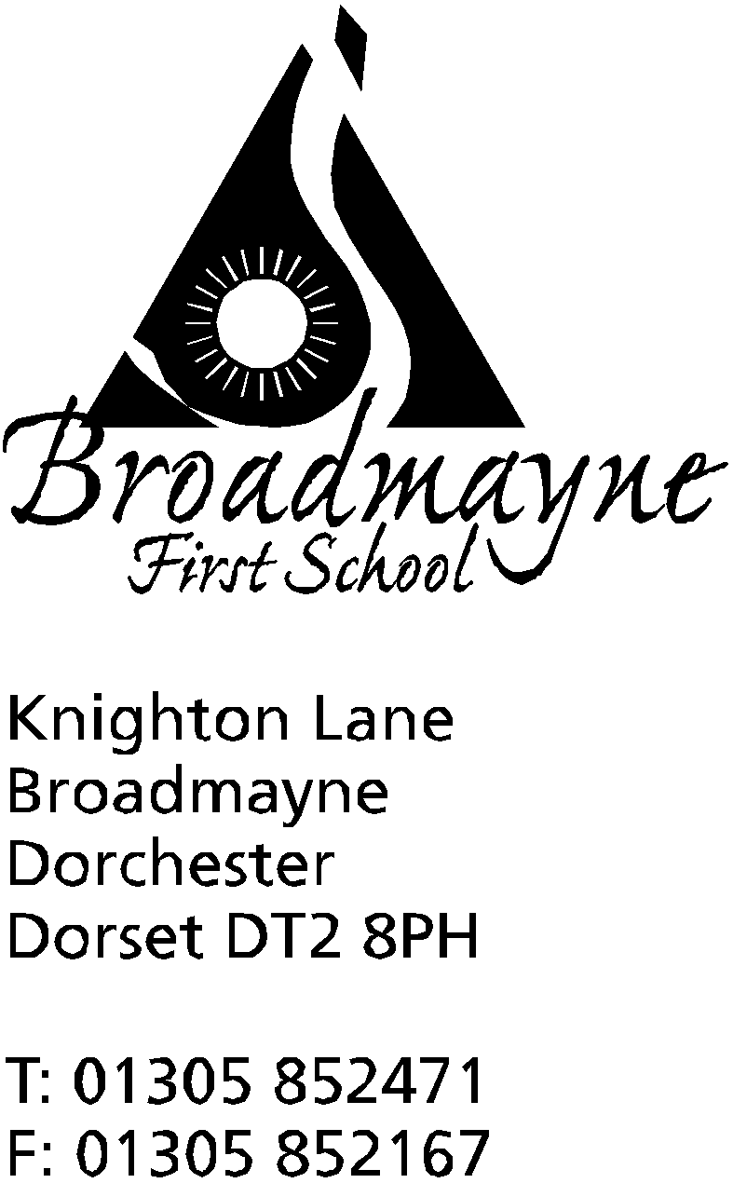

In Dorset

Headteacher
Helen Collings
10th December 2018

Autumn 2018: Newsletter No.6

Things to remember:
- Christmas Play DVD - have you returned the consent form? Your child can’t be in the film if not!
- the cut off date for ordering LFL Christmas lunch is Tuesday 11th December (to be served Wednesday 19th December)

Dear Parents and Carers,

The school is busy getting ready for the Christmas Play, whilst still keeping on top of what remains of the Autumn curriculum. The next two weeks are sure to pass by very quickly, so this will be the last newsletter of the Autumn term - it’s hard to believe my first term as headteacher is nearly over!

FABs Christmas Fair
Many thanks to all the FABs who worked so hard towards our Christmas Fair. It was a lovely evening, with a wonderful selection of stalls and activities, wood fired pizzas and mulled wine! The FABs made a profit of £1,362.17, which is going towards paying for the pantomime in February and refurbishing the Rainbow Room.

FABS Pool Fundraising Campaign update
After a fantastic Aviva Community Fund campaign, we received 9442 votes and as a result have been shortlisted as for the national finals – and secured £500 for reaching this stage. Thank you all for you amazing efforts. It is now with a panel of judges who make their decision on 24th January.
Our Crowdfunding page was extended until 11th December and we received over £790 in pledges. We also pledged some of our own funds to reach 25% of our target and as a result secured £5000 from the Dorset Youth Fund. Altogether we now have the funds to undertake the essential repairs to the pool itself this winter and continue to raise funds for a new pump room and toilet next year.
More great news – we have been selected as one of 3 local charities being supported by the Co-op Community Fund this year. If you or any friends/relatives have a Co-op membership you can choose to support Broadmayne Pool by signing into your membership account or by calling the membership helpline on 0800 023 4708 – it doesn’t matter where you shop in the UK! We then get 1% of the value of Co-op branded products purchased until November 2019! More info to follow on FABS Facebook Page.

Many thanks to everyone who has helped with this - and particularly to Jude baker, who has worked so hard to put everything together.

Eco-Greenhouse Project
A message from Mrs Stoker:
We are delighted to have been awarded a grant from the Dorset Gardens Trust to develop our outdoor area. We would like to use the grant to buy poly-tunnels for our raised beds, and to buy materials to build an recycled bottle greenhouse. This would enable more opportunities for the children to study the growth of seeds to plants, and grow a variety of fruit and vegetables. We need up to 1,200 2 litre clean recycled plastic bottles to complete the project. It would be great if you could collect these over the forthcoming festive period, and into the New Year. Please give these bottles to the school office when you can.

PE Kit
We are finding that many of the children do not have a full PE kit in school for their PE lessons, or sometimes no PE kit at all. Although we appreciate things can get mislaid, could you please use the holidays as a chance to check that your child has their full kit, as they cannot access the PE curriculum without it. We welcome children bringing in warm PE clothes to wear in case their lessons take place outside. {Please also remember that long hair must be tied back and earrings removed or taped for all PE lessons).

School Pond
A big thank you to Lizzie Nicholls who very kindly gave up her Saturday to help Mrs Stoker with clearing the pond area. Thanks to a grant from Silverlake benches have been bought, and a path will soon be laid to enable the children to really make use of this area.

School Safety
Please can parents ensure they do not walk across the school car park in order to access the school. It is too dangerous to come in or leave this way; instead the footpath at the front of the school must be used.

Dorset Armed Services Covenant Programme
We have been asked to share the following with you:

As part of the Armed Forces Covenant programme supported by the MOD, and on behalf of the Programme partners’, Dorset county council are taking forward a survey. We want to get a clear picture of the thoughts and opinions of life in Dorset for our Armed Forces, your families and the County’s veteran population. This will ensure we are doing our best to adhere to our Covenant pledges to ensure the Armed Forces Community in Dorset are not put at disadvantage due to their service to our country.
The Armed Forces Covenant Survey, which will take just 5 minutes to complete, is completely anonymous and the information gathered will help us to deliver relevant and meaningful solutions to issues that are currently being faced by the Armed Forces Community in Dorset. The link is here:
https://www.snapsurveys.com/wh/s.asp?k=153693903937

Christmas Party Day
Christmas Party Day will be held on the last Friday of term, the 21st December. There will be lots of lovely activities happening throughout the day, and this year instead of a fish and chip lunch, we will be providing the children with a buffet meal. We would like to invite you to contribute towards the cost of the day by making a donation of £1 on the SchoolMoney site. There is no obligation to do so, and we are very grateful for any contribution.

It only remains for me to wish everyone a peaceful and happy holiday, however you choose to celebrate Christmas. I look forward to seeing everyone again the New Year - there is no INSET day, so we will all be back refreshed and recharged on Monday 7th January 2019!

Yours faithfully,

Mrs Collings

Date | Event | Time
DECEMBER
Thurs 13th | Dress rehearsal of Christmas play- filmed  Last Cool Kids session
Mon 17th | Christmas play in school hall | 1.45pm
Tues 18th | Christmas play in Broadmayne Village hall  “ | 9.30 am  6.00 pm
Fri 21st | Last day of term; Christmas party day with lunch.
January 2019
Mon 7th | First day of Spring Term
Thurs 17th | Year 1 Class Assembly | 9.10 am

