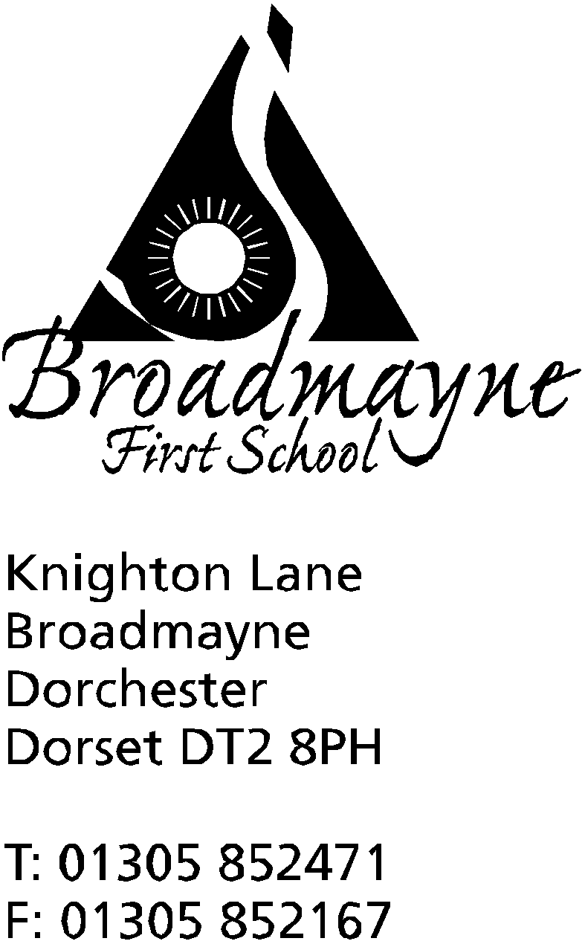

In Dorset

Headteacher
Helen Collings
Thursday 28th November 2019

Autumn 2019: Newsletter No. 8

Things to remember!
- Christmas Fayre - including exclusive Broadmayne Family Organisers!
- the ticket letter for the Christmas play will be sent out tomorrow, Friday 29th December

Dear Parents and Carers,
I can’t believe that there are only three weeks left until the end of term! The classes are beginning to get ready for the Christmas play, whilst also working towards finishing the Autumn curriculum. New Knowledge Organisers will be available on the school website towards the end of this term ready for the new term in January.

Driving away from school
I have had several parents express their concerns about the speed with which people are driving away from school after dropping their children off in the mornings. Parents who walk their children to school are sometimes being splashed by puddles when it is wet, and there are concerns for the safety of children. Please take care when using Knighton Lane - it is a narrow road to navigate and is often busy at school drop off and pick up times, and although there is a 30 mph speed limit, it would be sensible to drive at well below this speed at those times.

St Osmund’s Middle School Admissions
St Osmund’s Middle School is required to consult on its admissions arrangements if a) changes have been made to the school’s admissions arrangements or b) if the school has not consulted upon its admissions policy in the last 7 years.
As a result, St Osmund’s Middle School is consulting upon its admissions arrangements under point b. This is for the allocation of school places for the start of the academic year in 2021.
The consultations are running from Monday 25th November 2019 to Monday 6th January 2020.
Responses, including comments or objections, must be submitted either in writing to Mrs V Smyth, Clerk to Wessex MAT, Thomas Hardye School, Queens Avenue, Dorchester, DT1 2ET or by email to vsmyth@thomas-hardye.net by Monday 6th January 2020
Upon conclusion of the consultation period, all responses will be considered carefully and a report will be presented to the Governing Body prior to the determination deadline on the 28th February 2020.
The key dates for the consultation are set out below:
St Osmund’s Middle School consultation of Admissions Arrangements begins | 25th November 2019
Consultation ends | 6th January 2020
Governing Body of St Osmund’s Middle School, as the Admissions Authority, determine Admission Arrangements | 28th February 2020

Winter Illnesses
We have been informed by Public Health England that influenza is beginning to circulate - the North East is currently affected but there are schools in Somerset and the South West which have also had cases. The school will be taking extra provision in order to protect our children and staff, and the wider community, as much as possible - for instance teachers will be giving age appropriate lessons on infection control, and the school is following Public Health England guidance on actions to take. In the meantime please encourage your children to us a tissue in order to ‘catch it, bin it, kill it’ when they cough or sneeze, and to wash their hands whenever necessary.

Christmas Fayre
Don’t forget the Christmas Fayre which will be held at the school this Friday, starting at 5.30 pm - 7.30 pm. There are a host of stalls selling a wide variety of crafts, including the newly designed Broadmayne Family Organiser, which includes school dates throughout the year and illustrations by some of our children.

Yours faithfully,

Mrs Collings

Date | Time | Event
NOVEMBER
Friday 29th | 5.30pm-7.30pm | Christmas Fair
DECEMBER
Thurs 5th | 9-12 noon | Reception vision screening
Mon 16th | 2pm | Christmas play
Tues 17th | 9.30 am  5.00 pm | Christmas play  “ “
Weds 18th |  | Year 1 trip to the Shire Hall
Fri 20th |  | Last day of term; Christmas party lunch- school finishes at 2.30 pm
Mon 6th Jan 2020 |  | Back to school - First day of Spring Term

