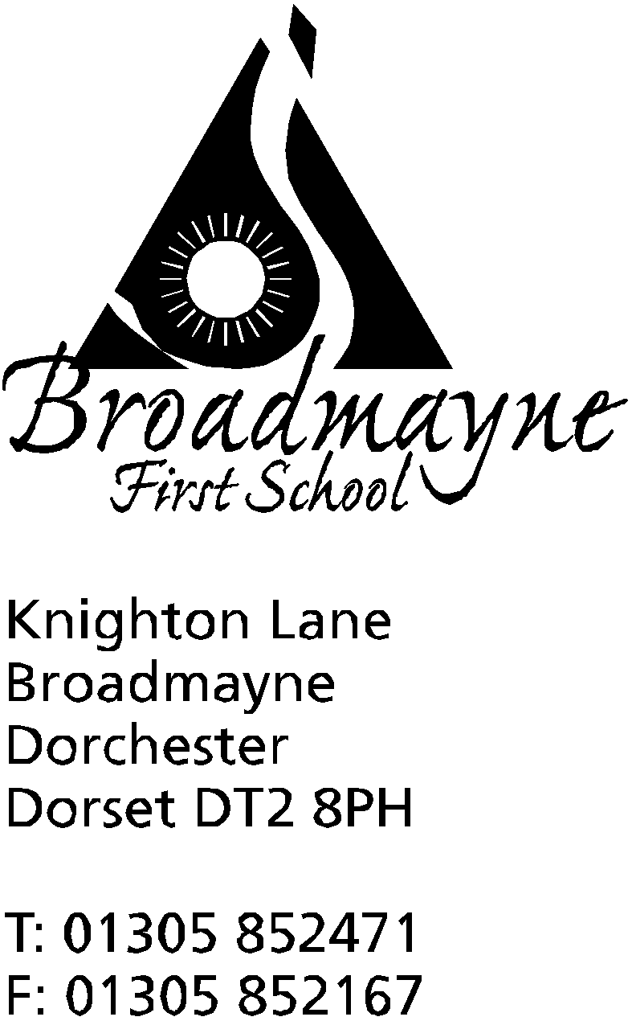

In Dorset

Headteacher
Helen Collings

Wednesday 1st May 2019

Dear Parents and Carers,

As we are now over half way through the school year, and my first year as headteacher of Broadmayne, I thought it would be a good time for us to take a moment to celebrate everything that has been happening in school, and to look forward to our plans for the future.

Thanks to the help of our staff, parents and friends, we now have freshly decorated toilets for our younger children, and a grant from Silverlake has allowed us to create a pond area that is accessible for whole classes to use. Although, despite our best efforts, we did not win the Aviva funding for the pool, the FABS have continued to investigate grants for this, and we have been able to carry out essential repairs and maintenance, and have recently received funding to begin the repair of the boiler room.

We have worked with our school community to decide upon three essential school rules, and Be Kind, Be Safe and Be Respectful were chosen, as it was felt these values summed up everything we try to encourage our children to be. We celebrate these every day, and in our Celebration Assemblies on Fridays, we congratulate those children who have really gone above and beyond in showing these values. The hot chocolate and biscuit sessions are much enjoyed, both by the children and myself!

We have responded to parent’s concerns about information being shared, and have invested in the texting service we use so that we can send texts more frequently, for instance to inform you of your children receiving rewards, or if children do not eat their lunches. We have also increased the number of opportunities for parents and carers to come in a take part in the learning taking place in school, for instance with Read With a Friend or Relative, or with Learn Alongside Your Child events. We have had a huge amount of positive feedback for these and continue to explore ways in which we can involve our parents in the work we do.

We have trained as a whole staff in understanding attachment issues, and we use this to help support the pupils in our school. As part of this, we have developed our ‘Rainbow Room’ to make it a warm and welcoming space for both adults and children to spend time in.

Our curriculum continues to develop and improve. Recently we have focused on raising the profile of science, and Mrs Stoker will be leading the school towards gaining the Primary Science Mark in the coming year. We have taken one of school values - Be Safe - and used this as a springboard for teaching children about keeping themselves safe, through the NSPCC Pants lessons, and ESafety work.

Miss Felgate and the Eco team have made great progress - we retained our Green Flag status and are moving forwards with providing recycling for a wide range of materials-bathroom products are next on the list. We are (still!) collecting bottles for our greenhouse project -who knew 1,200 bottles were so hard to collect (and difficult to store!), and with a grant from Dorset Gardens Trust we will soon begin to build the frame of
the greenhouse, ready to put the bottles to good use. We are continuing to collect Eco Bricks, and are currently designing building projects using these.

Our sports teams go from strength to strength - we encourage enjoyment in participation, but are always proud when our teams do well, such as in the recent football tournament. The range of activities the children have
been involved in this year has been amazing, including tennis, rugby, cricket, football and archery, and we haven’t even started the summer term athletics and swimming program! The Daily Mile is slowly getting us around the world, and children and staff enjoy running, walking or skipping their way around the playground every day. We were very pleased to gain some funding from Public Health England which enabled us to run Relax Kids sessions for years 1 to 4 throughout the Spring term.

We have developed our links to the wider world - Year 3 ran a successful Fair Trade Cafe, the profits of which went towards buying goats for farmers in developing countries,and the School Council have supported us in fundraising for different charities. We continue to work on learning about Nepal and supporting the Altevette Project, and we have been lucky to have visitors to the school to further our understanding of children’s lives in these areas.

We have listened to the views of parents, staff and children about Home Learning, and this is currently undergoing a review which will soon be shared with everyone - our intention is to create a simple, effective home learning system that everyone can understand and make use of.

Looking forward, in the near future the school has plans to develop the English curriculum, making quality children’s texts at the heart of our planning, and improving our cross curricular links. We will also be developing our maths expertise - Mrs Bassindale and Miss Felgate will be taking part in the Jurassic Maths Hub Teaching for Mastery course, which will not only develop their own expertise, but that of the wider staff too. We are currently looking at our topic work, and are discussing how this can be developed to engage all children and support them in every aspect of their learning.

Within the school, it is planned to use ring fenced funding to build a much needed cloakroom for Year 1 during the summer holidays, and we hope to be moving the school library into a more central place in the school, allowing us to use the room it is currently in for interventions, small group work, and meetings. Looking at the school grounds, we are hoping to soon be building our greenhouse, in the area that was the old music garden, and then we will be looking to further develop this area as a gardening zone.

I hope you will agree that this is an exciting and positive time for our school, and by working together as a school community we can ensure the very best outcomes for every child in Broadmayne.

As always, if you have any queries, concerns or suggestions, please feel free to contact me,

Yours faithfully,

Mrs Collings

