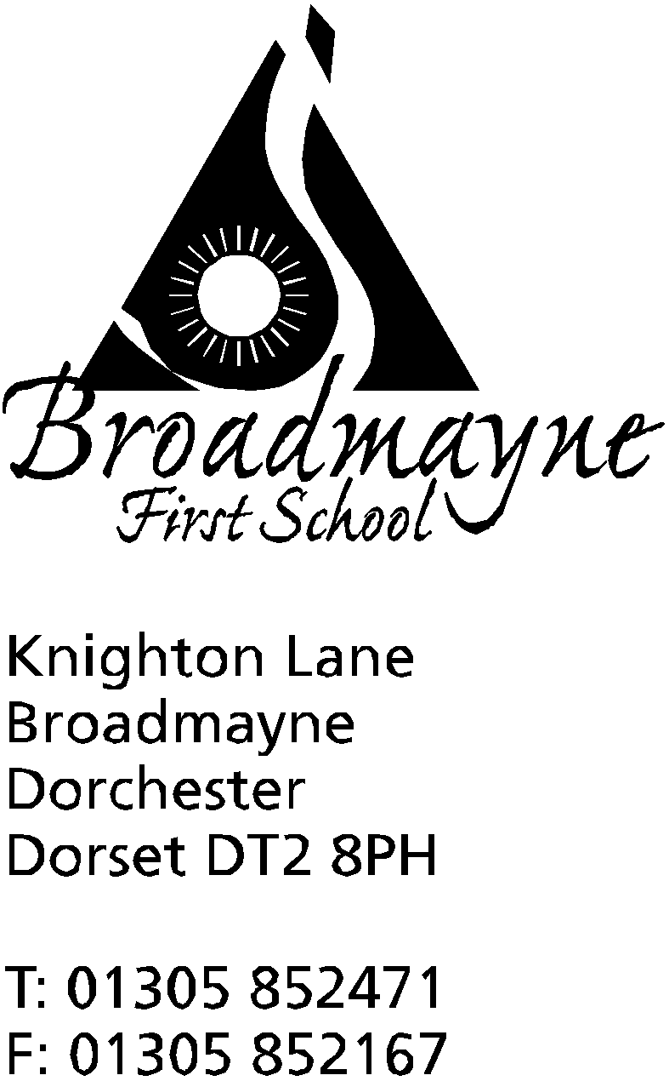

In Dorset

Headteacher
Helen Collings
Friday 17th January 2020
Spring 2020 - Newsletter 2

Things to remember:
- If you are interested in becoming a parent governor, please inform the school office by Monday of next week

Dear Parents and Carers,

We have had a busy start to the new year - the holidays already seem a long time ago! Here are some updates for you since we returned to school.

Steve Stubbing
We were very sad to hear of the passing of Steve Stubbing, who has been a great friend to the school for many years. Steve worked with us in support of our STEM (science, technology, engineering and maths) curriculum, finding us funding for trips and equipment, and sharing his knowledge with us all. He will be greatly missed for his kindness and generosity, and we extend our sympathies to his family at this sad time.
Dates for next academic year
I am aware that many parents are looking to book their family holidays this year, and as a school we want to support you in organising these during the school holidays. Due to the two week half term this October, we are having to change our dates slightly from those published on the Dorset for You Website. Please note for your diaries that after the summer holidays this year, we shall be returning to school for only one INSET day on Tuesday 1st September, and children will be returning to school on Wednesday 2nd September - this is earlier than on the Dorset site, in order for us to account for the two weeks in October. The October half term will be from Monday 19th October to Friday 30th, the children return to school on Monday 2nd November.
Inflatable Museum
The Dorchester Museum Inflatable Museum will be visiting Broadmayne Village Hall on Saturday 25th January from 11am-3pm. It provides a free, fun, drop-in experience, part of which will be understanding the Museums current redevelopment. The “new” Museum will open this summer.
The children and parents can take part in engaging activities and handle real objects from the museum’s collection including:
- Archaeology,
- Natural History,
- Social History and Fossils.
There will be children trails, and popular ‘Make and Create’ workshops inspired by the Museum’s collections.
Altevette
Mrs Stoker is having an amazing time in Nepal, visiting the girls’ school there. She arrived safely in Kathmandu, where she sent us an email to say it was an amazing city, but something of a challenge to cross the road safely! She is now in Pokhara at the school - this morning she was up at 5am to join in with prayers. She says she has had a wonderful warm welcome from the students, and will be spending the day working with them all.

NSPCC PANTS
During the week beginning February 3rd, the school will be teaching the children about keeping themselves safe using the NSPCC PANTS resources. These are designed to teach children how to stay safe from abuse, without giving explicit information or telling scary stories. In the lessons children will learn about the PANTS acrostic, which stands for:
Privates are private
Always remember your body belongs to you
No means no
Talk about secrets that upset you
Speak up, someone can help
More information about the underwear rule, including a short video and a parent’s guide, can be found at: nspcc.org.uk/underwearrule
We are very excited as this year we will be visited by Pantosaurus! He will be popping in to school to meet the children on the Monday afternoon of that week.
Reports
This year we are changing the dates on which we send out reports, and as a consequence of this, our next parent consultation evenings will also change. The longer written reports will be sent out at the end of this term, instead of the summer term. We want to trial this change as we feel it will give staff and parents the opportunity to set targets and then to reflect on them in the summer term, during the parent consultations.
Yours faithfully,

Mrs Collings
Calendar Dates- Spring Term First Half Term
Date | Time | Event
JANUARY
Tuesday 21st |  | IPAD Art Day for Years 3 and 4
Friday 31st | 1.30 -2.30pm | Year R Dance showcase at St Mary’s, Puddletown
FEBRUARY
Monday 3rd |  | Pantosaurus visiting the school -start of NSPCC Pants Week
Monday 10th - Friday 14th |  | Collaborative Writing Week
Wednesday 12th |  | Fire Safety team visiting Year R and Year 2
Thursday 13th | 9.15 am | Year 1 Class Assembly  FABS school disco
FrIday 14th |  | INSET DAY
Monday 17th - Friday 21st |  | HALF TERM

