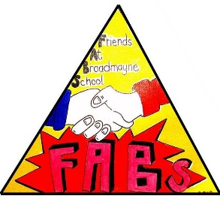
FABS (Friends at Broadmayne School)
ANNUAL REPORT 2017/2018

FABS objectives
The Broadmayne FABS (Friends at Broadmayne School) is a small group of parents and teachers, who work hard at putting on events and activities, all to raise funds for the school. We are also responsible for the maintenance and operation of the school community outdoor swimming pool.

Achievements/Activities
FABS organised 4 major events during this school year which were very successful.
Christmas Fayre – our popular event was a great success with tombolas, raffles, crafts, refreshments and Santa’s Grotto. Profit: £1246.99 | Chocolate Bingo – this is a great fundraiser which made a profit of £508.50.  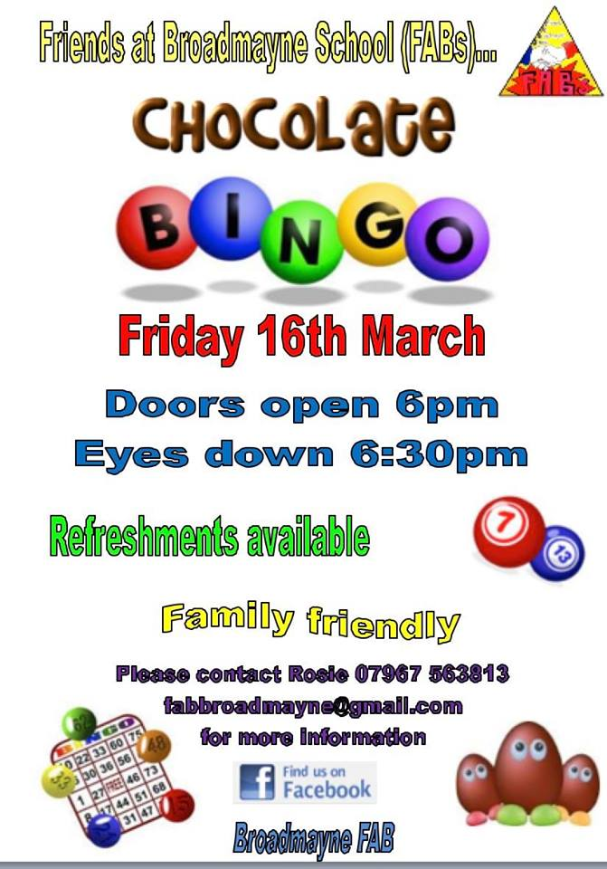
Happy Circus – our biggest fundraiser and highlight of the year was enjoyed by all. FABS also laid on a raffle, BBQ and bar. Profit of £3140.47. We also received £450 from Meyers for placing 60 advertising boards up before the event.  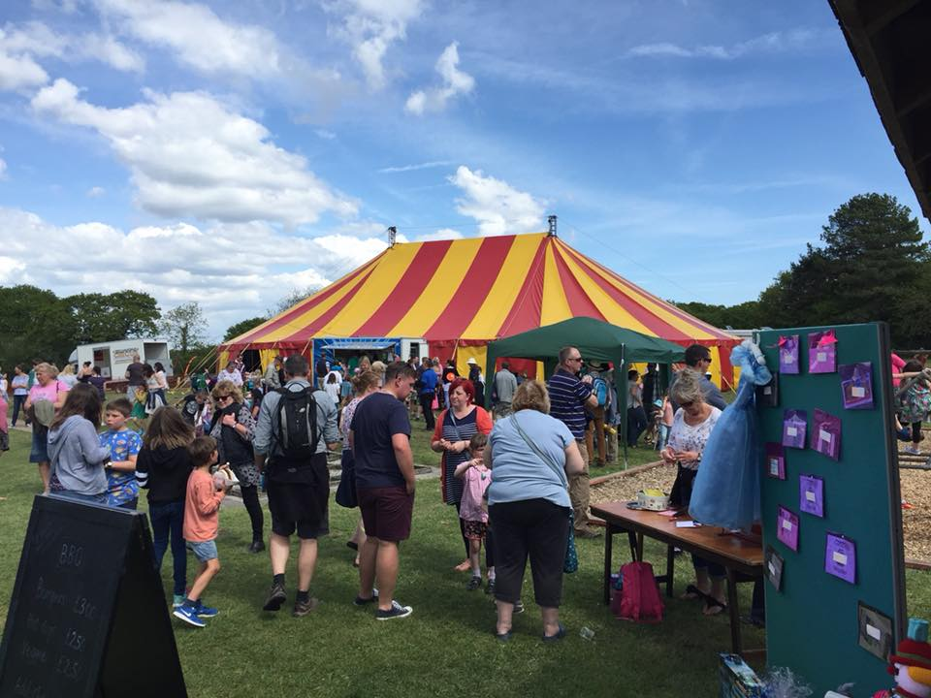 | Sports Day/ Summer Fayre – this was kept fairly low key but still generated a profit of £337.13 from the BBQ, bar and a handful of small stalls.  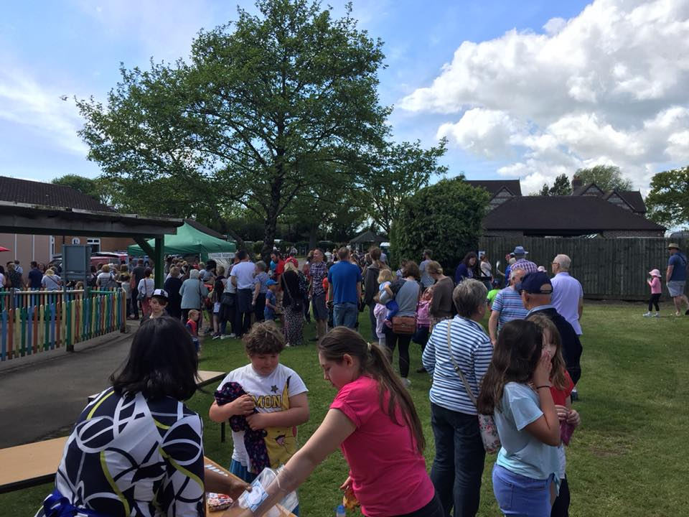

Friday Tuck Shop. Run by volunteers every Friday during summer term, we made a profit this summer of £449.74.
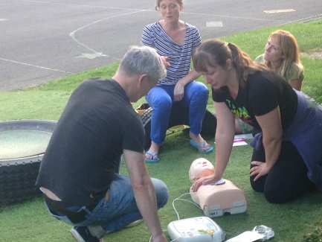
Swimming Pool Having had superb weather this year it was great to see the swimming pool full on so many occasions during school time and summer holidays. This year the uptake from parents to make donations for swimming was over 50% totalling £1094. However, Summer Swimming Passes has proved very successful. Summer swimming raised total funds of £750.40 with over half coming from the sale of passes (over 50 sold) and £90 generated from 3 birthday pool parties. Tim also arranged the Sponsored Splash again this year which the children enjoyed and generated further funds of £544.50.
Volunteers on Reach and Rescue Training

Gift Aid. FABS is now registered for Gift Aid. This means we can claim an extra 25% on all donations. This has generated a further £365.04 during 2017/18.
Thanks to our VOLUNTEERS!
A big thank you to all our volunteers who help run FABS and volunteer to organise events, run the pool and supervise swimming sessions.
What have we funded?
Money raised from our efforts this year have enabled us to fund the following …
1) Upkeep of the swimming pool including heating costs, Cresta fees and general maintenance £5174. This included repairs, heating contribution for 2016/7 and 2017/8 and new section of fencing and Building Control fees for new plant room.
2) Funding of Christmas Pantomime costing £750.
3) Individual class donations of £100 per class for school supplies.
4) Contribution of £141 towards the cost of each class going to see ‘Dippy’ the dinosaur at Dorset County Museum
5) Smaller one-off donations totalling £119.08 towards school events such as Easter eggs for the hunt and ice-creams for sports day etc.
6) Class donation of £50 for purchase of Times table App.

Financial Summary Sept 2017-Aug 2018

In summary FABS made a profit of £2206 during this year. Looking forward we started the current financial year on 1st September 2018 with total funds of £12398.61.

