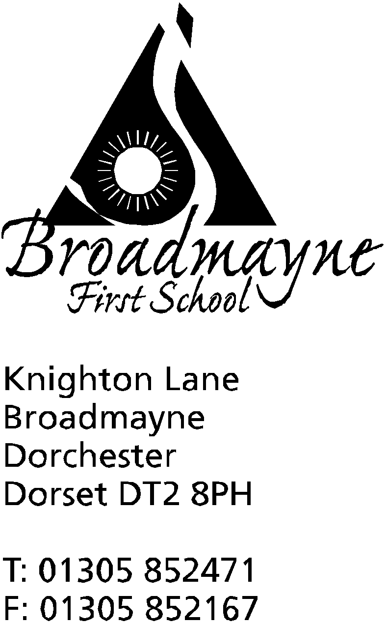

In Dorset

Headteacher
Helen Collings

Thursday 27th September 2018

Autumn 2018: Newsletter No. 2

Things to remember!
- Parent consultation letter for all year groups - sign and return form
- if you haven’t returned school photo permission letters, please do so, otherwise your child can’t be photographed by the school photographer!
- please send back permission slips for the use of The Spelling Shed

Dear Parents and Carers,

We have had a wonderful start to the school year; our new children in Reception are settling in well, and Mrs Bostock and Mrs Stoker are full of praise for how well they are doing. The continuing good weather has meant that we have been able to make full use of the outside area, and PE and Forest Schools have been happening regularly.

School nurse
Karen Caines, our school nurse, comes in a couple of times each term for a “Drop in” session. She is able to advise about various aspects of child care and has helped many of our families over the years. No appointment is needed and the dates for her visits are on the school calendar and displayed on the noticeboard in the office.

Harvest
We would like to invite you to our Harvest Celebration, which this year will be held in school at 9.30 am on Friday 12th October. The children will be singing some of their favourite seasonal songs and each class will have something to share. This year we would like to invite the children to bring in items which we can then donate to the local Food Bank. Having spoken to the organisers of the Food Bank, the following items would be particularly welcome:
Tins of meat, fruit or vegetables, soup, beans
pasta sauce
small packets of tea or coffee
ready meals
jam
toiletries such as toothpaste, shampoo

EYFS workshop
Mrs Bostock and Mrs Stoker are planning to run an evening workshop with information about the Early Years Foundation Stage curriculum for those parents with a child in the Reception class. This will be at 7- 8pm on Tuesday 16th October.

Parent consultations
A separate letter will follow with details of forthcoming parent consultations

Parent/Staff Work in
Would you like to come and help with making our school pond more accessible? Are you filled with the desire to rip out lots of overgrown plants so we can see the water in the pond once again? Do you have the morning of Saturday 13th October free? Then we have the perfect opportunity for you!
Mrs Stoker and myself are hoping to hold a parent/staff work in on Saturday 13th October from 9-12pm to tackle our pond area, which is in a rather sorry state. If you could come along, bringing useful tools, we are hoping to clear the nettles and long grass from around the pond, get ready an area for new benches, and clear the pond itself out at a time where we won’t be disturbing too many creatures. Please let the office know if you could make it - we will repay with snacks, hot drinks and our heartfelt thanks!

Children who are ill
As we move into the winter, it is inevitable that at times children will fall ill. Can I remind you of the procedure when this happens. School needs to be informed before 9 am on the day of any absence. If your child is likely to be away for several days, the school needs to be kept informed. Our safeguarding procedure means that we need to know the reason for any absence, and we will contact parents if necessary, as per our Attendance Policy.

Read With A Friend or Relative
We would like to hold one of our popular reading events on Wednesday 17th October. Everyone is invited to come into school for 9 am for half an hour, to enjoy reading with the children. Whether you are a parent, grandparent, aunt, cousin - we would like as many adults to come in and spend some time enjoying books with the children.

Photo Permissions
I do apologise for the amount of permissions we have had to seek from you recently, in order for your children to have photos taken or take part in online programmes. New data protection laws mean that we have to seek separate permission - and any trips the children go on need separate permissions for anyone other than the school taking photos. Hopefully this will all settle down soon, but in the meantime we ask you to bear with us - and keep signing the forms!

Waste Free Wednesday
As part of our continued drive towards becoming a more eco friendly school, every Wednesday will now be a Waste Free Wednesday. This means that we will try and minimise the amount of waste we produce at school during the day. As part of this, we will have a waste free lunch for staff and children. We ask that if your child has a packed lunch on a Wednesday that you include items that are not wrapped in single-use packaging, so that nothing need be thrown away, but instead can be brought home and reused. There will be no bins for rubbish in the hall on these days!

Altevette Project
The school have decided that they would like to support a project based in Nepal called the Altevette Project. This is a small project aimed at transforming the lives of girls in the remote Himalayan regions through education.Girls in this area are vulnerable to extreme poverty and exploitation and have little opportunity for education due to the lack of schools in such remote and harsh regions. The school have had a visit today from a volunteer, who has shared the story of the project with our children. We will be writing to the girls who are part of the project, and the School Council will be organising some small fundraising activities. The girls are currently in need of warm leggings and jogging bottoms for the winter, and volunteers will be travelling out to Nepal on the 8th October. If you have any items that your children have grown out of that you would like to donate before the trip leaves, please drop them into school over the next week. The project works with girls of all ages, so any sizes are most welcome!

St Mary’s Middle School Puddletown
St Mary’s have their first Open Evening for Year 4 children and their parents organised for Monday 8th October from 5-7pm. They extend a warm welcome to all our Year 4 families and hope that you can join them to find out what middle school can offer your children.

FABs (Friends at Broadmayne) events
The FABs AGM will be held at 6pm on Monday 8th October in the school hall. Everyone is welcome, and I know the FABs would be really pleased to see new people come along - even if you feel you can only spare a little time, or help with one event during the year, please come along anyway. The FABs do a fantastic job of fundraising for the school, particularly in helping keep the swimming pool running and open during the holidays and weekends. A huge thank you to them all for their work this summer - the pool has been so well used, we couldn’t do it without their hard work!

Cool Kids
We currently have a vacancy for a permanent member of staff for Cool Kids, our after school which is run on Thursdays from 3.15 pm until 6 pm. This is a popular activity based club, and you would be working alongside an experienced staff member. If you are interested please contact Mrs Foyle in the school office - or if you think you know someone who would be an ideal candidate, please pass the details on to them!

Wessex FM
Wessex FM have been interviewing some of our children to appear in their ‘School of the Week’ slot which will be aired next week. There will be various questions the children will no doubt answer in their usual honest way, and they can be heard every day at just after 7.30 am and again in the afternoon - a different question every day! I’m sure if your child is involved in this they will tell you all about it.

Please find an updated list of diary dates for the term overleaf. Thank you for all your support, and I look forward to a happy and productive Autumn term,

Mrs Collings

Date | Event | Time
OCTOBER
Mon 1st-Fri 5th | Life Education Van/ Healthy Choices week
Mon 8th  Tues 9th  Wed 10th  Thurs 11th | Parent consultations Yr 2, Yr 3,  “ Rec, Y1, Y2, Y4  “ Rec, Yr 3, Yr4  “ Yr 1 | 3.30-5.30 pm  “  “  “
Mon 8th | St Mary’s Middle School Open Evening for Y4 families | 5-7 pm
Fri 12th | Harvest Festival to be held in school | 9.30 am
Tues 16th | EYFS Curriculum meeting | 7-8 pm
Weds 17th | Read with a Relative or Friend | 9 am
Fri 19th | Whole school and Pre-School Pizza Day
Mon 22nd-Fri 26th | HALF TERM
Mon 29th | INSET day
Tues 30th | Back to school
NOVEMBER
Fri 2nd | Individual photos
Mon 5th - Fri 9th | Remembrance Week
Tuesday 6th November | Learn Alongside Your Child | 9am
Thurs 8th | School Nurse Drop In | 8.50 am
Mon 12th | Beginning of Anti-bullying fortnight
Weds 14th | Flu innoculations - optional
Fri 16th | Children in Need (further details to follow from the School Council) | 9.00 am
Tues 27th | Year 3 trip to Bovington Museum
DECEMBER
Mon 17th | Christmas play in school hall | 1.45 pm
Tues 18th | Christmas play in Broadmayne Village hall  “ | 9.30 am  6.00 pm
Fri 21st | Last day of term; Christmas party lunch
Mon 7th Jan 2018 | First day of Spring Term
Class Assemblies: | YR - 21/3/19  Y1 - 17/1/19  Y2 - 4/4/19  Y3 - 9/5/19  Y4 - 22/7/19 | All due to start around 9.15 am - teachers will confirm nearer the time.

