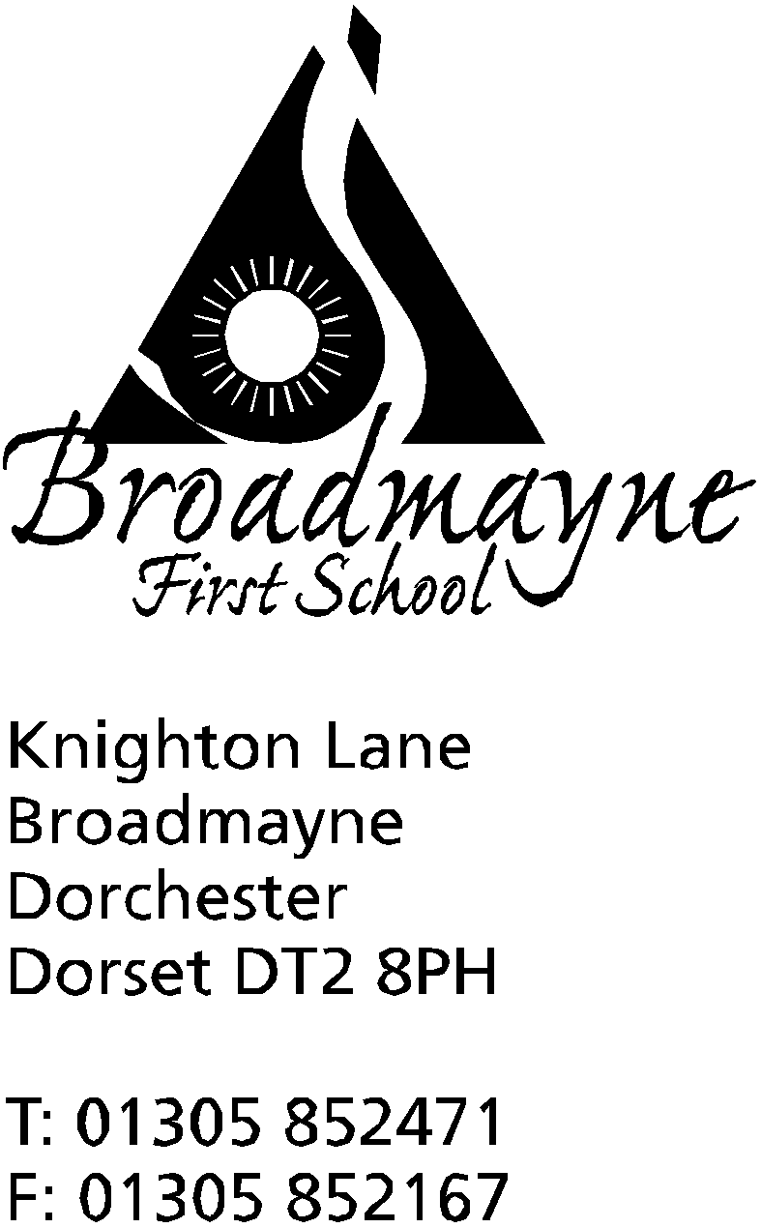

In Dorset

Headteacher
Helen Collings

Monday 30th September 2019

Autumn 2019: Newsletter No. 3

Things to remember!
- as the weather is becoming more unsettled, warm and waterproof coats are needed for playtimes!
- Year 2 trip to Safewise - please return slips and pay via School Money
- Year 4 parents, have you received your letter about next year’s trip to Hooke Court/information about St Mary’s Puddletown open evening? Please let the office know if not.

Dear Parents and Carers,

Welcome to the third newsletter of the autumn term.

Harvest Festival
We would like to invite you to our Harvest Celebration, which this year will be held in school at 9.15 am on Friday 18th October. The children will be singing some of their favourite seasonal songs and each class will have something to share. This year we would like to invite the children to bring in items which we can then donate to the local Food Bank. Having spoken to the organisers of the Food Bank, the following items would be particularly welcome:
Tins of meat, fruit or vegetables, soup, beans
pasta sauce
small packets of tea or coffee
ready meals
jam
personal care items such as toothpaste, shampoo, shower gel (the Food Bank have said that ones with unisex scents are really useful!)
Please ensure all food items are in date. Items can be brought in to school at any time during the week beginning Monday 14th - either to the office or handed to class teachers.
Parent Consultations
Parent consultations will take place on the 14th and 15th of October - further information will be sent out in a separate letter.
Strengthening Families Programme
The Dorset Youth Association (DYA), with funding from the Royal British Legion, are running several FREE parenting support sessions in September and October in Bovington.
The sessions give parents and their children a safe, supported space to build their relationship by learning skills and coping techniques for difficult situations. They provide help to recognise good choices and healthy ways of managing those more difficult and challenging times together.
The sessions are FREE and lunch/refreshments will be provided. They will be held at the Royal British Legion Club, King George V Road, Bovington BH20 6JQ
This programme is open to all families with 6-10 year olds. Parents or young people can refer themselves onto the programme by contacting DYA or by speaking to the school..
To join in with your child and make sure you don’t miss out on your FREE place, just ring or email for a booking form and take that first step to making yours a STRONGER FAMILY.
It may be possible to assist with childcare or transport costs. Specific requirements will be looked at on a case by case basis. More information is on the Dorset Youth Association website
If you have any questions please contact Lynne Rockey on 01305 262440 or email lynnerockey@dorsetyouth.com
FABS News
The school’s parents' association, the Friends of Broadmayne School (FABS) will be holding their AGM at 7pm Wednesday 9th October in the school hall. This is a chance for you to come along and find out what the FABS do, and how you can get involved in helping their work with the school. In these days of decreasing school funding we rely more and more on the FABS to help the school buy not just the little extras, but the essentials
to our children’s education and well being, and of course it is down to the FABS that we are able to keep our wonderful swimming pool. If you come along to the meeting, it doesn’t mean you will have to be involved in every event that happens - even helping out with one thing across the year is very welcome!
The FABS are planning a Halloween Bingo on Friday 25th October. This will be a bottle bingo, and to help collect bottles for prizes the school are offering a non school uniform day on Friday 11th October. In return for wearing non school uniform (not Halloween themed, please!) children can bring in a bottle for the bingo. Any bottle is welcomed, from ketchup to champagne! More information about the bingo will be sent out later by the FABS.

Clothes Swap
There will be a children’s clothes and toys swap event on Saturday 12 October at the Dorford Centre, Dorchester. Families are asked to have a clear out of anything they no longer use and pick up some pre-loved goodies for free! We’re hoping it will benefit our families, and of course it’s great for the environment! More information can be found via this link: www.dorsetcouncil.gov.uk/childrens-clothes-swap

DASP Skylarks Choir is looking for new members!
The DASP Skylarks has been running for many years under the direction of Mrs Kathie Prince. It is a choir for children in years 2 – 4 and rehearses Thursdays 3.45- 4.30pm at Damers School. The children sing songs in harmony, in a range of styles and perform in all of the DASP Music concerts and often also perform at various community events throughout the year. The sessions are always fun and the children gain in confidence from
taking part. Membership of the choir costs £30 per term (free to those in receipt of Pupil Premium funding).
If you are interested in your child attending a taster session, please contact Hanna Trevorrow (Head of DASP Music) at daspmusic@thomas-hardye.net

The Book People
On Tuesday 15th October we have The Book Bus visiting the school. Part of The Book People company, the bus will be on our school grounds all day, until 5 in the afternoon. Parents and children will be able to go onto the bus and buy books from the range they keep - all at discounted prices, and every book that’s sold will earn credit for the school! We are also taking part in the Big Book Boost with The Book People. For every ten pounds you spend on their website, you will be able to donate £1 to the school, at no extra cost to yourself.

More information on both of these events will be sent out in separate letters.

Yours faithfully,

Mrs Collings

Date | Time | Event
OCTOBER
Mon 7th | 5-7pm | St Mary’s Middle School, Puddletown, open evening for all Year 4 parents and children
Weds 9th | 9am | Read with a Friend or Relative
Fri 11th |  | non school uniform -bring something for the Bottle Bingo.
Mon 14th  Tues 15th | 3.30 - 5.30 | Parents Evenings-more details to follow
Tues 15th | all day | Book Bus in school
Mon 21st | all day | Year 4 trip to Nothe Fort
Fri 18th | 9.15am | Harvest festival (in school)
Fri 25th | AM | Individual Photos  Whole school and Pre-School Pizza Day  Break up for half term
Mon 28th-Fri 1st Nov | HALF TERM
NOVEMBER
Mon 4th | All Day | INSET
Tues 5th |  | Children return to school
Mon 4th - Fri 8th |  | Safe and Healthy Me Week
Thursday 7th | 8.45 am | School nurse drop in
Mon 11th-Fri 15th |  | Remembrance Week
Thurs 14th |  | Y2 trip to Safewise  Y3 trip to Bovington Tank Museum
Fri 15th |  | Children in Need Day - more details to follow from the School Council
Mon 18th | 2.30pm | Family photos
Tuesday 26th |  | Optional flu inoculations
DECEMBER
Mon 16th | 2pm | Christmas play
Tues 17th | 9.30 am  5.00 pm | Christmas play  “ “
Fri 20th |  | Last day of term; Christmas party lunch- school finishes at 2.30 pm
Mon 6th Jan 2020 |  | Back to school - First day of Spring Term

