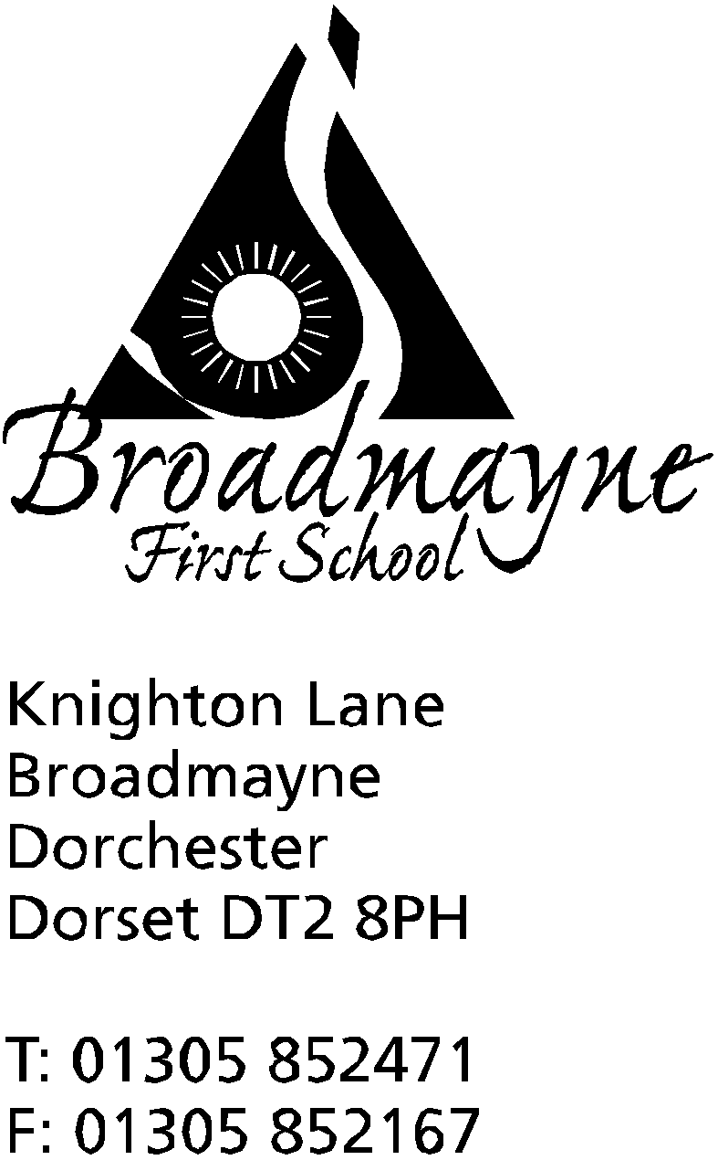

In Dorset

Headteacher
Helen Collings

Summer 2019 - Newsletter 6
Tuesday 9th July 2019

Things to remember:
- packed lunches on the last day of term
- school closes at 2pm on the last day
- Wear something red to school on Friday 19th July
- please ensure invoices for Holiday Club are paid

Dear Parents and Carers,
This will be the last newsletter of the year, as the end of term will soon be here. Reflecting on my first year as headteacher of Broadmayne, I would like to extend my thanks to all of you who have helped me along the way - it has been a steep learning curve, and there are still lots of things I would like to achieve, but it has been a really positive year, both for myself and the school. I would like to extend my thanks and appreciation to our hard working staff, who have really gone the extra mile this year, and most of all to our lovely children - the reason we are all here!

Here are some reminders of what will be happening over the next two and a half weeks:

Bikeability
Year 4 start bikeability lessons on Tuesday 9th July, with the second group on Tuesday 16th July. There have been some changes in the two groups -please check with Mrs Foyle in the office if you are unsure which group your child is in.

DASP Citizens
Some of you may know that in previous years, the children and staff in the school have voted for a child in each class who we feel is an excellent representative of a DASP Citizen, who would then be invited to an award ceremony at Thomas Hardye School. All the schools in DASP have decided to slightly change their approach to this. This year we will all vote as before, but we will be focusing on those children who we feel are representatives of our own school values - Be Safe, Be Respectful, Be Kind. These children will receive their awards in our final Celebration Assembly on Friday 19th July. Parents will be informed by text after the awards are given out, as children are not told beforehand.

Wear Red for our Defibrillator Fund
On Friday 19th July we are inviting everyone to come to school wearing something red, with a donation for our defibrillator fund. As you know, this will be our focus for fundraising for the coming year, as we aim to equip the school with an invaluable community resource. Every amount helps, no matter how small!

Reports
School reports will be sent out on Friday 12th July. We hope you find these reports a useful summary of your child’s progress and attainment over the year. If you have any queries about your child’s report, please contact your child’s teacher.

UNICEF Shoe Share
The School Council would like to use the last day of term as an opportunity to collect old or unwanted children’s shoes to donate to the Shoe Share project being run by Clark’s shoes and UNICEF. The project aims to use the shoes to raise money for UNICEF’s ‘School in a Box’ project - more details will follow before the end of term.

Swimming Pool
You may have noticed we have had some issues with the pool recently. Despite the school and the FABS investing a considerable sum of money in repairs in early Spring, we have been really disappointed that there have been further issues with the running of the pool since then. We are currently tracing a series of faults in the boiler, which has meant the heating has not been working. However, with the warm sun and a very efficient insulating cover for the pool the water has stayed relatively warm, and I am encouraging all classes to swim if at all possible.

Meet the Teacher
On Tuesday 16th July from 3.15 - 3.45 pm there will be a short ‘Meet the Teacher’ session for parents whose children are currently in Years R, 1,2 or 3. This will be a chance to meet your child’s new teacher for September and see the classroom your child will be in - staff will take the opportunity to run over any new routines you might need to know for the Autumn term.

Final Celebration Assembly
As mentioned above, there will be a final Celebration Assembly of the year on Friday 19th July. This will be a very special occasion for us, as children will receive awards for across the year, and will also find out who they and their classmates have voted as their new school councillors.

Musical Performances
A huge well done to all those children who have performed in front of the school and parents on the instruments they have been learning this year. We are so proud of you all, and everyone has enjoyed your performances! We have had lots of positive feedback about this approach, and we hope to do something similar next year.

Last Day of Summer Term
As mentioned before, the last day of the summer term will be Tuesday 23rd July. We will be having a whole school picnic at lunchtime on that day. Children who bring their packed lunch in will do so as usual, whilst those booked for hot school meals will have their meals changed to a packed lunch by the school - no need for you to do anything. If, however, you would like to send in extra food for your child, you are quite free to do so. We then plan to eat out on the field together at lunchtime. Please don’t forget that school will close at 2pm on this day.

NEW Beginner Brass Lessons for children in Years 2, 3 and 4 (current Y1,2 and 3)
In order to encourage more students to learn brass instruments, DASP Music are now offering a new after-school group trumpet lessons for beginners, to take place at St Mary’s Middle School in Puddletown.
The classes will be on a Tuesday 3.45pm – 4.15pm starting in September. Lessons will cost £4.25 per lesson (assuming a group of 4). Lessons will be taught by Mr Kevin Penfold. We are hopeful that we may be able to provide instruments to borrow in order to get the children started as well (although this is to be confirmed).
If you are interested in your child joining these new beginner brass lessons, please contact Head of DASP Music, Hanna Trevorrow, directly by email:htrevorrow@thomas-hardye.net before the end of this term.

If I don’t get the chance to see you and speak to you personally, I wish you a peaceful and relaxing holiday, and see you all in the Autumn Term - Y1,2,3 and 4 on Wednesday 4th September, and our new Reception class on either the 5th or the 6th!

Mrs Collings
Calendar Dates
Date | Time | Event
Tuesday 9th | all day  5.30 pm | Bikeability training - Group 1  Full Governor’s Meeting
Thursday 11th | 2pm | Thank You Afternoon
Friday 12th |  | Reports given out
Tuesday 16th | all day  3.15 - 3.45 pm | Bikeability training - Group 2  Year 2 trip to Sandworld  Meet the Teacher - getting ready for your child’s new class
Thursday 18th | AM | In House Football Tournament
Friday 19th | PM | Wear Red for our defibrillator fund  Final Celebration Assembly
Tuesday 23rd | 9.15 am | Year 4 Leavers Assembly  LAST DAY OF SUMMER TERM -school finishes at 2pm - return Wednesday 4th September for Years 1-4

Please see over for a calendar of important dates for 2019/20 academic year.

2019/20 Calendar of Important Dates

Date | Event
Mon 2nd September  Tuesday 3rd September | INSET days
Wednesday 4th September | Y 1,2,3 and 4 back to school
Thursday 5th or Friday 6th | New Reception children start
Mon 28th October - Friday 1st November | Half term
Monday 4th November | INSET day
Tuesday 5th November | Children return to school
Friday 20th December | Break up for Christmas holidays
Monday 23rd Dec - Friday 3rd January | Christmas holidays
Monday 6th January | Return to school -Spring term begins
Friday 14th February | INSET day
Monday 17th Feb - Friday 21st Feb | Half term
Friday 3rd April | Break up for Easter holidays
Monday 6th April - Friday 17th April | Easter holidays
Monday 20th April | Return to school
Friday 8th May | Change of bank holiday
Monday 25th May - Friday 29th | Half term
Friday 17th July | Break up for summer holidays
Monday 20th July | INSET day

