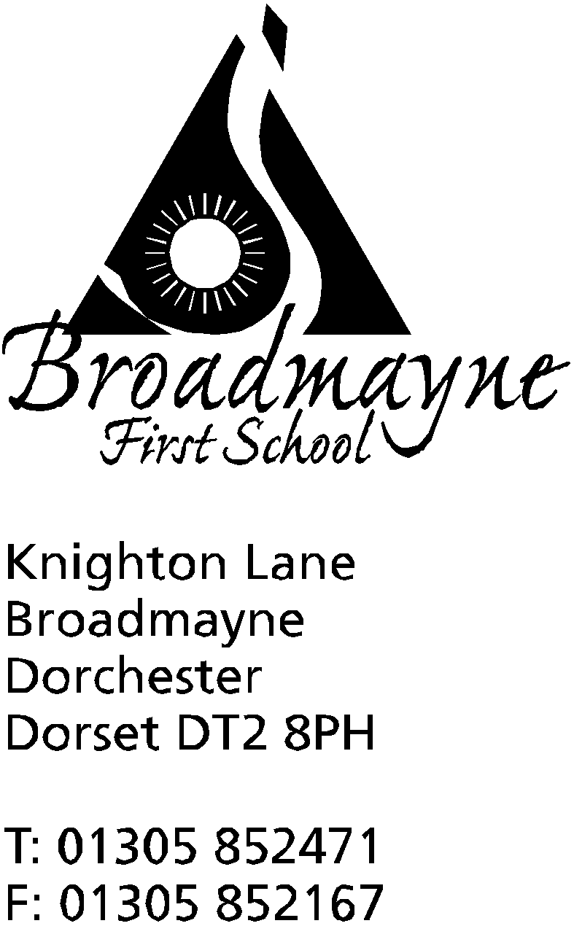

In Dorset

Head teacher
Helen Collings
Thursday 30th January 2020
Spring 2020 - Newsletter 3

Things to remember:
- Have you returned your slips for the Reception class dance festival on Friday?
- Year 4 parents - please return consent slips for the Year 4 DASP concert
- The week beginning 3rd February is NSPCC Pants week - parent resources and information can be found on https://www.nspcc.org.uk/preventing-abuse/keeping-children-safe/underwear-rule/

Dear Parents and Carers,

We are keeping our fingers crossed that the weather will start to improve over the coming weeks, as we look at ways in which we can further improve our lunchtime provision in school. We are lucky to have students from Kingston Maurwood College coming in to work with us, and part of their role will be to work with our children on PE activities at lunchtimes. Some of our Year 4 children have been involved in training to become Playtime Leaders in school, and they will soon be working with small groups of children to make playtimes even more active and fun.
Cosy Club and I Can Club
You may have heard your child talking about attending Cosy Club during lunchtime, or your child might have been invited to I Can Club. If you would like to find out a little more about these two projects we are running, please come along to a short information session I will be running on Monday 3rd February at 3pm.
Staff Information
Sadly, Mrs Treviss will be leaving us at half term, in order to pursue a new career in her own business. Whilst we wish her all the very best with her venture, we are very sad to see her go-she has been an essential part of the school for so long, and I know parents and children will miss her too. We are currently advertising for a new staff member to take her place, and we hope to appoint just after half term.
We are pleased to announce that Sophie Russell has now moved to fill the parent governor vacancy in the school. As there were no other nominations for the role the process was straightforward as there was no need to go to a public vote.
After half term Mrs Bostock will be stepping back from her role as our Special Educational Needs Coordinator (SENDCo). She has worked in this challenging role for many years, and we would like to extend our thanks to her for the fantastic support she has provided for the school during this time. Ms Carter will be stepping into the role, and there will be a period of handover in the run up to half term.
Altevette
Our link with the Altevette Project was strengthened this month after Mrs Stoker visited the school in Nepal.
Thank you very much to our community who helped to raise over £300 for the charity. The money contributed towards the purchase of maths and science resources for the school, and the children and staff were so pleased with the new equipment which will help to enrich the teaching and learning of the curriculum. Thank you also for the writing and colouring pencils which were much appreciated. Mrs Stoker said that the children were delighted to receive letters and cards from many of our pupils. Y2, who will be learning about Nepal next term, are busy writing replies to their new pen-pals in Nepal. To help support raising more funds for the school, you are welcome to use the following link when ordering from Amazon: www.smile.amazon.co.uk please select Altevette Project. Amazon will donate 0.5% of your net purchase price at no cost to you.
Nut Free School and Sandwiches
Please remember that the school is a nut free zone at all times. Please be careful with sandwich fillings, particularly with things such as chocolate spread, as these sometimes contain nuts. Nutella and peanut butter in particular can’t be brought into school.
Breakfast Club/Cool Kids
The school policies for these clubs have been revised and will be sent out to all parents who currently make use of them. Please ensure you sign and return the sheets.
Support Work in School Course
Whitehead Ross Education and Consulting are running a 'Support Work in Schools' L2 City and Guilds Qualifications. The course is aimed at unemployed parent helpers. It is a FREE course which could be of benefit, particularly to those looking at some point to move into working within schools.
For further information you can call 01305 261626 or email workforceskills@wrecltd.co.uk
Children’s Mental Health Week/PANTS Week
The week of 3rd-9th February is both Children’s Mental Health Week and PANTS Week in school. A letter with more detail will follow, but during the week we will be working with our children on how to keep themselves safe, and will be offering another of our very popular Children’s Mental health workshops. Our focus will be on building resilience and connecting with our children. As you know, at Broadmayne we are always looking for ways to support the mental wellbeing of our entire community, and we look forward to putting a particular focus on this for the week.
At the end of the week we will be holding a Number Day-you may recall we held a very successful one of these in a previous year. On the day we are inviting everyone to come in wearing something to do with number (in previous years we had everything from children in onesies and tutus to someone dressed as a calculator!) We will be inviting parents and carers to come in that morning to join us in maths and number based activities. The day is used to fundraise for the NSPCC, a charity that supports the school a great deal, particularly through PANTS Week, so we are inviting children to bring in a donation on the day for this worthy cause.
FABS-Fundraising
You may have noticed the lovely cookie sales that are taking place on Tuesdays after school. These are part of the FABS fundraising drive to raise funds to help refurbish the classrooms. Each class will be helping fundraise through cookie sales and Year 1 are currently raising money for their classroom.
FABS-School Disco
The FABS have organised a school disco for Thursday 13th February. The disco will run from 5.30pm - 7pm and all year groups are invited, although Reception are asked to be accompanied by an adult. Tickets can be bought in advance from the school office for £1.50, or will be £2 on the night. If your child would normally attend Cool Kids a separate letter will be sent to you.
FABS- Swimming Pool
The FABS are hoping to begin putting into place plans for the rebuild of the boiler room and chemical room for the school swimming pool. Despite not raising as much money as they had initially hoped with various grant applications, they are hoping to have enough to cover the cost. They are now looking to put together a working party of people willing to help with moving this forward. If you have experience of building works, managing trades, planning… please get in touch - we don’t expect you to be in charge of the entire project! Names can be left with the school office and they will be passed on to the relevant people.

Yours faithfully,

Mrs Collings

Calendar Dates- Spring Term First Half Term
Date | Time | Event
JANUARY
Friday 31st | 1.30 -2.30pm | Year R Dance showcase at St Mary’s, Puddletown
FEBRUARY
Monday 3rd |  | Pantosaurus visiting the school -start of NSPCC Pants Week
Tuesday 4th | 9am | Reading and Phonics Workshop - has been sent out about this
Monday 3rd - Sun 9th |  | Children’s Mental Health Week
Thursday 6th | 2.30pm & 5pm | Building Resilience and Connection Children’s Mental Health workshops
Monday 10th - Friday 14th |  | Collaborative Writing Week
Wednesday 12th |  | Fire Safety team visiting Year R and Year 2
Thursday 13th | 9.15 am  5.30pm-7pm | Year 1 Class Assembly  FABS school disco
FrIday 14th |  | INSET DAY
Monday 17th - Friday 21st |  | HALF TERM

