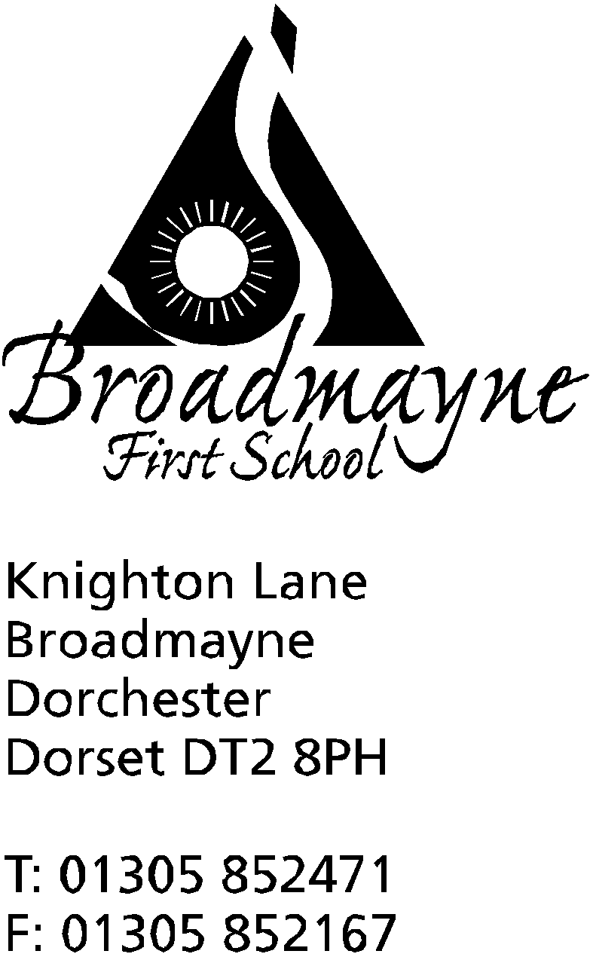

In Dorset

Headteacher
Helen Collings
Friday 29th May 2020

Dear Parents and Carers,

As a staff we have been thinking about your child’s return to school, whether as a key worker child, one of the children who are part of the first phased return, or in one of the year groups waiting to come back. Even if your child is not included in the first phase it is still important that you start to prepare them now for their return to school. This letter contains some thoughts and practical ideas about how you can start this preparation. Although we are aware that there is lots of uncertainty at this time, there are some practical steps we can start taking now to aid transition.
Lots of things will be familiar to your child on their return but there will be changes to our daily routines and how we operate. The experience of returning to school will be unique for every child and some will find it easier than others. Please be reassured that the staff will be very conscious of this and we will do everything possible to support the children.
The following guidance has been taken from Lynn McCann at www.reachoutafc.com. Please take from it anything you feel would be right for your child. The worksheets are written in short, clear sentences, formatted in small chunks and are visual with lots of opportunities to colour. They are flexible for you to add anything specific for your child. These activities are completely optional, however sharing your child’s lockdown experience with us could be enormously helpful with transition. There are some activities and information following and others attached to this email that will support this. I do hope you find these useful.
As always, if there is anything you would like to share with us, you can do so via any of the following emails addresses:
Mrs Collings headteacher@broadmayne.dorset.sch.uk
Reception staff - year-r@broadmayne.dorset.sch.uk
Year 1 - year1@broadmayne.dorset.sch.uk
Year 2 staff - year2@broadmayne.dorset.sch.uk
Year 3 staff = year3@broadmayne.dorset.sch.uk
Year 4 staff - year4@broadmayne.dorset.sch.uk

Yours faithfully,
Mrs Collings
Finding Hope In The Familiar
This situation is new to all of us. In any transition, it’s important to start with the familiar. What is it that we do know? As parents, you may have learnt a lot about your child over the last few weeks. If you would like to write your thoughts down and share them with us, that would be great. Asking the children about their experiences in lockdown is useful as well. Some children may find it difficult to communicate in this way so I have attached some visual worksheets to help. Please see ‘Transitioning Back To School’ and ‘My Lockdown Experience’. You can use colour coding to indicate if there is a worry and its intensity.
The Importance of a Transition Period
We don’t expect children to arrive on Day 1 and hit the ground running. School will be different. For children who struggle with change, it will be especially difficult. We will not be able to simply pick up where we left off. As we find out more about how we will operate, we will let you know so that you can communicate these changes to your child - we will try and let you know about these changes as soon as we can. Please see ‘Easy Read Social Story’ and ‘Social Story We Will Be Going Back To School’. Both worksheets cover the same idea. One is in a basic visual format, the other more in depth but still with visuals. Also there is a longer social story here, which, although American, has some useful points in it. https://www.socialstories4kids.com/wp-content/uploads/2020/05/Returning-To-School-During-COVID-19.pdf
Considering The Child’s Lockdown Experience
Understanding and sharing your child’s experiences during lockdown will help the staff transition your child back into school. For example, some children may not have done very much school work at home because of various reasons such as:
- home is home and school is school and they do not meet!
- some children, used to additional classroom support, may have found it overwhelming and too stressful
- some children will have enjoyed setting their own agenda and having more freedom.
- parents and carers may have had to prioritise their own working from home
The connection between families and school, over the next few weeks, is a great opportunity to strengthen our ability to work closely together to support our children.
Communication Issues
Being at home and being at school is very different in terms of communication. Some children may have experienced very narrow communication within their own immediate family in a very quiet environment. Some children will have experienced communicating with family and friends in different ways through technology. Returning to a communication rich environment will be another adjustment. There will be more adults and children around and it will be noisier. This may be more difficult for some than others. Just sitting and listening, especially for children with ADHD who may have developed their own style of learning at home, will be huge. We are very aware of this and again will do everything possible to support.

Social Interaction
From the start to the end of the day, the experience of getting involved again, will be another adjustment. Social interaction is different for every child and they deal with it in many different and sometimes complex ways. Our plan for phased, smaller classes may benefit this. Some children will come back and pick up friendships where they left off. For others, they may be worrying about forgetting how to interact. Some children will want to talk about their experiences amongst themselves during play. We need to be careful how children fit into this as their experiences may have been different and sharing this information may be overwhelming or upsetting for some. As a school, we will be setting expectations of looking after each other through our values of being kind, being safe and being respectful. There will be some social challenges upon return and we want to reassure you that we are aware of this and are planning accordingly with ways to support the children.
Sensory Needs
We are also aware that some children will have experienced a significant shift within their sensory systems. They might be on heightened alert – more sensitive to noise, crowds, smells etc. Coming back to school for these children will be intense and overwhelming. They may have coped with their sensory needs at home through using headphones for online learning, having quiet space, lots of breaks and freedom. Others may have been upset by changes in routine and not being able to visit special places. It would be very useful for parents to share such information with the school to help us with our understanding. We are very mindful that sensory issues will be a big issue for some children.
Independence and Adapting to Change
Children can find it very difficult to process change. When school ended it was very sudden and it was a major change to life as we knew it. When we go back, it will be a further change and while some things will be familiar, there will be new ways of doing things that we will need to embed into our school day. We will communicate changes to routine and classrooms as early as possible prior to return so that your child has time to become familiar with the unfamiliar. We will give time to the children in the first week to practise the changes.
Emotional Support
Children may have experienced many emotions –the joy of being at home, not getting up in the morning and putting uniform on or worry about the virus. Children are vastly different in how they process their emotions. Some might find it difficult to recognise their emotions and what they are connected to which can cause distress. Some children feel emotion in a very big way and are hyper sensitive to the emotions around them so with all the emotion currently around, these children may have really struggled. Fear may also still be a factor
for some time. We are very aware of the above and will be giving lots of time to allow children to communicate their emotions by listening, talking and giving them time to process what is happening.

