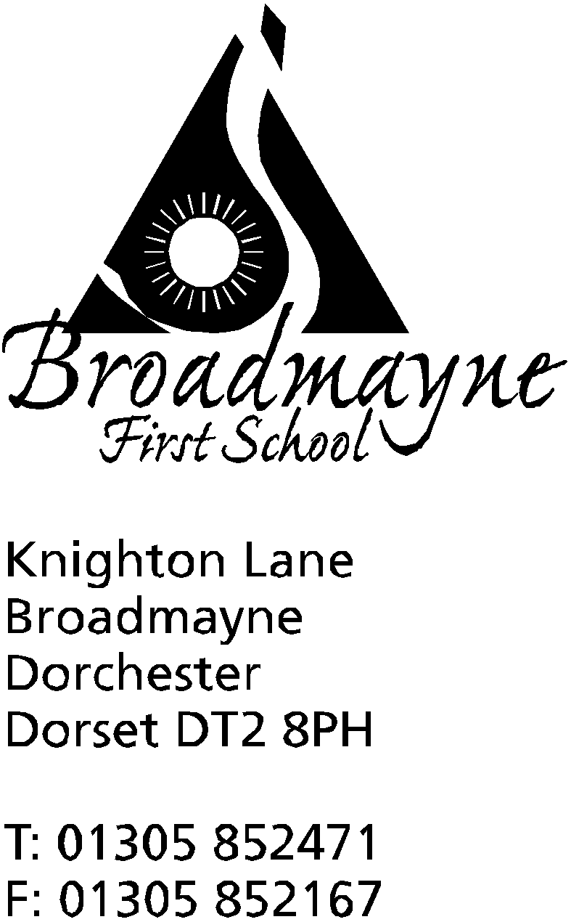

In Dorset

Headteacher
Helen Collings
Tuesday 29th September 2020

Autumn 2020: Newsletter Number 5

Things to remember!
- Warm, named coats please, as the weather is getting colder.
- Please check you have ordered school meals - the new menus for after half term will soon be on the Local Foodlinks website

Dear Parents and Carers,

Well, it feels as if we went straight from summer to winter last week - what a change in temperature! We are still outside as much as possible though, so please make sure your child has a warm coat to wear. We also need to follow government guidance on keeping our classrooms well ventilated, which means doors and windows are open more than usual, so please make sure children have plenty to keep them warm in class.

Covid-19 Update
The school continues to operate under the Public Health England and DfE guidelines, and I would like to thank you all for your ongoing support with this. The children are experts at the ‘Face, Hands, Space’ rule! I have been watching what is happening in other parts of the country with regards to local lockdowns, and wanted to let you know how this may affect us in the future. Currently, we have no plans to ask parents to wear masks when entering the school grounds, but it may be that we are advised to do this at some point - if so, I hope you will be able to support us with this.
If we do have a positive case within the school, we will take advice from the DfE and PHE and will only close a bubble if we are advised to do so. If this is the case we will inform parents and carers that a positive case has been identified, but we will not identify who the person involved is. Bubbles may close at very short notice, and I can only apologise in advance if this is ever the case for us.

Parental Consultations
With the increase of restrictions around social distancing, it will not be possible for the school to have face to face parental consultations this term. Instead, just after half term we will be sending out a questionnaire to all parents asking you to share your views on how your child is settling back in at school, and to highlight any particular successes or concerns. You will have the option to ask for either an online or telephone conversation with your child’s teacher - you may well feel you do not need this, and it is not compulsory! Of course, we are always happy to listen to any concerns you may have at any time, and you can use the year group email addresses to contact members of staff directly.

Harvest
We are busy thinking of a way to share our Harvest Festival celebrations with you all, whilst keeping within the guidelines of our school risk assessments. Sadly, it will not be possible to invite parents and carers in this year, but we are currently planning a different way for the children to share their work with you - all will be revealed soon!
We still want to collect food donations for our local food bank - they have been a great support for several of our families over lockdown, and we would like to show them how much we appreciate the great work they do. We are inviting you to bring in food, toiletries and household cleaning items to donate to the food bank. There will be a box outside the office door from Monday 5th October, where you can leave your donations, and we can store them safely before donating them to the foodbank. No fresh food please, and please do check the date on any packets or tins of food you bring in.

HeartSmart
A huge thank you to the FABS, whose generous funding has allowed us to become a HeartSmart school! Part of our new PSHE curriculum, HeartSmart is a creative approach that we use to build character, emotional health and resilience in children, equipping them with foundational principles and skills that will improve their mental health, relationships and academic achievement. At Broadmayne we want everyone to know they are loved, cared for, and valued. We recognise the importance of educating the heart alongside educating the mind, and we are using HeartSmart to do just that.
You might find your child coming home and talking about Boris, the robot that is made from scraps, and the 5 principles of HeartSmart:
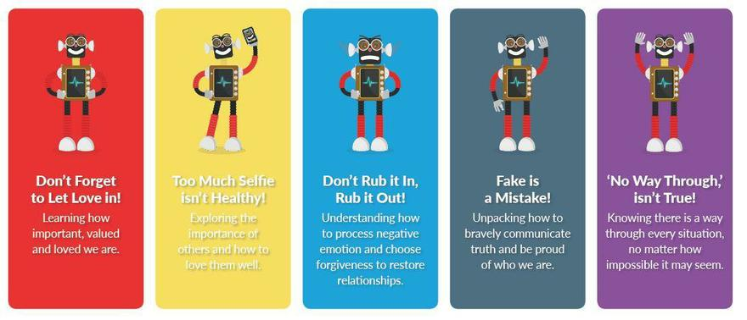
Photographs
The photographer will be in school on Tuesday November 10th to take individual portraits of the children. As you can probably imagine, a lot of thought and planning has gone into this to ensure we can minimise risk for everyone while it takes place.
Unfortunately we are not currently able to offer the family photo slots we would normally make available to you-we will keep you informed if guidance changes and this can take place, but at the moment it will be individual photos of children within school only.

Base Club/Cool Kids
A letter will be coming out at the beginning of next week, informing you of some changes to our after school care when we return to school after half term. Please look out for this if you currently use either Base Club or Cool Kids, or if you are thinking of using them in the future.

Reaching Out Campaign
Dorset Council and Dorset Citizens Advice have launched a new campaign encouraging residents financially affected by the COVID-19 pandemic to seek support before things become more difficult.
With nearly 50,000 people in the Dorset Council area furloughed during the crisis and potentially 15,000 unable to return to work due to redundancy or business closure, the Reaching Out campaign signposts to the wide range of support and advice available- this may be of help to some of our families and I would encourage you to make use of it if needed.

Yours faithfully,

Mrs Collings

Calendar Dates- Autumn Term 2020
Date | Time | Event
OCTOBER 2020
Monday 5th |  | Harvest donations for the local food bank welcome from today - please leave in the box by the school front door
Monday 19th to Friday 30th |  | Half term - 2 weeks
NOVEMBER 2020
Monday 2nd |  | Second half of Autumn term begins
Tuesday 10th | 9am | School photographer visits to take pupil photographs
DECEMBER 2020
Monday 21st to Friday 1st Jan |  | Christmas holidays
JANUARY 2021
Monday 4th |  | Return to school for beginning of Spring term

