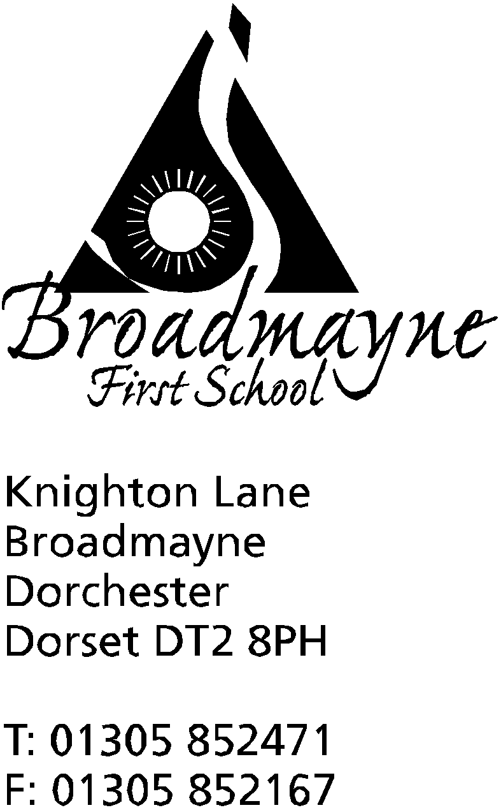

In Dorset

Headteacher
Helen Collings
Wednesday 13th March 2019

Spring 2019 - Newsletter 6

Things to remember:
- Red Nose Day - Friday March 15th - wear something red!
- recycling in school - see Eco news below
- we are still collecting clean, 2 litre plastic bottles for our greenhouse project
- Year 4 concert at THS Wednesday 20th - have you returned permission slips?

Dear Parents and Carers,

Once again I am writing a newsletter very soon after the previous one due to the amount happening in school!

Swimming Pool Update
You may have noticed some work that has been taking place at the pool. These are urgent repairs that are needed to ensure our children will be able to use the pool in the summer term. This has been partly funded by our FABs, and partly by the school, from a part of our budget which is ring fenced and can only be spent on things related to sport. If you have any questions or concerns around school budgeting, please do not hesitate to come and speak to me, and I will attempt to make a rather tricky subject as clear as possible.

Eco News
Year 3 ran a very successful Fair Trade Cafe, and their hard work resulted in a profit of £40. Each class will now vote on what donations they would like to spend the money on with the ‘Send A Cow’ charity - details of which can be found here: https://www.sendacow.org/
The school is now able to offer collection of tetra-paks, which will then be taken to our local recycling centre. We have also teamed up with Frome Valley First School to offer pen recycling. If you have any biros, fountain pens, markers or highlighters which are no longer used, please bring them in to school to be recycled.
Can we also remind you that Waste Free Wednesday runs every week

School Council Message
The School Council would like to say a huge thank you to everyone who sponsored a child in their recent fundraising activities. Over £630 was raised which will be put towards raising the profile of science across the school, including working towards gaining the Primary Science Mark. We are currently enjoying Science Week across the school, and have had some fascinating assemblies, workshops and presentations linked to the theme of ‘Space’, and to the work we are covering within our own classes.

A message from some previous pupils
Hello Broadmayne First School! We are Liv and Isla - we used to go to Broadmayne (the best school ever!) and are now in year 7 at DMS. We and some of our friends are getting involved with Comic Relief this year by organising a sponsored three-legged walk. The walk is at Thorncombe Woods on 17th March any time
between 3pm and 5pm. Anyone of any age can take part, so your parents can join in too, Comic Relief (also known as Red Nose Day!) is a charity that raises money for lots of good causes, both here in the UK and internationally. We would love for you to get involved and help us raise money!
Squash and homemade cakes will be available to buy both before and after you have finished your walk! We hope to see you there! Sponsor forms are available to pick up from the school office.

Parent’s Forum
The school has decided to trial holding a Parent’s Forum on a regular basis, to give us all the opportunity to sit down and discuss any immediate concerns or issues that parents may have. Social media and messaging groups are great for finding out dates and passing on information, but the opportunity to discuss things at greater length is always useful. The first meeting will be at 9am on Wednesday 20th March. It will be an informal meeting, where you can come along to discuss any issues relating to school, or to share your views - tea and cake will be served!

FABs
The FABs have organised a Barn Dance in the Village Hall on Friday 22nd March, from 6.30 pm - 9.30 pm. If you have never been to a barn dance before, now is the chance to come along and take part in the fun, whether you are joining in with the dances, or spectating! It’s a great night out for all the family, and music will be provided by the well loved local band, The Black Sheep. Tickets are available from the school office or the village shop.

Learn Alongside your Child
Our next Learn Alongside Your Child session is on Tuesday 19th March. This time our focus will be on the English curriculum. Please meet in the hall for 9 am.

Yours faithfully,

Mrs Collings

Calendar Dates

Date | Time | Event
Weds 13th | 3.30 - 5.30pm | Parent Consultations
Friday 15th |  | Red Nose Day- wear something red for charity
Tuesday 19th | 9-10.10 am | Learn Alongside Your Child - focus on spelling and writing
Wednesday 20th | 9am | Parents Forum
Friday 22nd | 6.30-9.30pm | FABs Barn Dance, Village Hall
APRIL  Mon 1st, Tues 2nd, Weds 3rd |  | Y4 residential trip to Hooke Court
Thursday 4th | 9.15 am | Year 2 Class Assembly
Friday 5th |  | Last day of Spring Term

