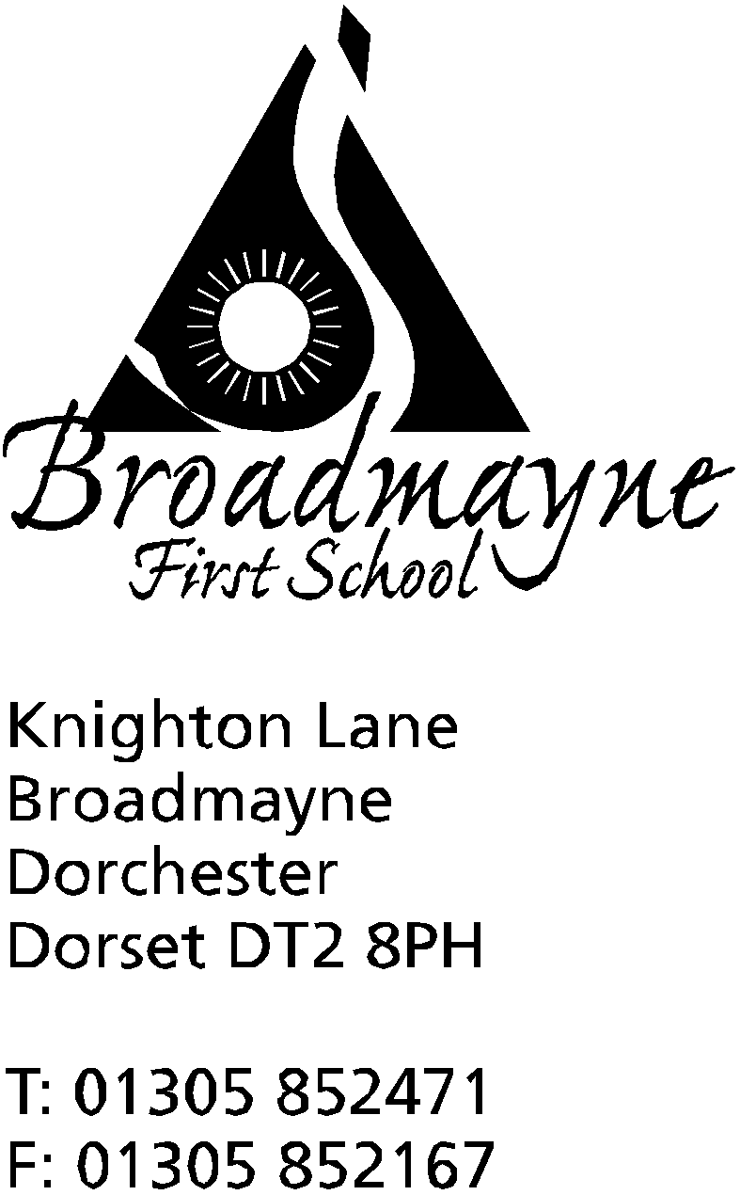

In Dorset

Headteacher
Helen Collings
7th May 2019

Summer 2019 - Newsletter 2

Things to remember: There are several sport related letters being sent out at the moment- please ensure they are returned as quickly as possible!

Dear Parents and Carers,

I hope you all enjoyed the bank holiday weekend - it seems unbelievable that it is less than two weeks until the half term holidays! This letter is to let you know about some events we have been asked to publicise, and to share some information about school.

Ticks
With the warm weather approaching, the likelihood of children coming into contact with ticks becomes more likely. Ticks are small, and can vary in size from being as small as a tiny freckle, to the size of a baked bean. Ticks can be found across the UK, and survive in many different habitats, and we do occasionally find them in the school grounds. Ticks cannot fly, swim or jump. Current medical advice is that it is best practice for the school to remove a tick if we find one on your child - we will try and contact you to let you know if we are going to do this, and to discuss with you any further details. To avoid ticks, the recommendations are that children wear long sleeves/trousers (not always practical in the summer, but we always ask children to wear these for Forest Schools work). There are also insect repellents that can deter ticks.
If you require any further information, there are Public Health England leaflets available in the school foyer.

Extended October Half Term - 2020
The DASP schools are proposing to have a two week October half term next year (NOT this coming October), the dates of which would be 19th - 30th October. In order to allow this to happen, the schools would start back two days earlier in September - on the 1st, which would be an INSET day, but it is hoped that a two week half term will help break up what is a long Autumn term. The DASP office are interested in hearing parents views on this; if you have anything you wish to share please email Karen Weir at daspoffice@manorpark.dorset.sch.uk

Eco Team
We are continuing to work to extend our recycling as much as possible. We are now collecting bathroom plastics, including such things as the lids for soap dispensers which until now have not been recyclable.Don’t forget that we are happy to collect and recycle batteries, but please be aware that we cannot collect flat disc batteries, such as the ones found in watches. Please also can you ensure that corroded batteries are not sent into school, as these can pose a health and safety risk.

FABS-Splash Lottery
On Saturday 18th May the FABS are launching a school lottery to help raise funds for the swimming pool. For £1 a week there is a guaranteed prize for one supporter and every ticket is entered into the jackpot draw to win a massive £25,000!
Signing up is easy, please use the following link
https://www.yourschoollottery.co.uk/lottery/school/broadmayne-first-school
Or alternatively go onto the www.yourschoollottery.co.uk website and search for Broadmayne.
Anybody can sign up so please do let grandparents/friends etc know too.
Good Luck!

DASP Music Fest 2019 – 29th June @ The Thomas Hardye School.
DASP Music Fest is a FREE all-day family music festival celebrating youth music. In addition to performances by all of the DASP ensembles and other invited groups, including our Starlings choir, there will be workshops, open mic, ‘come and try’ instrument session, barn dance, big sing, refreshments and much more.
Workshops will include percussion, ukulele, jazz and improvisation, DO RE MI Time (for Key Stage 1 children) and Big Sing and are open to all adults and children. Please come along, support youth music and have a fantastic day!

DASP Music Tesco blue tokens
Please support DASP Music by putting your blue tokens in their bucket in Tesco in Dorchester – from 1st May to 30th June they are one of the charities being collected for by the Tesco Bags of Help scheme. We work closely with DASP music, and they have provided many lovely activities for our children, including the Year 4 Singing Festival, so your help would be much appreciated.

Dorchester Cricket Club
Dorchester Cricket Club are excited to announce that cricket training and matches are getting underway this term and all boys and girls from Broadmayne School are very welcome. Along with the All Stars on Saturday mornings for 5 to 8yr olds, where registration is completed in a couple of minutes online by visiting the All Stars website and typing in Dorchester CC, we are also offering opportunities for U9s, U11s & U13s in Sunday mornings from 10 till 1130.
This will all take place at Dorchester Recreation Ground with qualified coaches with the very best facilities, and events, festivals, and BBQ's are organised throughout the summer and starts on Sunday 5th May.
For further information please contact Simon Joslin on 01305 262850 or alternatively just turn up and give it a go!

Yours faithfully

Mrs Collings

Calendar Dates

Date | Time | Event
MAY
Thursday 9th | 9.10 am | Year 3 Class Assembly
Tuesday 14th May | 9am | Year 1 phonics meeting for parents
Tuesday 21st | 9.15 am  7 pm | Reception Class Assembly  New Reception parents meeting
Thursday 23rd |  | Last day of half term - Outdoor learning Day  School Pizza Day
Friday 24th |  | HALF TERM
Monday |  | Return to school

