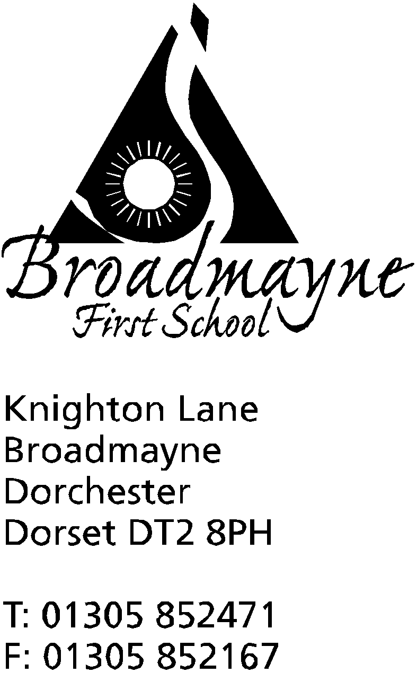

In Dorset

Head teacher
Mrs Helen Collings

Wednesday 28th November 2018

Dear Parents/Carers,

Christmas Play

The Christmas Play will be held on Monday 17th and Tuesday 18th December, with one performance in the school hall and the other two in the village hall.

The play this year is called ‘The Very Hopeless Camel’ and is set to be another uplifting combination of songs and dances from across the classes. As always, spaces are limited due to fire safety regulations and space, and so we are operating a ticket system. Two tickets per family will initially be issued, and we will do our best to accommodate requests for further tickets if we have space. There is no charge for tickets, but we will be collecting for charity at the end of each performance - this year the children have chosen Save The Children and The Altevette Project as their chosen charities.

On Thursday 13th we will be filming the dress rehearsal, and copies of the DVD will be available to buy for a cost of £6.50 and can be ordered and paid for via the SchoolMoney website. Data protection rules means we need your permission for your child to appear in this DVD - please complete the slip at the end of this letter and return it to the office no later than Friday 7th December.

After the school performance on Monday 17th we will send children home wearing their costumes, and will keep their uniforms in school. On the morning of Tuesday 18th we ask that you bring children directly to the village hall wearing their costumes for 9 am, where they will be registered. There will be no Breakfast Club on this day. Please ensure children have coats, as they will walk back to school after the performance, where they will change into their uniform for the day. They will then bring their costumes home in a bag, ready to get changed and be back at the village hall for 5.30pm for their final performance. This sounds complicated, but works really well!

Letters are currently being sent out by teachers to advise you about costumes, if needed - please pop in and see us if there are any problems.

We are planning on providing a creche during the performance at school on the 17th. If you are able to help with this please speak to Mrs Foyle or Mrs Collings.

Many thanks, and we look forward to seeing you at one of our performances,

Mrs Collings

School Christmas Performance 2018
Ticket Request - Please return by Friday 7th December 2018

Child’s Name: ……………………………………….……… Class: ……………………..

Parent’s Name: …………………………………………………………….

We would like our TWO tickets for:-
(Please tick below. You may split your choice i.e. 1+1. Remember 2 tickets maximum per family)

Monday 17th December  1.45 pm - School hall | Tuesday 18th December 9.30am-Village hall | Tuesday 18th December  6pm - Village hall

If additional tickets are available we would like them for:

Performance | Number of tickets (please do not include the original 2 tickets)
Monday 17th 1.45 pm School hall
Tuesday 18th 9.30 am Village hall
Tuesday 18th 6pm Village hall

------------------------------------------------------------------------------------------------------------------------------------------

Christmas Play Creche

I would like to book a place for my child at the crèche on Monday 17th December from 1.30 pm.
Child’s Name: ……………………………………………. Age: …………..

Signed: ………………………………... Parent/Carer Please Print Name: ……………………………….

Contact number: …………………………

------------------------------------------------------------------------------------------------------------------------------------------

Data Consent

I give consent for my child …………………………………………. to be filmed for the Christmas DVD 2018 and for the sale of the DVD.

Signed : …………………………… Parent/Carer Please Print Name: …………………………….

Date: ……………………………………….

