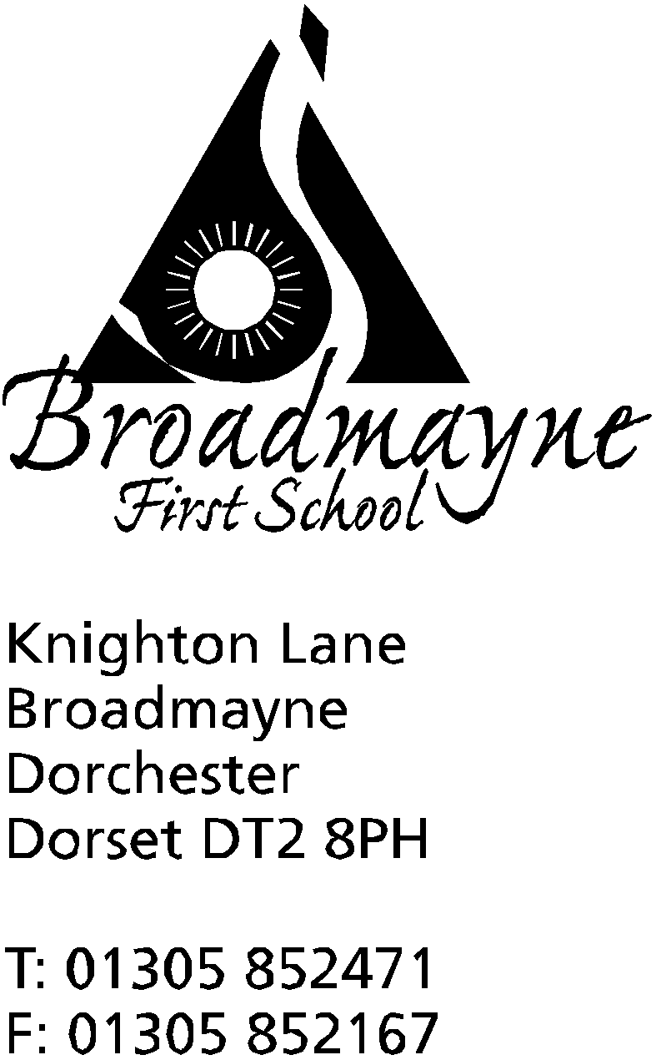

In Dorset

Headteacher
Helen Collings

February 26th 2020

Dear parents

We will be celebrating World Book Day during the week of 2nd March, and have planned lots of exciting activities for the children to take part in across the week.

On Monday 2nd March a visitor from Dorchester Library will be talking to the school in assembly about what the library has to offer and encouraging any children who are not regular visitors to join up and start using this wonderful, free service!

On Tuesday 3rd March we will be holding our annual Books at Bedtime in school from 5.30-6.15pm. Please bring your child, dressed in their pjs, to the school hall ready for a bedtime story. Cuddly toys are also welcome! Staff will be sharing some of their favourite bedtime stories with the children. During this time, we would like to invite parents to stay in the hall where there will be tea and biscuits available to buy. The children will return to the hall for their usual hot chocolate and biscuit after their stories.

We would like to offer adults the chance again to take part in a book swap to be held in the hall while the children are listening to their bedtime stories. If you have one or more books (in good condition please!) that you are happy to contribute to the swap please send them in to the office as soon as possible to allow us to get the book swap ready for you. This is a good chance to have a clear out of books you no longer want along with the chance to acquire some new reading material! It is also very beneficial for the children to see their adults talking about and enjoying books.

The children are also going to get the chance to have a book swap during the school day on Tuesday. We would like as many children as possible to bring in one or more books that they would be happy to swap for another book from someone else. Again these books need to come into the office as soon as possible to allow us to get the swap ready for the children. Please do not send in any tatty books that you would not want to rehome yourself! Each class will have the chance to visit the book swap at some point during the day.

Thursday 5th March is World Book Day. We are going to continue with our Books at Bedtime theme this year. We would like to invite the children to bring in their favourite bedtime story on World Book Day that they can share with the class. The children are welcome to come to school dressed in their pjs for the day if they would like to. All classes will take part in reading activities during the day.

Also on Thursday 5th March we would like to invite you into school for Read with a Relative. We have received a lot of requests for this to be held at the end of the day so we would like to invite you into the hall at 2.30pm for some shared reading time with your children at the end of the day.

We are looking forward to an exciting week! Please feel free to pop in if you have any questions.

Yours sincerely

Mrs Norman

