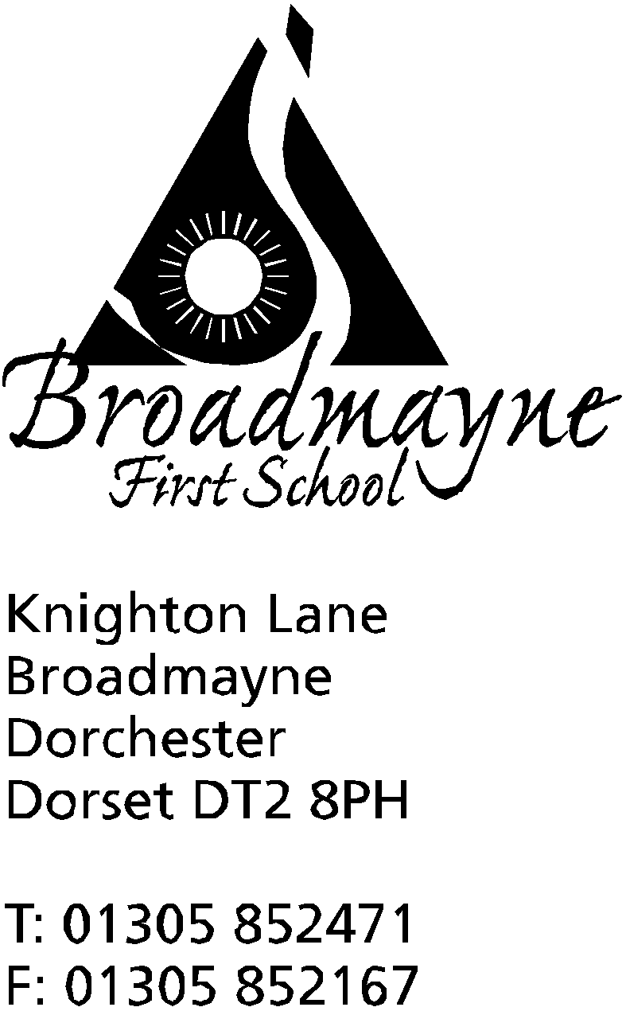

In Dorset

Headteacher
Helen Collings
Wednesday 7th October 2020

Autumn 2020: Newsletter Number 6

Things to remember!
- Harvest donations can now be left in the boxes by the office door
- Please send in your clean, empty jam jars for lantern making - a box will be available for this at the front of school too
- Please be aware there will be a skip being delivered to the school car park on Monday morning

Dear Parents and Carers,

It’s hard to believe we are nearly at the end of our first half term of the new academic year! I would like to take a moment to say thank you to our brilliant staff who have all gone above and beyond to make the return to school as positive an experience as possible for our children. I cannot tell you what a joy it is to be able to walk around the school and talk to the children as they go about their day, or to look out my window and watch them playing (or to sit in my office being serenaded by the drum lessons!)

FABS News
Despite the recent lockdown and the continuing issues around social distancing and rules on gathering together, our FABS are still thinking of ways they can continue to support the school, both by raising all important funds, but also by arranging events that bring our wider school community together. Two events that have been put into the school diary are as follows:

Lantern Walk- The Bright Lights of Broadmayne - Thursday 12th November - parents and children are invited to come back to this outside event in the evening to take part in a lantern lit walk around the school and woods area. This will be a ticketed event, so we can ensure social distancing, and there will be a pumpkin carving competition, hot dogs, hot chocolate, glow sticks and much more! FABS will send more details out soon - in the meantime please save the date, and send in any clean, empty jam jars as soon as possible for lantern making in classes!

The main fundraising event for the year will be an online auction. This auction is to raise money for the classroom refurbishments and to provide the school with as much up to-date technology as can be afforded. The FABS aim is to raise £5000 from this event, which will run from 23rd November to Sunday 29th November. If you would like to donate a gift or have a skill or time that you could donate please get in touch! The money raised will benefit your child first hand and the FABS and the school would be very grateful if you could get in touch to support us with this event.

The fundraising the FABS have undertaken has had a real impact on the school recently. In my last newsletter I introduced you all to HeartSmart, our new PSHE approach which our FABS funded - there are some useful links to the parent’s section of this on our Facebook page. They have also begun the plans to refurbish our classrooms - we began Year 1 over lockdown:

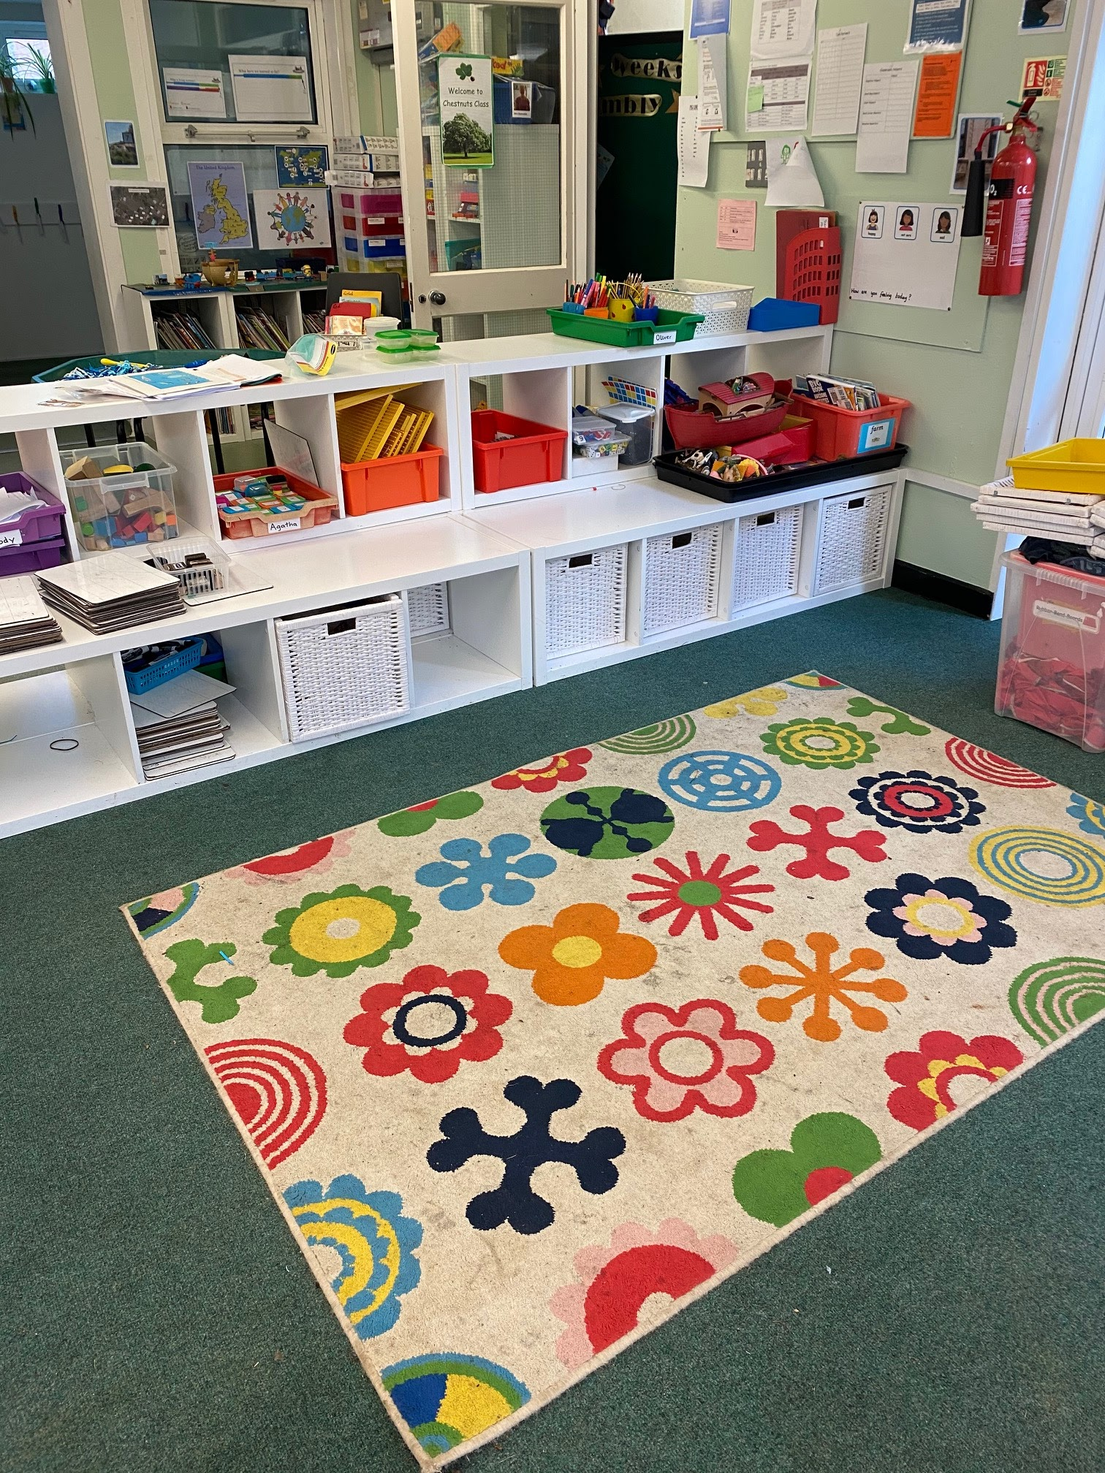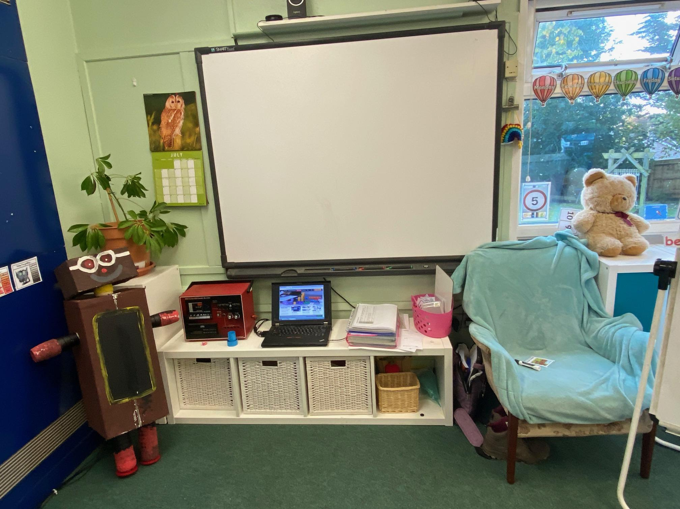
You might notice Year 1 have their own Boris the Robot from HeartSmart next to their whiteboard!

Thanks to the FABS we also have started work on creating the new seating area for the swimming pool:
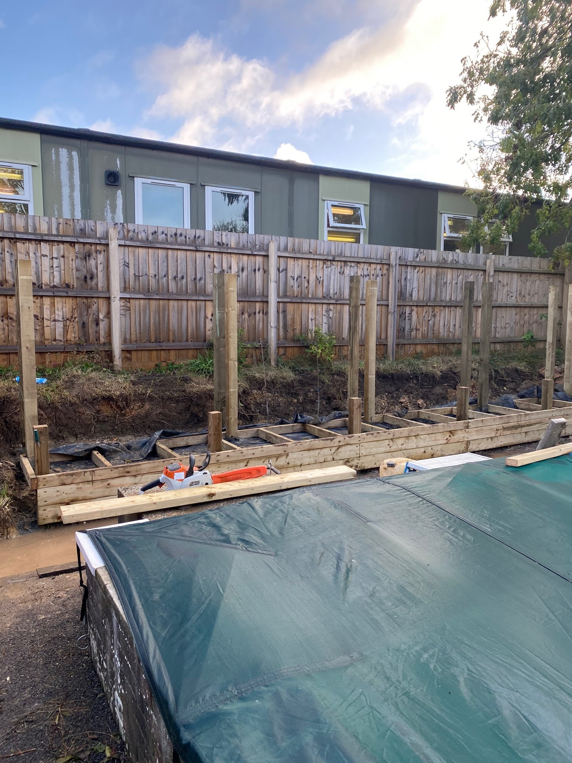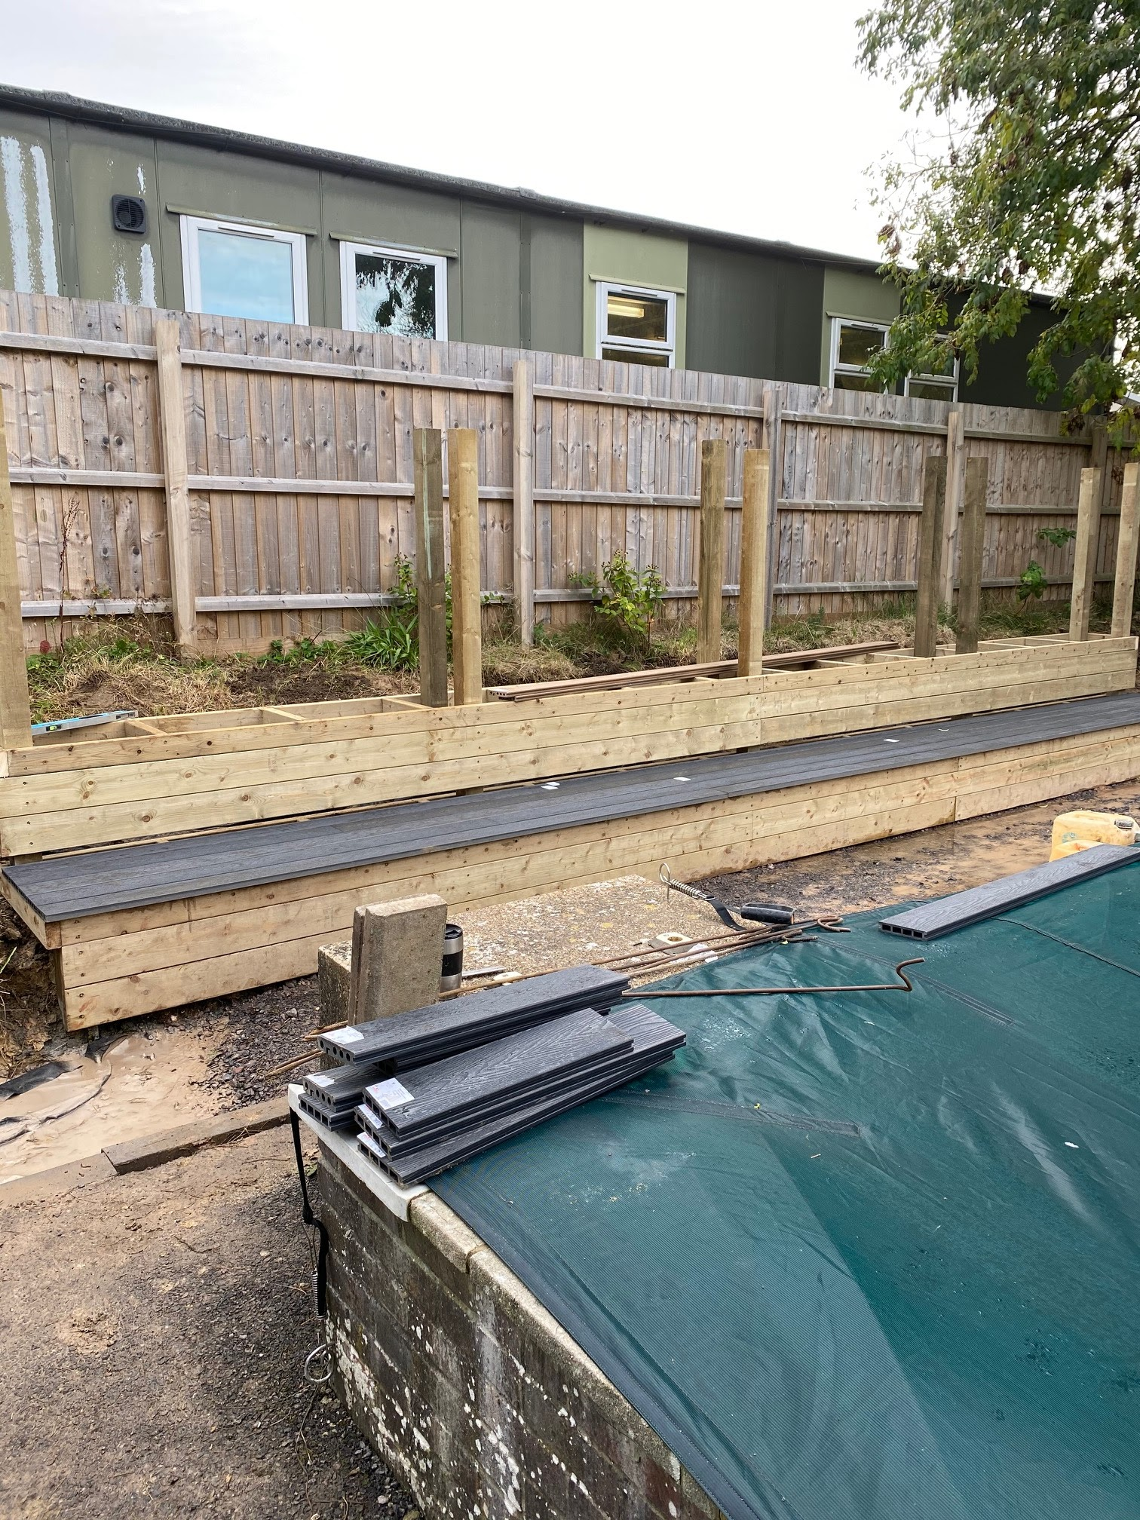
Despite the recent challenging weather the company building has made great progress, and hope to be finished by the end of this week.

Football Club
After half term Trevor Senior will be trialling the reintroduction of his Friday lunchtime football club. Due to social distancing rules, we will only be able to offer this to children in Years 3 and 4 for the time being. The club will run from 12.20pm to 1pm every Friday, weather dependent, and will cost £1.50 per session - payable directly to Trevor. Please use the form here to sign your child up for this: https://forms.gle/1Ke72BV8d6UPsWpk7
Please note - the school cannot accept any money for this club - all money must be paid directly to Trevor in a named envelope.

School Lunches
As you know, we are reintroducing hot school meals once we return after half term. This has taken quite a lot of organising, and I hope parents and children will bear with us as we get the finer details correct! Local Food Links will be laying on their traditional Christmas meal on Wednesday 16th December. If you would like your child to take part in this meal, you will need to order via the LFL website athttps://my.localfoodlinks.org.uk/login LFL have informed us that the menu for after half term will be live on their website from next Monday, the 12th October.

LFL’s new online ordering system https://my.localfoodlinks.org.uk/login is working well, and they plan to switch off their old system at the end of October. Some families may still have monies owing to them which can be transferred to the new system. This will not happen automatically as they are two entirely different systems that are not linked.
If you believe you have money on the old myschoolmeals ordering system, please can you contact the LFL Team: support@localfoodlinks.org.uk before Friday 23rd October and they will be happy to transfer the money to their new system for you. The credit will stay on your new account until you are ready to use it.
The system will be switched off on Friday 30th October so please do not delay – contact LFL as soon as possible.

They will need the following information to enable us to transfer the money between systems:
- Your Name
- Email address used for myschoolmeals
- Name of child/children
- School
- Class or Year
Toilets at School
I know that our families understand that the school is operating a cleaning schedule that is above and beyond the routine we had before the onset of Covid-19, including our toilet areas, and our expectation is that our pupils are part of the routines that we have put in place. The younger children have proven to be fantastic at taking responsibility for ensuring their toilets are clean, and have shown admirable independence in wiping down high touch areas after use, and understanding the importance of good hygiene.
We have, however, had some issues with the older children’s toilets, particularly the boys toilets recently. These toilets are cleaned regularly by staff, and are checked in between times, but staff should not be using valuable teaching and support times away from the children for toilet cleaning purposes, and so our expectation is that the children work to keep their own toilets as clean as possible. Unfortunately this has not been the case, and these areas have often been drenched in water, toilets are left unflushed, and some children appear to be rather ‘off’ with their aim when using the toilets.
Please can I ask you to speak with your children about the importance of keeping toilets clean, and to ensure they understand how to use a toilet correctly. We cannot manage this without their help, and it is for their own comfort that we want our toilets to be as clean and fresh as possible.

Staffing Update
We are really pleased to welcome two student teachers from Bath Spa University, who will be joining us for part of the coming year. Jordan Mallon will be based in the Year 4 class, whilst Hannah McConaghy will be in Year 1. We are excited to be helping them both on their journey into teaching, and look forward to working with them as they develop their skills over the coming months.

Library News
The library in Dorchester is currently unable to offer their usual range of activities within their building, so have asked us to spread the word about some fabulous opportunities they have coming up that our families can get involved in:
- On Saturday10 October 10.00am – 11.00am Treehouse Theatre will be performing the Magic Paintbrush. When Liang, a Chinese peasant boy is given a paintbrush by a mysterious stranger – he discovers that whatever he paints magically comes to life. Join in at home and share your speedy sketches. This is an online event using Zoom. Ideal for families with children aged 2 – 7 years. Book a FREE ticket for the whole family on Eventbrite now!
- On Friday 29 October 11.00 – 11.45 ZooLab will be taking us on a wicked adventure! Families can follow our friendly witch, Zog, on a rhyming broomstick ride! She offers a ride to a selection of amazing animal hitchhikers, who the children will get to meet! However, it's not all plain sailing. Will Zog’s journey end with a bump? Ideal for families with children aged 5+ Book a FREE ticket for the whole family on Eventbrite now!

Yours faithfully,

Mrs Collings

Calendar Dates- Autumn Term 2020
Date | Time | Event
OCTOBER 2020
Monday 5th |  | Harvest donations for the local food bank welcome from today - please leave in the box by the school front door
Wk beg. 12th |  | Harvest Week
Monday 19th to Friday 30th |  | Half term - 2 weeks
NOVEMBER 2020
visits by Chrissy
Monday 2nd |  | Second half of Autumn term begins
Tuesday 10th | 9am | School photographer visits to take pupil photographs
Thursday 12th | TBC | Bright lights of Broadmayne Lantern Walk
Monday 23 - Sunday 29th |  | Online auction for FABS - come and grab a bargain!
DECEMBER 2020
Wednesday 16th |  | LFL Christmas Lunch
Friday 18th |  | Christmas Party Day
Monday 21st to Friday 1st Jan |  | Christmas holidays
JANUARY 2021
Monday 4th |  | Return to school for beginning of Spring term

