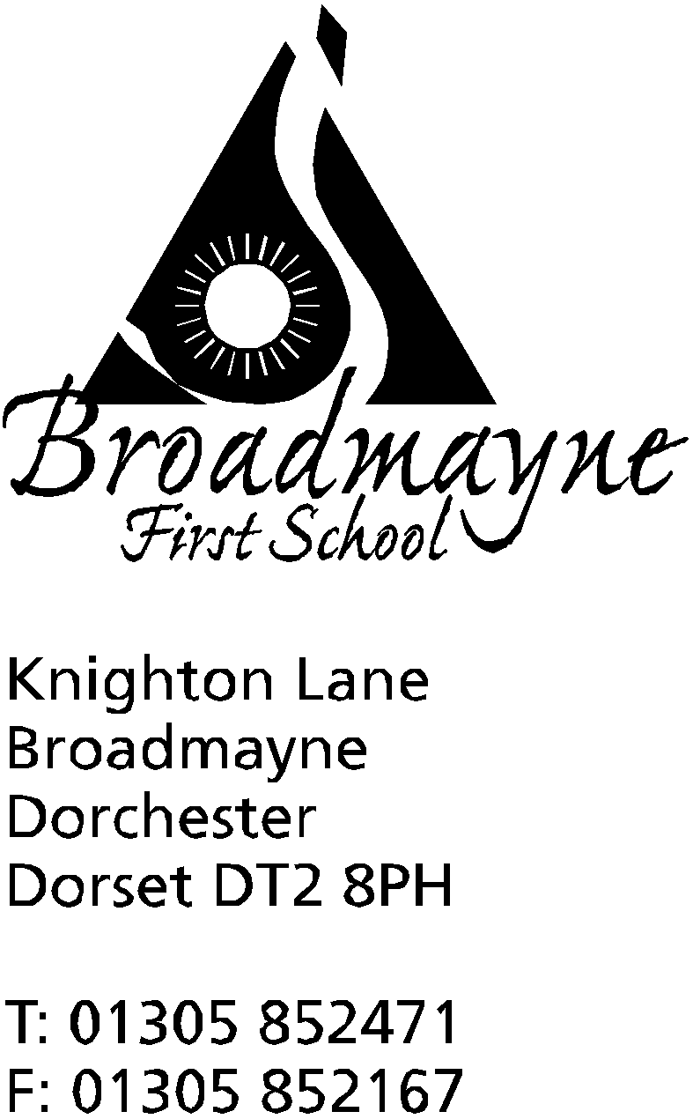

In Dorset

Headteacher
Helen Collings
Monday 29th June 2020

Dear Parents and Carers,

The weather has taken a turn for the worse - I hope you all managed to keep out of the recent wind and rain! Unfortunately the forecast for the next week or so isn’t looking too great, but we are keeping our fingers crossed that better weather will return before the end of term.

School Uniform
I know many of you will be thinking about school uniforms for September. Although children attending school at the moment are not required to wear a uniform, it is our expectation that all children will return in September in normal school attire. As a reminder this is a white shirt or polo shirt with grey or black shorts/trousers/skirt/pinafore and black shoes. We have made two small changes to the uniform requirement which I hope you will find useful - children of all year groups may wear plain black trainers instead of more traditional school shoes, and Reception children only may wear black or grey jogging bottoms. We feel these are practical and sensible additions to the uniform that will help us all. The teachers do have a request, however- please could you try and buy trainers with velcro fastenings rather than laces for the younger children - we have found recently we are spending a lot of time tying laces!

Year Group Photos
The FABS are thinking of producing year group photos for the end of the year which could be purchased by parents. In order to do this you would be asked to send a photo of your child in and these would then be collated into a lovely end of year memento. Before they begin this process, they would be interested to know how many families would take part in this and would be interested in purchasing a photo - please click this link here to register your interest: https://forms.gle/xadZPKKphYe91TDT9

A Message from the School Nurse Team
Dear Parents / Carers of children in years R to 6
Do you have concerns about any aspect of your child’s health or well-being?
If so, our School Health Nursery Nurses are available to provide you with information, advice and guidance in relation to a number of issues such as:
Emotional wellbeing including anxiety about returning to school
Friendships
Healthy eating, weight management and physical activity advice
Parenting
Bed-wetting and toileting
Hearing
Behaviour

If you would like to speak to a School Health Nursery Nurse, please email us at dhc.snadmin.westdorset@nhs.net providing us with your telephone number as well as your child’s name and school, so that we can call you back . If you would prefer an Attend Anywhere video appointment online instead of a phone call, please let us know. This will need to be booked in advance. We will do our best to call you back within two working days.
For more information and guidance, please visit the Dorset HealthCare website at www.dorsethealthcare.nhs.uk and search for the School Nursing webpage
PLEASE NOTE THAT THIS SERVICE WILL ONLY BE AVAILABLE UNTIL MONDAY 20TH JULY BUT WILL RESUME AGAIN ON THURSDAY 3RD SEPTEMBER – PLEASE BE MINDFUL THAT ANY REQUESTS SENT DURING THIS TIME MAY NOT BE RESPONDED TO UNTIL SEPTEMBER
IMPORTANT: If you have an urgent medical concern or any COVID-19 query, you will need to speak to your GP or ring NHS 111

Transition Circle Times for Years 2 and 3
As a school we have been trying really hard to think of ways in which we can invite our Year 2 and 3 children back into school to see their friends and teachers again before the end of this academic year. With the guidance we are expected to follow and the ongoing rules around social distancing this is not proving easy. We are thinking of splitting our classes in half and inviting the children in for an afternoon of circle time activities with their current teachers, and hopefully the teacher they will be having in September. In order to quickly plan this as time is rather short, could you let me know via this link if you would like your child to attend: https://forms.gle/LKsmwye3tVtyv3RXA
This would have to be on the field so would be weather dependent, and would need a rapid response from yourselves - please reply by tomorrow, Tuesday 30th.

September return to school
At the moment schools have received no guidance from the government on what we are expected to provide on our return in September. We are planning for several scenarios, but sincerely hope that all children will be back and we can resume ‘normal’ school life once again. The dates we have set for return remain unchanged, and I have added them to the end of this newsletter.

As always, we are here to work alongside you during this time, and if you have any concerns we are always here to help as much as we can. We know that the enthusiasm for learning at home is waning, and we would encourage you all to find whatever way works best for you and your family.

Yours faithfully,
Mrs Collings

Calendar Dates- Summer / Autumn Term 2020
Date | Time | Event
JUNE
Monday 29th | 4.30pm | Meeting for new Reception parents
Tuesday 30th | 7pm | Online meeting for new Reception parents
JULY
Wednesday 15th | all day | Transition day in school- Year 4
Thursday 16th | all day | Transition day in school-Year 4
Thursday 16th |  | LAST DAY OF SUMMER TERM FOR ALL CHILDREN
Monday 20th |  | INSET DAY
SEPTEMBER 2020
Tuesday 1st |  | INSET DAY
Wednesday 2nd | PM | First day of new academic year for Years 1-4  Transition afternoon for YR children-details to follow
Thursday 3rd | PM | Transition afternoon for YR children-details to follow
Friday 4th | PM | Transition afternoon for YR children- details to follow
Week beg.Monday 7th6482 |  | New Reception children start Autumn term - details to follow

