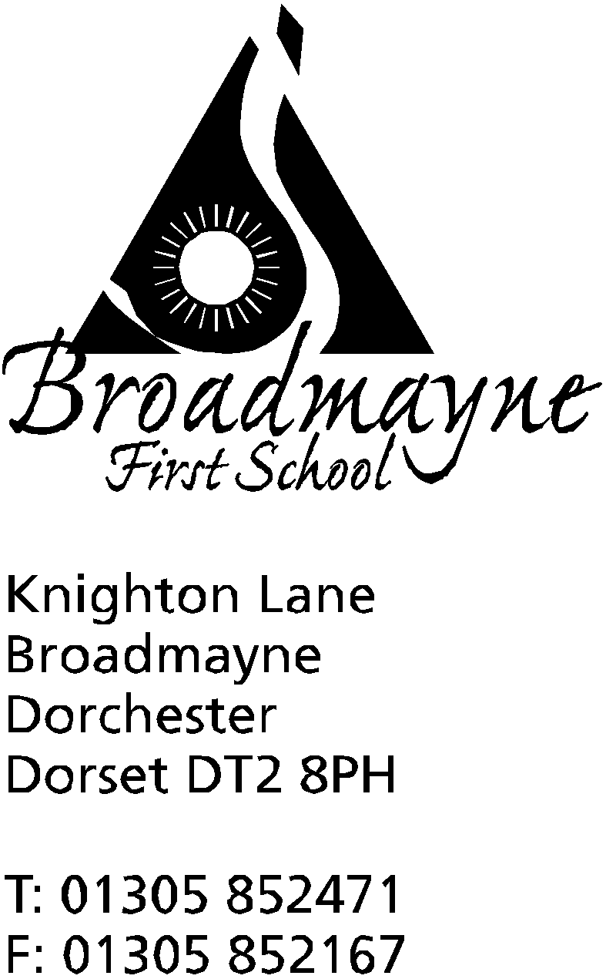

In Dorset

Headteacher
Helen Collings
Monday 20th April 2020

Dear Parents and Carers,

It feels very strange to be welcoming you all back to the summer term, but I hope you all had the chance to take some time to relax over the Easter holidays. The school continues to be open for our key worker and vulnerable children as it was before, and during, the holidays.

Hopefully you will all receive an email from your children’s teachers today, outlining their plans for the next few weeks. As we all know, the lockdown has been extended for another three weeks, but after that we don’t know what the government's plans are. I am trying to plan for a variety of scenarios, and am hoping we are all given plenty of notice before anything changes so we have time to put these in place.

Please ensure you keep in contact with our staff, as we want to ensure everyone is safe and well. You will be contacted by phone or email - a quick reply is all that is needed, but if you would like a chat, or your child would like to chat with their teacher or another member of staff, just let us know- we are all really missing the children and are very happy to make contact over the phone! Staff will reply as soon as possible to emails, bearing in mind they are either at school or at home managing their own families at the same time.

The government has released guidance for schools and parents (most recently at midnight on Saturday night!), relating to home learning, but our approach will remain much the same as previously. Each class will take a topic based approach, with both online and offline learning opportunities. Some of these will be shared via either Tapestry or Google Classroom and you will also be kept informed via email. As always, we fully appreciate that every family is different, and there is no expectation for all tasks to be completed. If you want to share the children’s learning you can do so via Google Classroom or Tapestry, via email either to myself or the year group emails, or you can bring in books or folders once we are back at school - we are happy with any approach that works best for you. Our focus for everyone is to keep the enjoyment of learning alive in whatever form that might take, and to look after everyone’s mental health. Once we are all back at school, whenever that is, we can ‘fix’ the learning gaps - ‘fixing’ emotional health is a much more difficult challenge, so please remember we are fully supportive of whatever choices you make to support your families in this area.

Government guidance for learning at home can be accessed here: https://www.gov.uk/guidance/supporting-your-childrens-education-during-coronavirus-covid-19

The Year 4 children should have now received their offers of a middle school place - please let us know if you have not. Please don’t worry about transition arrangements as we are talking with all the middle schools to ensure as much is put in place as possible, whatever happens over this term. Equally we will be contacting our new Reception families this week- we have lots of ideas for welcoming them to the school!

We are intending to send school reports out to you all by the beginning of next week - I’m sure you will appreciate this is a difficult task with only a skeleton staff at school. These will be coming to you in the post so you have a physical copy. If you have moved house or changed address within the past few months and you have not informed the school, or you are unsure if you have, please can you let us know as soon as possible. We have had two instances recently where we have sent things out to the wrong address because our records were not up to date. A quick email to office@broadmayne.dorset.sch.uk is all that is needed - my advice is to err on the side of caution and let us know anyway, even if you think you already have!

I will keep you all informed of any developments as we hear about them, but up until now the first we hear of anything is in the daily briefings, along with everyone else, and I don’t anticipate this to change much in the near future-these are difficult and challenging times for us all.

As always, please keep yourselves and your families safe, we are thinking of you every day,

Yours faithfully,

Mrs Collings

