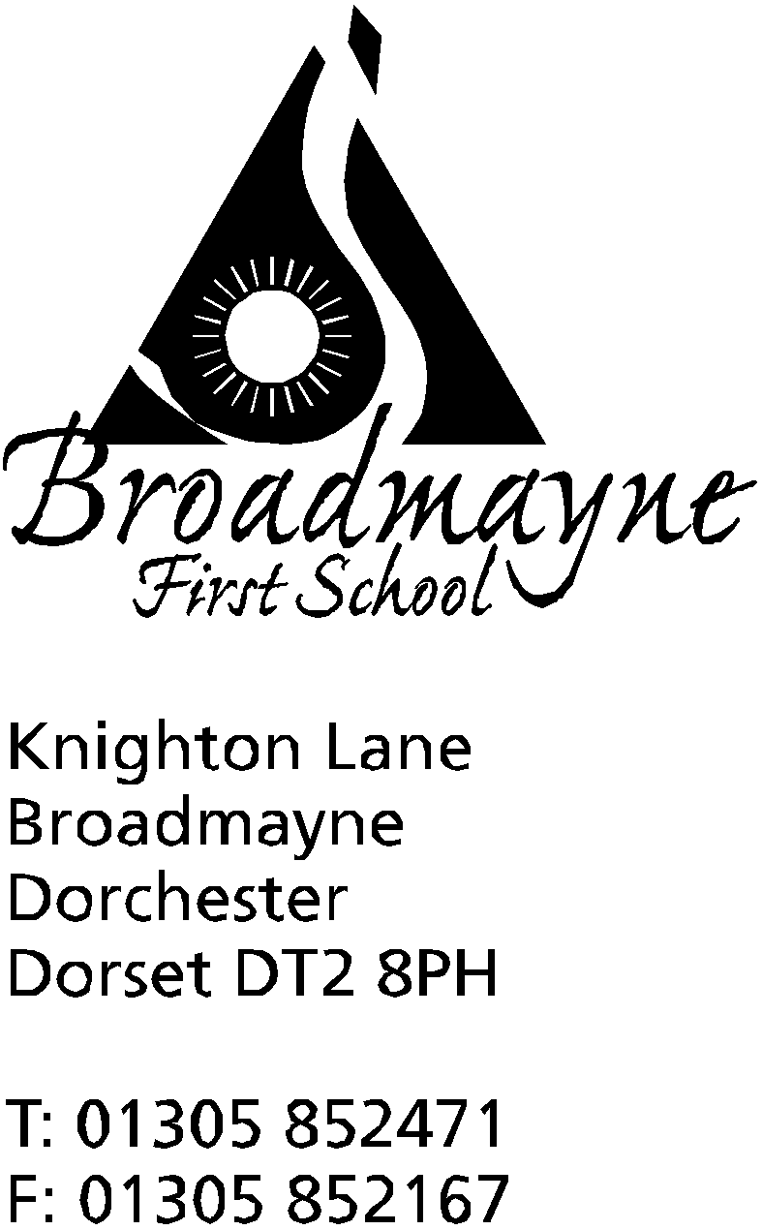

In Dorset

Headteacher
Helen Collings

19th November 2018

Autumn 2018: Newsletter No.5

Things to remember:
- Year 3 trip - have you signed and returned the permission slip, and paid using School Money?

Dear Parents and Carers,

Despite the coughs and colds that are making their annual appearance (including the headteacher losing her voice for two days!), staff and children are working hard and making the most of this time before the busy Christmas period begins. The weather is due to get colder this week -please ensure children have warm coats to wear for playtimes.

Learn Alongside Your Child
Thank you to everyone who came along to take part in Learn Alongside your Child. We were so pleased to see so many people attending, and the feedback from everyone was very useful - thank you for filling out the forms! We plan to hold more of these events once Christmas is out of the way.

Poppies and Remembrance Week
All the children took part in different activities linked to Remembrance day, and Year 3 paid a visit to the war memorial in the village. Our sales of poppies raised £203 for the Poppy Appeal, many thanks to everyone who contributed.

Children in Need
On Friday 16th the school took part in Children in Need day. The children wore spotty clothes, and we had lots of parents coming in to take part in our Wellbeing Morning. A total of £195 was raised for the charity - thank you everyone!

Year 3 Museum
Year 3 will be opening their WWI museum to parents and friends on the afternoon of Thursday 29th November.

Swimming Pool Update
Thank you so much to everyone who voted, and persuaded others to vote for the FABs swimming pool funding bid in the Aviva Community Fund. As of the time of writing this letter we have 7,250 votes -whether this is enough to get us through to the next round remains to be seen, but what a fantastic effort for a small community! Thank you to everyone involved!
School Lunches
We have had a few issues with some of our hot school meals since half term, which we informed our supplier of. They have shared some useful information with us which we are hoping will help in the future:
Highlighted Issues
Parents forgot to order in time – LFL menus are normally for half a term PLUS the first week of the following half term. 7 days notice is always required to order or cancel a meal. The pre-ordered meals may have lulled parents into a false sense of security when pupils returned from the half term and meals were in place. Other caterer’s online systems cover an entire term whereas our system is for a maximum period of half a term plus one week. We add the additional week to enable schools to have time to remind parents to order after a holiday (because of the 7 day notice period required).
ACTION: LFL will remind all schools when a new menu goes live and, also, after a holiday to communicate with parents.
Many parents have forgotten when ordering (particularly if ordering on a mobile phone) to press either the order button each week and then the Pay and Confirm Button (even for free meals) at the end of the process.
ACTION: Please remember to check after placing an order by pressing the “View” button which will list all confirmed orders (NB free meals will show as “not paid” until the school has paid the invoice but the order will be listed). Our parent database was cleansed this year (GDPR) and currently has 248 addresses. Parents are able to sign up to the database via our website: https://www.localfoodlinks.org.uk/for-parents/ We will also put this information on Facebook and Twitter.

School Admissions
We have been asked to inform you that Dorset County Council are running their annual consultation on the School Admission Arrangements for 2020/2021, with effect from Monday 12th November 2018 to Friday 21st December 2018, and parents are welcome to contribute. Details of the consultation will be available to view at https://www.dorsetforyou.gov.uk/education-and-training/education-and-training.aspx?folderIds=5377,43802. Responses must be submitted either in writing to School Admissions Team, Dorset County Council, County Hall, Dorchester, DT1 1XJ or by email to schoolorganisation@dorsetcc.gov.uk by Friday 21st December 2018. Upon the conclusion of the consultation period all responses will be considered carefully and a report will be presented to the shadow executive prior to the determination deadline on 28th February 2019.

Apollo Project
Over the coming year Dorchester Arts will be working with Dorchester-based musician and composer Geof Edge, as well as a team of experienced project managers, writers, producers and musicians, to create a spectacular outdoor musical performance by children in Maumbury Rings.
This performance will be held on July 19 2019, to celebrate the 50th anniversary of one of the great events in human history and will be free to attend. They will sing Apollo - One Giant Leap - a cantata for children's voices that describes the dramatic events of the Apollo 11 space mission in July 1969, the climax of which was Neil Armstrong's first step on the Moon's surface and his famous quote: “That’s one small step for a man, one giant leap for Mankind.”
The performance will be the centrepiece of a weekend of moon-related celebrations entitled ‘Moonbury Rings’, and will include Luke Jerram’s Museum of The Moon, a 7m diameter suspended, internally illuminated sculpture of the moon; a display of artworks and sculptures created by local schools and community groups, and an outdoor cinema event featuring moon- and space-themed films.Dorchester Arts is currently Crowdfunding to help reach as many young people as possible and give hundreds of children the opportunity to participate in a major music event.Can you help us?Please donate through our Crowdfunding page at https://www.crowdfunder.co.uk/apollo- one-giant-leap - there are some great rewards and thank you for helping us achieve lift off!
Meditation
There is a small group that meets to practise meditation and mindfulness every Friday morning at 8.30 am - in the outdoor classroom if the weather is good, or in the library if not. Everyone is invited - parents, children and staff often go along, and it is a great way to start a Friday! Please come along and find out more about it.
Puddletown First School Nearly New Sale
Our friends at Puddletown First School have asked us to advertise details of the ‘Nearly New’ Sale they are holding at their school. They are keen to encourage both sellers and buyers-there are tables available if you would like to reserve one. If you are interested you can ring Hannah Roberts on 07788714355.
The sale will be held on Saturday 24th November, from 10 am - 1pm.

Yours faithfully,

Mrs Collings

Date | Event | Time
NOVEMBER
Tuesday 27th | Y3 trip to Tank Museum
Thursday 29th | Y3 WWI museum
Friday 30th | School Christmas Fayre | 5.30pm  -7.30 pm
DECEMBER
Thurs 13th | Dress rehearsal of Christmas play- filmed  Last Cool Kids session
Mon 17th | Christmas play in school hall | 1.45pm
Tues 18th | Christmas play in Broadmayne Village hall  “ | 9.30 am  6.00 pm
Fri 21st | Last day of term; Christmas party lunch
Monday 7th Jan 2019 | First day of Spring Term

