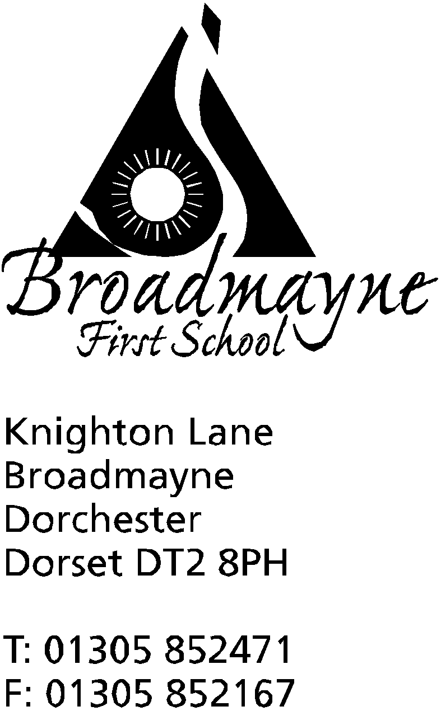

In Dorset

Headteacher
Helen Collings
Wednesday 13th February 2019

Spring 2019 - Newsletter 4

Things to remember:
- Slips for clubs starting after half term

Dear Parents and Carers,

This is an extra newsletter to add several things that have been arranged since the letter I sent out last week.

Number Day
Thank you to everyone who helped their children dress up for Number Day, and to all of you who came along and joined in with our Learn Alongside your Child sessions. We had a fantastic turn out, and lots of positive feedback, and the school raised just under £100 for the NSPCC. The next Learn Alongside your Child session will be in English - more details to follow next half term.
Fair Trade Cafe
Each year we like to support Fair Trade Fortnight with our own Fair Trade Cafe. This year, Year 3 will be running their Fair Trade Cafe in the week following half term (beginning Monday 25th February). Each class will have the opportunity to visit the cafe on different days, and 70p will purchase a drink and a snack made using Fair Trade ingredients - please donate money via your child’s class teacher.
Headlice
We have had a report of headlice in one of the classes at school this week. As it is half term it would be an ideal time for everyone to take part in a bug busting session, so that all children’s hair is checked and treated as necessary. As a parent I have tried every treatment under the sun, but still find conditioner and combing every couple of days the best method!
Eco Schools
We are pleased to announce that we have retained our Green Flag status due to all the good work going on within school - well done to Miss Felgate and the Eco team! There are some recycling updates to share with you all
Plastic bottle lids can be sent or taken into Lush shops for recycling. The free post address to send them is
FREE-POST, LUSH GREENHUB.
More information can be found at https://disposalknowhow.com/lush-plastic-bottle-tops/
Walkers Crisps are also recycling crisp packets - more information at https://www.walkers.co.uk/recycle

Another website you might find of interest is Surfers Against Sewage, who we are working with as part of our anti plastic campaign, at https://www.sas.org.uk/our-work/beach-cleans/

ToddlerCalm Sessions
Are you facing challenging behaviours at home? Are you experiencing "terrible twos" or living with "threenager"? Maybe you would just like to understand more about toddler behaviour and development or want to know more about how to support your toddler's emotional needs?
Michelle Carter-Grogan, our Year 4 teacher works with ToddlerCalm West Dorset and will be offering a 2 part Understanding Behaviour Workshop in the Broadmayne Preschool building (formerly Broadmayne Children's Centre) on Friday 15th March and Friday 22nd March 2019. Each session will take place from 9.30am - 11.30am. Spaces are being offered at a discounted rate of just £10 per family for families who attend Broadmayne preschool/school. Please note it is important to attend BOTH sessions.
Spaces are limited and will be offered on a first come first served basis.
Sessions are suitable for any parent who has a child between the ages of 1 and 5 years and can be booked by emailing michellecartergrogan@calmfamily.org. Please use reference BMUB.
Relax Kids Session for Parents and Carers
On Thursday 28th February we are pleased to be able to offer parents and carers a Relax Kids session from 3.30pm - 4.30 pm. This is a great opportunity to learn how to support your child with some of the Relax Kids techniques, whether they have had some lessons already, are about to take part, or you would simply like to find out a little more about it. Sian will be covering the following during the session:

A brief introduction to Relax Kids - how she got involved in Relax Kids, her background related to therapeutic parenting, gentle parenting, PACE techniques.
A brief explanation about the brain and how stress impacts our ability to learn, retain information and how Relax Kids relaxes the part of the brain that can become particularly heightened.
She will then cover the 7 stages of relaxation, before a short question and answer session at the end.

I am mindful that it can be very difficult to relax when you have your children with you, so am happy to offer childcare for this session. However, there are three other clubs happening in school at the same time, so space will be limited - please let us know via the slip below if you would like to attend, so we have an idea of numbers.

Wishing you all a happy and relaxing half term,

Mrs Collings

---------------------------------------------------------------------------------------------------------------------------------------------------
Relax Kids Session for Parents and Carers - Thursday 28th February 2019

- I would like to attend the Relax Kids session
- I would like my child to attend the creche during the session

My name:__________________________________________________________________

My child_____________________________________________________________________

Signed:_______________________________________________________________________

--------------------------------------------------------------------------------------------------------------------------------------------------

