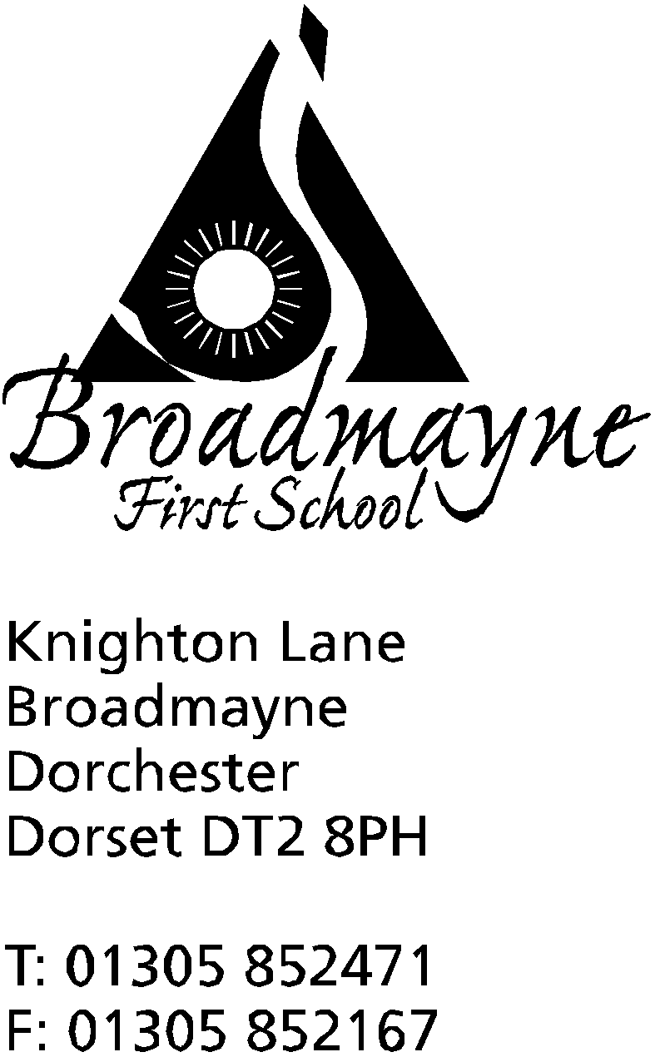

In Dorset

Head teacher
Mrs. Melanie Austin

28th June 2017

Summer 2017: Newsletter No. 5

Dear Parents and Carers,
In my last letter I mentioned the chilly start to the swimming season…well, that all changed rather rapidly! We are racing towards the end of the school year, with many exciting events still to come. Our future Reception class have now visited us 3 times and we are really looking forward to welcoming them in September. On Thurs 20th July we will sadly be saying goodbye to our wonderful Yr 4 pupils, who will be leading the Leavers’ assembly that morning.

Staff update
In September Mrs Bostock will be reducing her teaching commitment to 4 days a week. We are happy to have appointed Mrs Jo Stoker to teach on the other days. Mrs Crumbleholme and Mrs Thompson will be our regular supply teachers across the school. We are so lucky to have a fantastic team who work really closely together to ensure the best possible outcomes for our children. We are currently finalising the teaching assistant timetable.

DASP Citizens
The following children have been voted by their classmates to best embody the 7 DASP Caterpillar qualities. (Caring, communicative, courteous, confident, conscientious, considerate, co-operative)
Yr 4: Amy Pinney
Yr 3: Lewis Ward
Yr 2: Sam Burgess
Yr 1: Ted Russell
Yr R: Rowan Cake

Sports days
Thank you to the parents and other carers who came to support the children on our potted sports day last week. We would also like to thank Mrs Howells, Mr Gibbons and other staff as well as Mr Dailey and the Yr 8 junior sports leaders for running the event. Due to the extreme heat we kept the children in at lunchtime and halved the length of the potted sports with additional shaded rest areas and cold drinks; the children were very sensible about keeping their hats on. Next Tuesday 4th July at 1.30 we are hoping to see you all for our traditional sports day (reserve date is Tues 11th if it rains). The FABs are planning to hold their annual Summer fair on the 4th with stalls, ice cream, cream teas and pizzas. Let’s hope for good weather!

Treasure Island
M & M productions gave a lively rendition of the classic children’s tale with plenty of audience participation. Thank you for donations received so far- still welcome if you haven’t got round to it yet!

Headlice
The little creatures seem to be very active currently in some classes. This is a problem shared by all schools and it is very difficult to eradicate them completely. We have found that the most effective method is for everyone to check their children at least once a week, preferably at the weekend, in the hope that we can begin (and hopefully end) each week nit-free!

Book Fair & Book audit
Thank you to those of you who purchased books at the Book fair- we earned over £100 commission, which has been spent on some lovely new books. On Thursday 29th Mrs Gillott and Mrs Hargrave will be starting the considerable task of auditing our individual and group reading books so children won’t be bringing home reading books for the next few days. Soon we will be ordering some new books to replace the outdated or damaged ones.

DASP Litfest
During the week beginning 3rd July, all DASP schools will be celebrating literacy with a wide range of events. All Yr 2 children are offered an all-expenses-paid trip to The Thomas Hardye School library, where they will meet author and illustrator Paul Stickland. On Fri 7th July schools have been asked to select 8 children who are showing a particularly positive attitude to reading and writing to attend the celebration “Litfest” at Thomas Hardye School.

Thank you afternoon –change of date from Fri 7th to Mon 17th July at 2.15
We have had to change this date due to other conflicting events on the same day- we are very sorry for any inconvenience caused. The Thank you afternoon will now be held on Mon 17th July at 2.15. Invitations to our volunteer helpers are being sent out over the next week.

Swimming Gala/Sponsored Splash!
A letter is on its way with details of the FABs fundraising Sponsored Splash: it will take place on the morning of 10th July, with 17th as reserve date (am).

Library Summer Challenge
On Mon 3rd July a representative from Dorchester library will be coming to talk to the children about this year’s Summer reading challenge: “Animal Agents”- more details to follow.

Clubs update
After school swimming club numbers are building up on Wed and Thurs but we have such low numbers on Mondays that we have decided to stop this session unless more children are booked on by the end of the week. Please let the office know if your child would like to join (Yrs 2-4)

Yours sincerely

Diary dates
July
Week beginning Mon 3rd | DASP Literacy festival
Mon 3rd | Yr 3 trip to Ridgeway
Tues 4th pm at 1.30 | Traditional sports day (reserve Tues 11th)  FABs Summer fair
Wed 5th | Yr 1 trip to Pizza Express  Yr 2 trip to Thomas Hardye School
Thurs 6th | DASP transfer day (visit new classes/schools)  Yr 4 out all day- others am only
Fri 7th | DASP Litfest
Mon 10th | Sponsored Splash! (am)
Tues 11th 5.30 pm  1.30 pm | DASP Citizenship ceremony  Sports day reserve date
Thurs 13th 9.15 for 9.30am start | In-house football tournament
Mon 17th at 2.15 | Thank you afternoon
Thurs 20th at 9.10 am | Yr 4 leavers’ assembly  Last day of Summer term
Fri 21st | Staff inset day

Dates for 2017-18 school year
Mon 4th and Tues 5th September: INSET days
Wed 6th September: First day of Autumn term for Yrs 1-4 and 1st half of Reception class
Thurs 7th September: 2nd half of Reception class
Fri 15th December: Last day of Autumn term
Half term: Mon 23rd- Fri 27th October inclusive
Other Inset days: Mon 30th October 2017, Friday 9th Feb 2018
5th Inset day to be confirmed

Spring term 2018
Friday 9th February: INSET day
Mon 2nd Jan to Fri 29th March
Half term: 12th-16th Feb

Summer term 2018
Wednesday 25th July: INSET day
Mon 16th Apr to Tues 24th July
Half term: 28th – 1st June

