BFS Geography KO - Journeys (How do we know where we Are?) Yr 2 AUTUMN Term !
How do we know where we are in the world? We use a map!  How do we know how to get to somewhere else? We follow a route on a map.  How can we show where we are?  We can draw a sketch map. | 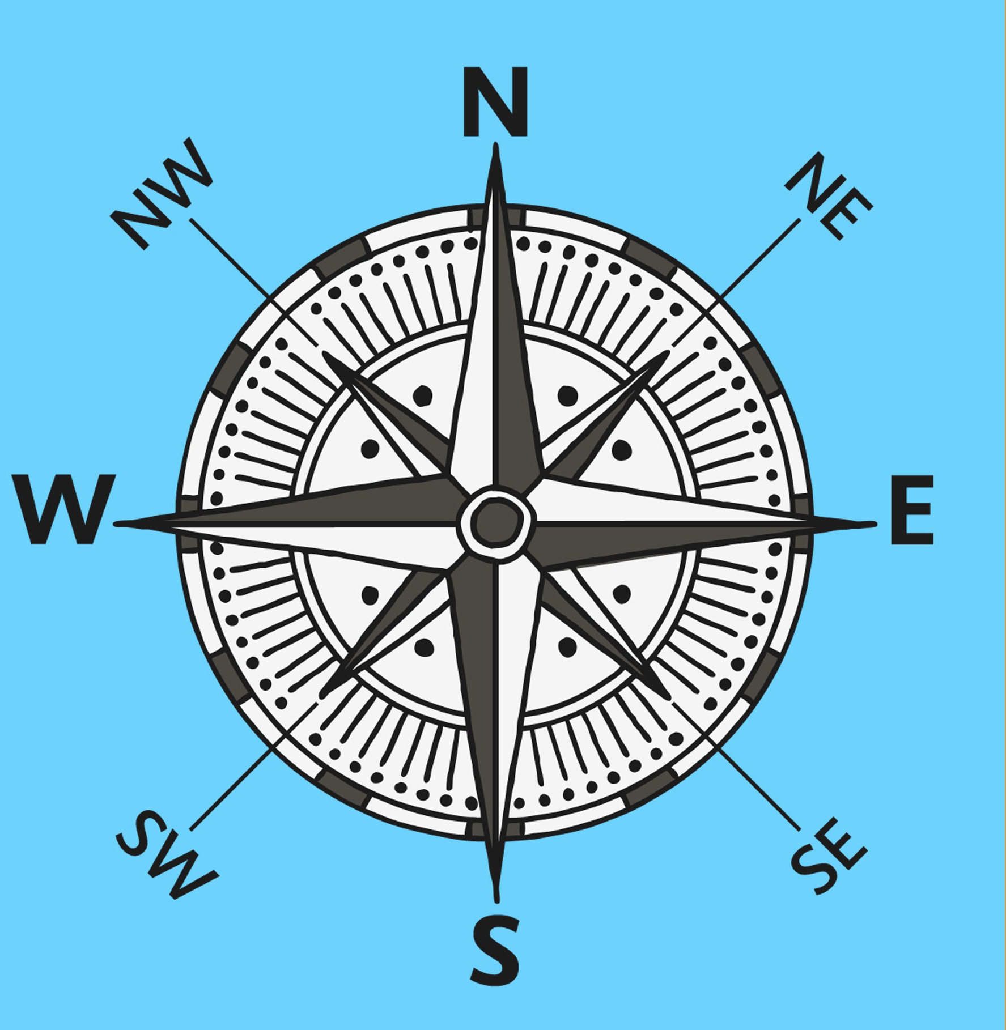  North South East West  A compass
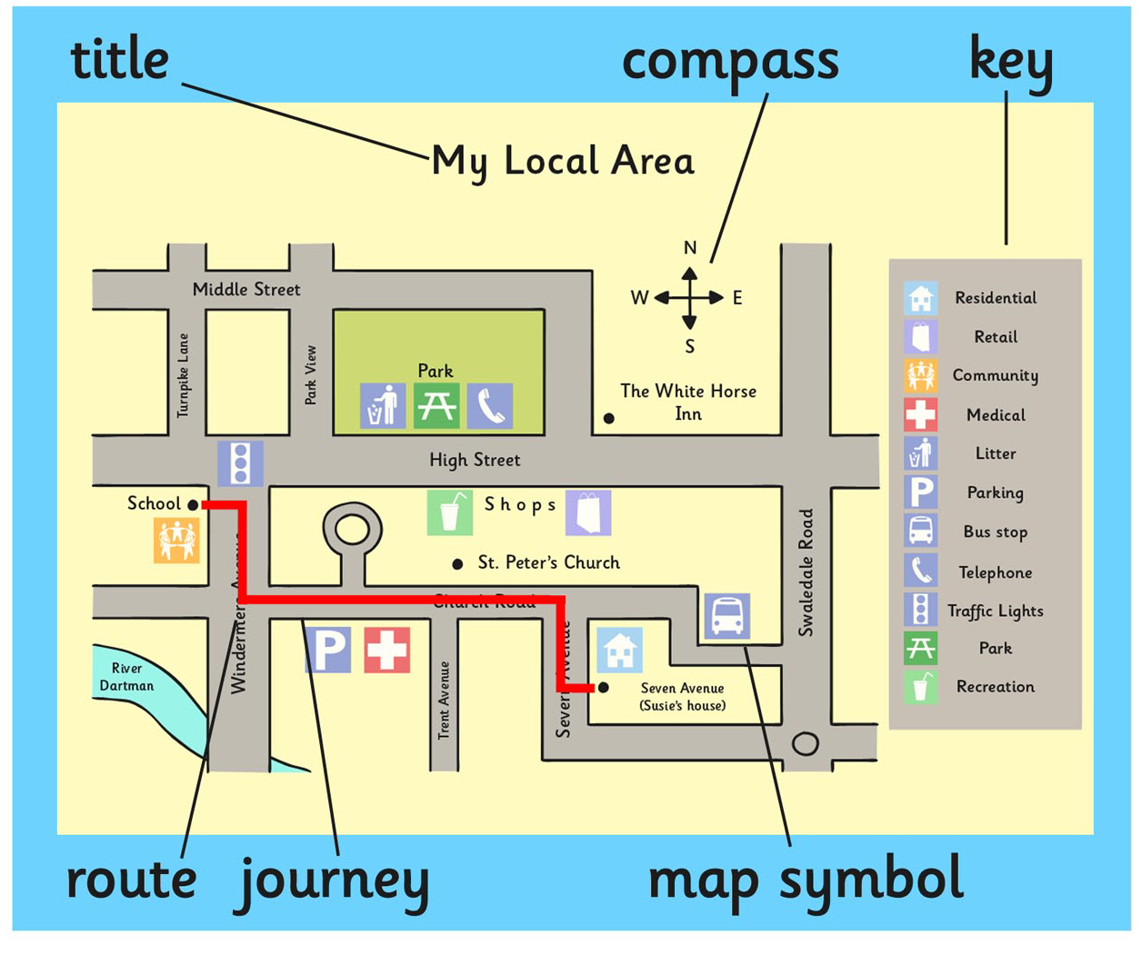  A map | 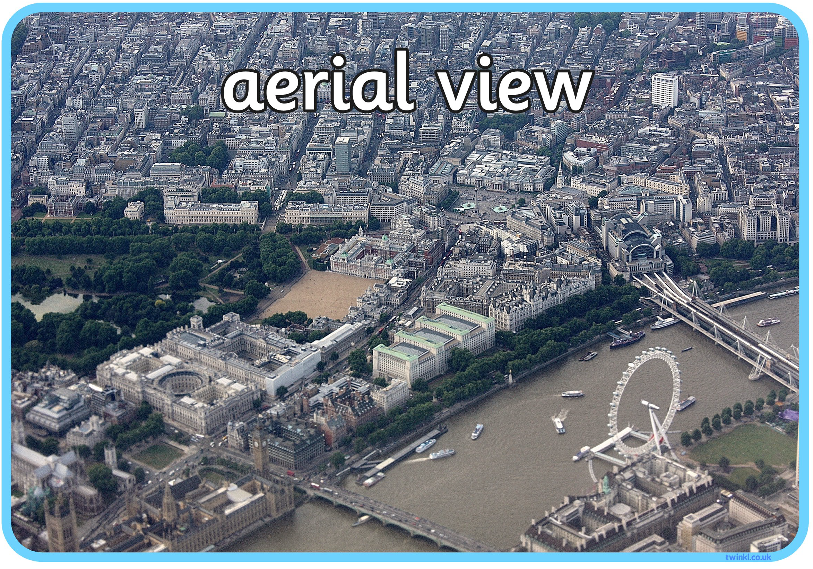  An aerial view
Geography of the World  - There are 7 continents-  Europe, Asia, Africa, North America, South America, Antarctica, Australia  - There are 5 oceans -  Pacific, Atlantic, Indian, Southern, Arctic. | Vocabulary  map - a picture that shows where we are  sketch map - a map that drawn by hand  feature - a place on a maps  symbol - small picture to show a place on a map  globe - a ball shaped map  atlas - a book with maps of the world  route - the journey from one place to another  aerial view (birds eye view) - the real view from above  sea - water around land  ocean - large area of sea  continent - area of land with many countries  compass - an object which tells us the direction we are travelling in.

