BFS Year 2 Science knowledge Organiser - everyday materials

Key Knowledge  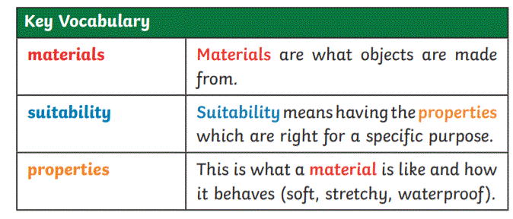  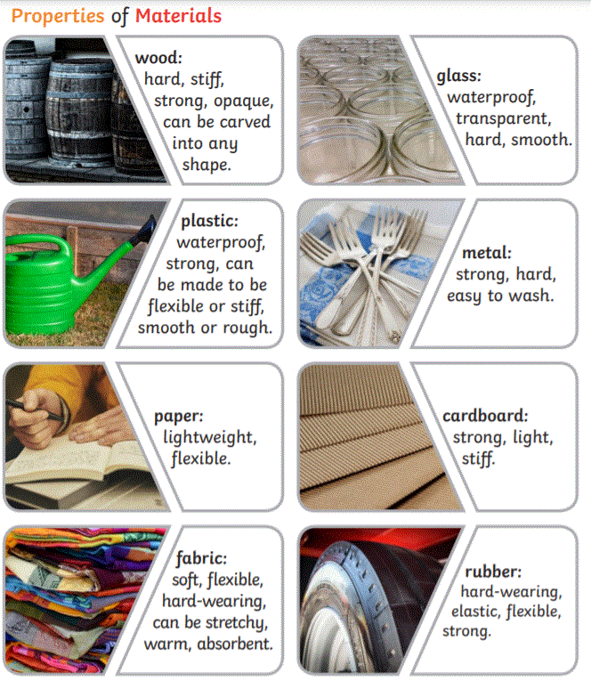 | These materials can be obtained naturally or man-made in a factory.  Everyday materials are used to make many things. Some objects are made from more than 1 type of material.  plastic  metal  Changing Materials  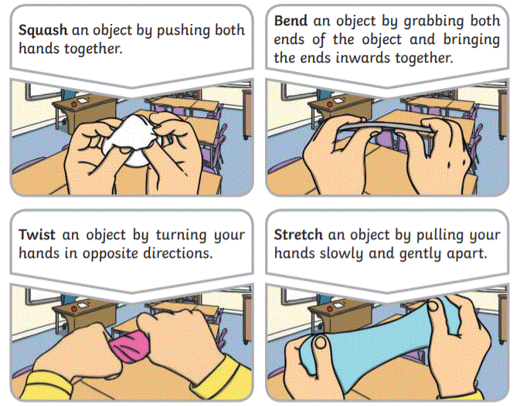People who developed new materials  