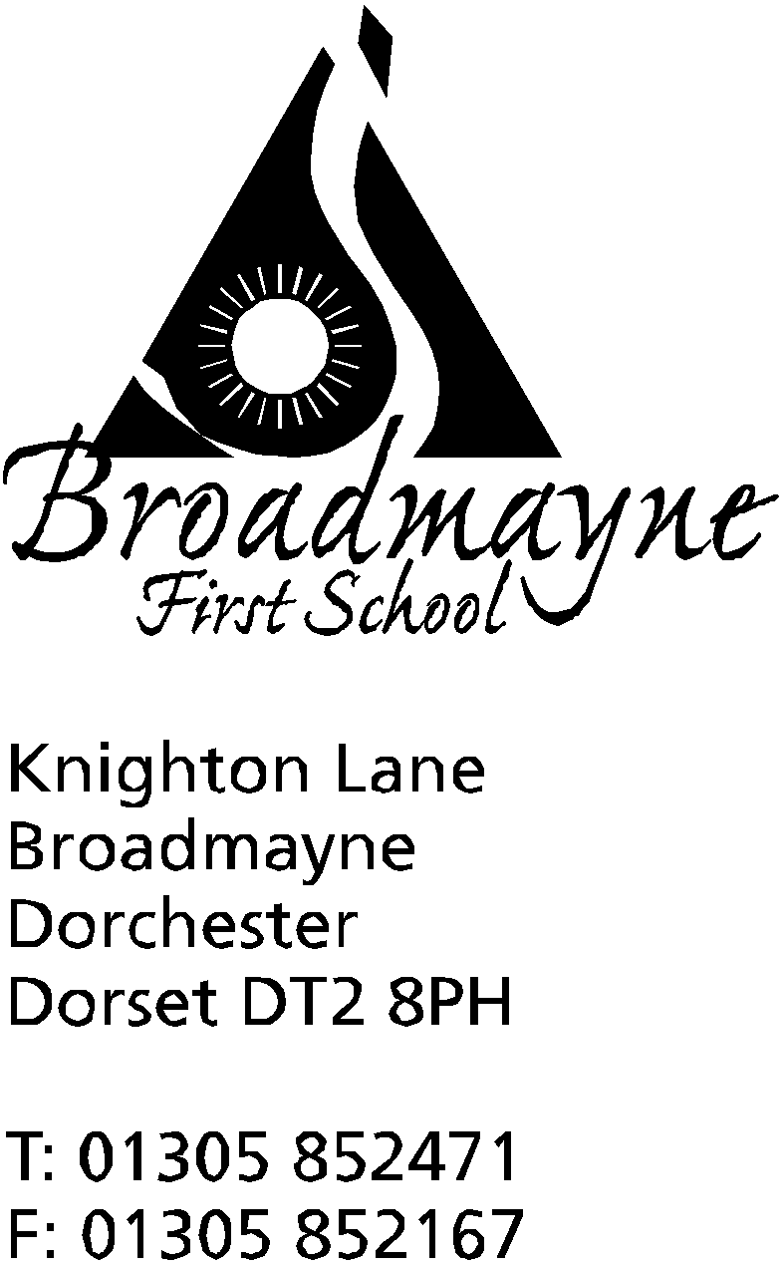

In Dorset

Headteacher
Helen Collings

7th September 2018
Autumn 2018: Newsletter No. 1

Dear Parents and Carers,

A warm welcome to you all, we are all very excited to be back at school with a new year ahead of us. I hope everyone had a happy and relaxing summer holiday; it certainly made a pleasant change to see the sun shining so often!
I am proud to be taking over as the new Headteacher for Broadmayne, and am looking forward to working closely with you all to ensure the best possible outcomes for your children. Those of you who know me from my time as Year 4 teacher and Deputy Head will know that my door is always open, and I am more than happy to take the time to talk with parents over any concerns or worries - or to share good news! I look forward to carrying on the wonderful work Mrs Austin did with the school, and to build on her achievements.

Staffing
We are pleased to welcome Ms Carter, who will be teaching Y4 from Monday to Thursday, and Ms Foster who is our new TA in Year 2. We are looking forward to working with them both.

School Money
You will by now have received information about our new online payment system, School Money. From now on, all payments for school activities will be made through this system. If you have any problems, please contact Mrs Foyle in the office- however, this is a new system to us as well, so please bear with any teething problems we may have!

Class and Curriculum Information
Teachers will be sending out information letters next week to let you know some of the important information about each class. We would also like to invite you to a ‘Meet and Greet’ session with each teacher, who will provide you with an overview of the year’s routines and curriculum. The dates for these are on the calendar attached.

Nut Allergies
We will continue to be a ‘nut-free’ school and ask that lunchboxes do not include any products containing nuts. Thank you so much for your co-operation with this; our priority is always the safety of our children.

Lunchtime Staff
Schools often find it difficult to recruit staff for lunchtimes, and we are no exception.
We are looking for extra support for our lunchtime team. If you could help us out on even just one lunchtime a week, even on an occasional basis, we would be very grateful. The role would include helping children with their food, and supervising playtime - please speak to Mrs Foyle in the office.

Music Lessons
Sadly, we have said goodbye to Mrs Badley, which means we will no longer be able to offer her ukelele or recorder lessons. However, we have recently had a qualified music teacher contact us who would be keen to offer lessons - please could you fill out the attached form if you would be interested in continuing with or beginning lessons - these would be offered to Years 3 and 4. If there is enough interest the groups will go ahead. Mrs McCourtie (piano) and Mr Fisher (violins) will start lessons week beginning 10th September; Mrs Hubble (keyboard|), Mr Rushbrook (guitars and ukelele) and Mr Page (drums) will be starting lessons week beginning the 17th.

A cheeky request
We are currently working to update and decorate the school, and we have started with the staff toilets. One of the toilets needs replacing - is there anyone out there who could help us with this? We need a plumber to fit a new toilet - we are happy to supply a replacement but need someone with expertise to make sure it is safely fitted! Please let us know if you could help out-we will repay you with cake and our endless gratitude!

Recognition of Good Behaviour
We are currently in the process of updating our Behaviour Policy and our reward system. Our intention is to have a common thread that runs across all classes, and so we have decided to have just three rules or values that we expect the children and adults in our school to adhere to. These are Be Safe, Be Kind and Show Respect. These link directly with the DASP caterpillars, but are simpler for the children to remember. We will have a Celebration Assembly every Friday where certificates for those children who have gone ‘above and beyond’ will be awarded, and these children will also be invited to have hot chocolate and biscuits with me.

Photo permissions
You may have heard about the new data protection laws that have come into force recently. As part of this, we are asking you to fill out a photo permission form. It is really important that you fill this out and get it back to school - if we do not receive consent from you, we have to assume that you do not want your child’s photo taken or used within school in any circumstances. We also have a new Privacy Statement for parents and children which can be found in the foyer of the school; this gives information on how we use data within school.

Mindfulness and Meditation
Sharon Simmonds, a previous parent of the school, is offering to run meditation sessions on a Friday morning. In this busy world in which we live it is so good for us all to take some time out for a short while. Here is what she has to say:

A welcome call to all children, parents, carers and teachers to our weekly Mindful Meditation before school on a Friday 8.25 until 8.45 . The group is led by Sharon Simmonds from Holistic View, a local business, and holistic therapist with over 20 years of experience in many self help techniques, and Mrs Bostock. - even some of the teachers join in - it makes us feel all relaxed and happy!
The cost is just £1 each.

Clubs
This half term we will be offering a range of clubs. Please find details of those which have been confirmed. Action Van (sports multi skills for all year groups) will run until half term, and then will start again in the Spring. Please note that if you have signed your child up for a club they do need to commit to attending every session, and the school needs to be informed if for some reason they cannot attend. If a club is oversubscribed we will operate it on a first come, first served basis, and will run a waiting list.

Day | Club | Time | Start date | Year groups | End date | Led by | Cost per session
Mon | Tag Rugby  Gym club | 3.15 -4.15  3.15 -4pm | 17.9.18  17.9.18 | 3&4  1&2 | 15.10.18  15.10.18 | Mr Gibbons  Mrs Howells | Free  Free
Tues | Starlings  Football | Lunchtime  3.15 -4.15 | 11.9.18  18.9.18 | 3&4  1&2 | N/A  tbc | Mrs Bostock  Mr Gibbons | Free  Free
Weds | Action Van | 3.20 - 4.20 | 12.9.18 | all | 17.10.18 | Action Van | £2.50
Fri | Football | 12.30 | 14.9.18 | 2,3,4 | 14.12.18 | Trevor Senior | £1.50

Mr Dailey is hoping to offer some additional sports club; further details to follow.

Wishing you all a happy and positive start to the new school year,

Mrs Collings

Please find diary dates below; we will inform you of further dates as we receive them.

Date | Event | Time
SEPTEMBER
Mon 17th | Yr 2 Meet & Greet  Governor’s Extraordinary Meeting | 2.45  6pm
Tues 18th | Yr Rec Meet & Greet | 2.45
Weds 19th | Yr 4 Meet & Greet  Y3 trip to Maiden Castle | 2.45  All day
Thurs 20th | Yr 1 Meet & Greet | 2.45
Fri 21st | Yr 3 Meet & Greet | 2.45
OCTOBER
Mon 1st-Fri 5th | Life Education Van/ Healthy Choices week
Mon 8th  Tues 9th  Wed 10th | Parent consultations Yr 2, Yr 3,  “ all classes  “ Yr Rec, Yr 1, Yr4 | 3.30-5.30  “  “
Fri 12th | Harvest Festival to be held in school | 9.30
Fri 19th | Whole school and Pre-School Pizza Day
Mon 22nd-Fri 26th | HALF TERM
Mon 29th | INSET day- no school
Tues 30th | Back to school
NOVEMBER
Fri 2nd | Individual photos
Mon 5th - Fri 9th | Remembrance Week
Mon 12th | Beginning of Anti-bullying fortnight
Weds 14th | Flu innoculations - optional
Fri 16th | Children in Need (further details to follow from the School Council) | 9.00am
DECEMBER
Mon 17th | Christmas play in school hall | 1.45
Tues 18th | Christmas play in Broadmayne Village hall  “ | 9.30 am  6.00 pm
Fri 21st | Last day of term; Christmas party lunch
Mon 7th Jan 2018 | First day of Spring Term

Action Van All year groups (£2.50 per week) – Starting Weds 12th Sept. 3.20-4.20pm

My child would like to attend Action Van

Childs Name & Year Group: ………………………………………………………….

Signed ……………………………………………………………………….. (parent / guardian)

Please print name:......................................................................................

My child will be collected by:
………………………………………………………………………………………………………………………………

Football Club Y1 & Y2 – starting Tues.18th Sept. 3.15-4.15pm
My child would like to attend football club with Mr Gibbons

Child’s Name & Year Group: …………………………………………………………

Signed ……………………………………………………………………… (parent / guardian)

Please print name:.......................................................................................................
My child will be collected by:

…………………………………………………………………………………………………………………………………

Tag Rugby Club Y3 & Y4 (free)– starting Mon. 17th Sept. 3.15-4.15pm

Child’s Name & Year Group: ………………………………………………………….

I would be available to help ………..

Signed …………………………………………………….. (parent/guardian)

Please print name:..........................................................................................

My child will be collected by:

…………………………………………………………………………………………………………………………………

Trevor’s Friday Lunchtime Football Club - Y2,3,& 4 - £1.50 per week (to be paid directly to trevor, not to the school office)– starts Fri 14th Sept
My child would like to attend Trevor’s Friday football

Child’s Name & Year Group: ……………………………………………………………………..

Signed: ………………………………………………………………………………….. (parent/guardian)

Please print name:....................................................................................................
My child will be collected by:
………………………………………………………………………………………………………………………………
Gym Club Y1 & 2 (free) - starting Monday 17th Sept 3.15 - 4 pm
My child would like to attend Gymnastic Club
Child’s name and year group:..................................................................................................

Signed:................................................................................................. (parent/carer)

Please print name:..............................................................................................
My child will be collected by:
---------------------------------------------------------------------------------------------------------------------------------

Recorder/Ukelele groups (Yrs 3 and 4)
My child would be interested in learning:
ukelele
recorder
Child’s name:
Year group:

