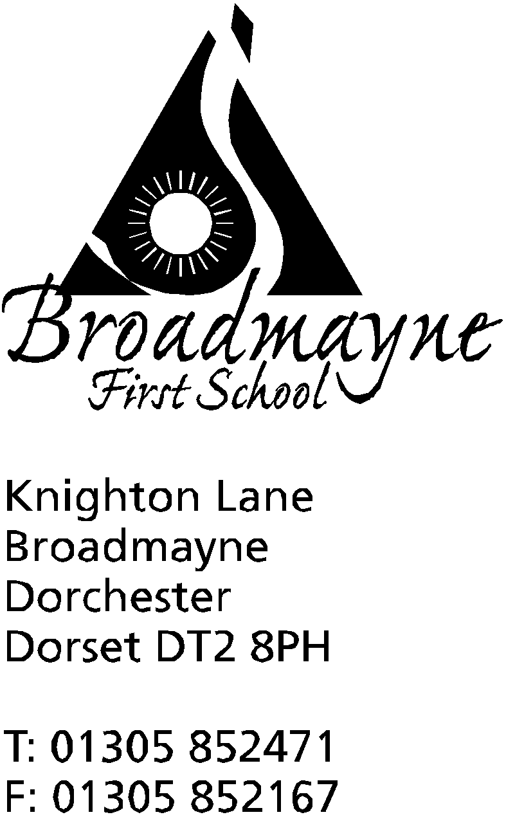

In Dorset

Headteacher
Helen Collings
Wednesday 18th March 2020

Dear Parents and Carers,

I am writing to share with you our plans for the school in more detail, should we have to close. One of my concerns is that the school will be forced to close at very short notice, and I wanted to reassure you all of our plans before that should happen.

Our plans to support the children and their families are as follows:

Reception and Year 1
Reception and Year 1 children will each be given an exercise book to bring home, with suggestions for work and projects within it. Please use this book to record the work the children do. As well as this the staff will be using Tapestry to keep in touch with you all, so please log in as often as possible, particularly if the school closes for a long length of time, as work will be shared via this. If you have not accessed Tapestry yet, please contact the school as a matter of some urgency.
Tapestry will allow staff not only to share work and ideas with you all, but you can also post pictures back to them of what your children have been doing, which is a wonderful way for us all to keep in touch! You can also access links and ideas for home learning via the school website (details below).

Years 2, 3 and 4
As with Reception and Year 1, these children will bring home an exercise book with links, project ideas and work in, as well as login details for online learning platforms. Should we be shut for an extended period, we will be using Google Classroom as a way to keep in touch. Staff will post messages and work, and children can message back, work online and send that work back to staff. You will also be able to access links and ideas for learning via the school website (details, again, below)

We will be sending these books home today. Please keep them safe until needed. If children are currently absent and we close, we will endeavour to get their work to them - please ask another parent to pick it up for you if possible.

School Website
We have created a page within the ‘Parents’ section of the school website which will have links to our main online sites, and ideas for things that can be done at home. It also has links to where you can go for help and support at this unusual and difficult time. Please bear with us as it is currently under construction and may have a few mistakes at times! The link is here: http://www.broadmayne.dorset.sch.uk/web/parents/190331

Keeping in Contact
We have created new email addresses for the staff specifically for this period, so that you can contact us directly and we can respond. Please message us with photos or examples of what you have been doing as a family, and we will try and respond as quickly as possible, although please do bear in mind that staff will have other things to work on, and I do not expect them to be available online all day. The email addresses are as below:
Reception staff: year_r@broadmayne.dorset.sch.uk
Year 1 staff: year1@broadmayne.dorset.sch.uk
Year 2 staff; year2@broadmayne.dorset.sch.uk
Year 3 staff: year3@broadmayne.dorset.sch.uk
Year 4 staff: year4@broadmayne.dorset.sch.uk

Mrs Collings: headteacher@broadmayne.dorset.sch.uk

The staff at school will be contacting every family at least once, and ideally twice, every week via phone or email to check in with you -please use this as an opportunity to let us know how you all are, if there is anything you are worried about, and to share any good news! I will warn you that if staff do not receive a response at least once a week, you are likely to receive a phone call from me to check everything is OK, and possibly a home visit if I am really concerned.

I would like to reassure all of you that I have no expectation of children being online all day completing work. This is an unprecedented time, and I feel strongly that families need to do whatever is needed to ensure they come through it as safe and well as possible. If we are closed, we will not be moving our children’s learning forward in any way that will mean that there are gaps between our children when they come back to school, as we recognise not every parent can commit to a full learning programme. Please, keep reading with your children, practise the basics such as times tables, number bonds and counting, and keep them active as much as possible. Once we are all back at school we will do our job and get everyone back where they need to be.

As I have said, it may be that we are not forced to close, but I hope this leaves you feeling reassured of our support if it does need to happen,

Yours faithfully,

Mrs Collings

PLEASE ENSURE THE SCHOOL HAS UP TO DATE DETAILS FOR YOU, PARTICULARLY EMAIL ADDRESSES AND MOBILE PHONE NUMBERS

