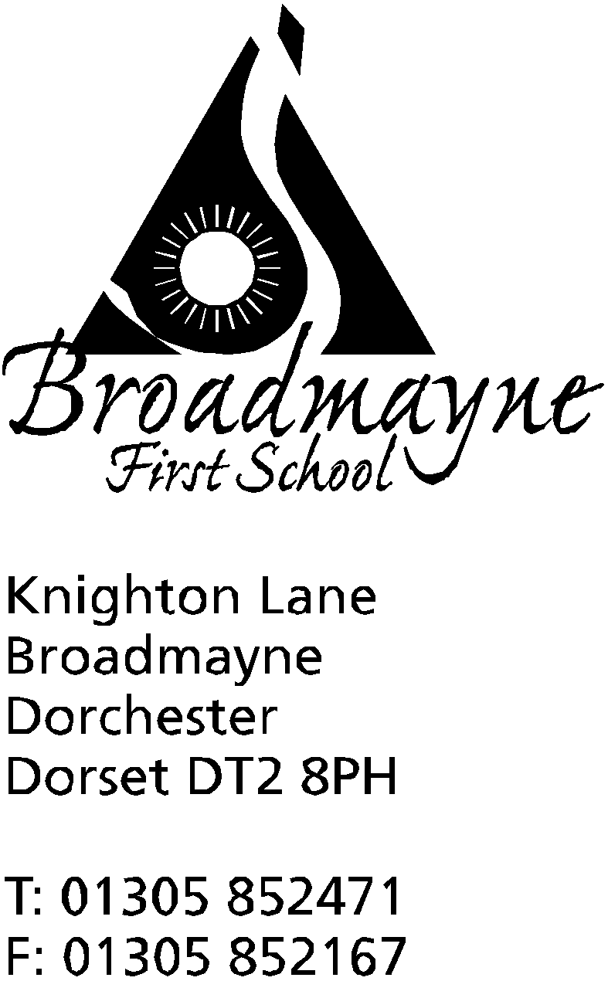

In Dorset

Headteacher
Helen Collings
Monday 21st September 2020

Autumn 2020: Newsletter Number 4

Things to remember!
- Reception parents - have you signed your forms for Tapestry?

Dear Parents and Carers,

We have been so lucky with the weather over the past couple of weeks, and the children (and staff!) have loved the opportunity to get outside as much as possible and make the most of it! We have had lots of PE, visits to the woods and outdoor activities taking place every day, and the children are really enjoying being able to eat their lunches outside.

Hot School Meals
Thank you all so much for supporting us whilst we have been deciding how to move forward with providing hot school meals. The good weather has meant that having packed lunches has allowed us to have a picnic outside most of the time, which has been lovely! We are going to trial reintroducing hot school meals after half term, and so parents will now have the opportunity to order these meals from our meals provider, Local Food Links. Please remember that if your child is in Reception, Year 1 or Year 2 they are still entitled to a free meal via the Government’s Universal Infants Free School meals offer.
Link to order: https://my.localfoodlinks.org.uk/login

Parents Evenings
With the ongoing issues around the management of Covid-19, the school is rethinking how we are going to approach parents evening this term. I will be sending a letter out later this week to explain our new approach to you.

Covid 19 Updates
The school continues to operate a dynamic response to the Covid guidance. A huge thank you to all of you for supporting us with this - we try to make as few changes as possible, and to keep you informed of any changes as quickly as we can!
The Department for Education coronavirus (COVID-19) helpline is available to answer questions about coronavirus (COVID-19) relating to education and children’s social care. Staff, parents and young people can contact this helpline by calling: Phone: 0800 046 8687 on Monday - Friday 8am -6pm or at the weekends between 10am and 4pm.

As you can probably imagine, the school has been receiving a lot of calls and questions about the health of our pupils. With children starting to mix together again, it is no surprise that they are going to get seasonal colds and coughs but not all illnesses mean they need to stay off school or self-isolate. Just to remind you again that COVID-19 symptoms are a high temperature (hot to touch on the back or chest), a new continuous cough (continuous cough is coughing consistently for a while and not just every now and again), a loss of or change to taste or smell. More detail of the symptoms can be found at: https://www.nhs.uk/conditions/coronavirus-covid-19/symptoms/
Please see below a brief reminder of different types of illness and what action should be taken:
What to do if... | Action needed... | Return to school when...
...my child has COVID-19 symptoms* | - Do not come to school  - Contact school to inform us  - Self-isolate the whole household  - Get a COVID-19 test  - Inform school immediately about the test result | ...the test comes back negative
...my child tests positive for COVID-19 | - Do not come to school  - Contact school to inform us  - Agree an earliest date for possible return. (Min 10 Days)  - Self-isolate the whole household | … they feel better (but not before 10 days). They can return after 10 days even if they have a cough or loss of taste/smell. These symptoms can last for several weeks  All children who test positive must complete the 10-day isolation.
...my child tests negative | - Contact school to inform us  - Discuss when your child can come back (same/next day) | ...the test comes back negative and your child feels well enough to return

Vomiting and diarrhoea
If a child has sickness and diarrhoea they should not come to school. Parents/carers should contact the school to inform them of a child’s absence and ring the school on each day of illness. A child can return to school 48 hours after the last bout of sickness or diarrhoea as long as they feel well.
Colds
If a child is poorly with symptoms of a cold such as a runny nose or sore throat,
- Check temperature and for symptoms of COVID-19
- If no COVID-19 symptoms, come to school if well enough
- If not well enough, ring on each day of illness
Children can come back to school when they feel well enough and are not showing symptoms of COVID-19.
I would like to warn all our families that the rules for self isolating apply to our staff and their families as well, and this could mean that at some point the school faces the difficult situation where we do not have enough staff to keep our children safe. In this case we may have to close parts of the school, or the whole school. I will do everything I can to avoid this, but I feel it is only right to warn you all that this possibility exists.
Families Dorset Magazine
The Families Dorset Magazine provides endless ideas, help and advice for families trying to successfully navigate through the early Autumn term including:
* Learning resources for school catch up;
* Homework tips;
* Supporting a Dyslexic Child;
* A-Z of Early Years Activities;
* 18 Best New Children's Books for autumn;
* Party game ideas;
* Childcare post lockdown;
* Clubs & Classes inspiration;
* Autumn Outdoor Activities & Crafts;
* Brilliant Halloween recipes & family games;
* Best board games for rainy days.
You can also enter to win National Book Tokens as well as an all-inclusive family holiday to Santa's Lapland in Finland in 2021!
The digital version of the magazine can be found via the following link: https://bit.ly/2DUhrQE

Barnardo’s ‘See, Hear, Respond’ service
See, Hear, Respond is a service provided across England by Barnardo’s and other national and local community-based organisations in response to the coronavirus (COVID-19) outbreak.
See, Hear, Respond, provides support to children, young people and their families who aren’t currently seeing a social worker or other agency, and who are struggling to cope with the emotional impacts of coronavirus (COVID-19). See, Hear, Respond will support from pre-birth up to 18 years of age and those with special educational needs under the age of 25.
See, Hear, Respond will contact every referral made, so no child is missed. Help is available in one or more of four ways:
- an online hub of support and information
- online counselling and therapy
- face-to-face support for those most affected and at risk of some of today’s most pertinent issues, such as criminal exploitation, and
- helping children and young people reintegrate back into school
You can access via the ‘See, Hear, Respond’ service self-referral webpage or Freephone 0800 151 7015.

FABS
Due to ongoing Covid restrictions, our wonderful parent/teacher association, the FABS, are unable to meet face to face at the moment. Instead they will be holding a virtual meeting via Zoom - details as follows:
Thursday 1st Oct 8pm
Meeting ID: 987 2781 9171
Passcode: hJ3yi3

Please do join in, particularly if you are a parent new to the school. The school relies on the FABS for support in many areas, and as you can imagine the revenue stream is very little at the moment - we are hoping for some great ideas for fundraising!

Macmillan cake sale
Our neighbours in Spring Gardens are doing a cake sale this Friday for MacMillan Cancer Support. As you know charities are struggling this year and the Big MacMillan Coffee Morning they usually hold at this time of year has had to be cancelled, so this is a way of doing a little something to help. Cakes will be available to buy in small or large boxes for a suggested donation of £5 or £10, boxes can include either a whole cake or a selection of cupcakes and cake slices. They will be on sale between 10.30-12am at 1 Spring Gardens and between 2.30-4pm at 2 Spring Gardens.

Yours faithfully,

Mrs Collings

Calendar Dates- Autumn Term 2020
Date | Time | Event
OCTOBER 2020
During October - dates TBA |  | Parent consultations
Monday 19th to Friday 30th |  | Half term - 2 weeks
NOVEMBER 2020
Monday 2nd |  | Second half of Autumn term begins
DECEMBER 2020
Monday 21st to Friday 1st Jan |  | Christmas holidays
JANUARY 2021
Monday 4th |  | Return to school for beginning of Spring term

