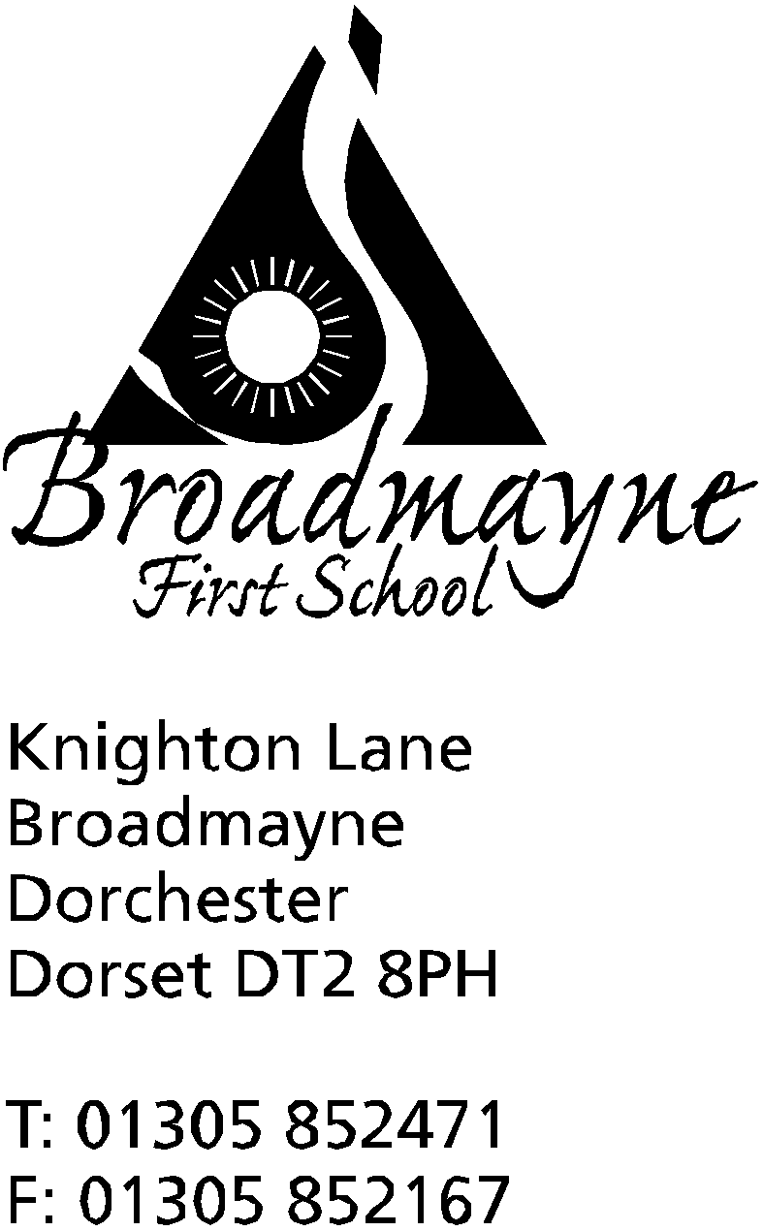

In Dorset

Headteacher
Helen Collings
Tuesday 9th June 2020

Dear Parents and Carers,

It seems that every time I sit down to write to you all, a new set of guidance is released by the government and I have to change everything I’ve written! This morning the BBC have reported that the government are now scrapping their original proposal to bring back all primary children before the end of term. Please see below for more information about this.

Road Closure
The first part of Knighton Lane is due to be closed from 9am - 4pm on the 17th and 18th June, which is next Wednesday and Thursday. If you are coming to school, you will not be able to access us from Broadmayne Cross. Please refer to the attachment to this email.
Instead, we are proposing that if you are coming to school for around 9am and you are concerned you might not be able to access us in time, you instead take the A35 towards Dorchester, and take the first turning on the right onto Loscombe Lane. If you follow this road all the way around, it brings you out near the church at West Knighton, and if you turn sharp right here, it will bring you to the school. Loscombe Lane is very narrow, and there is likely to be more traffic than usual using it, so I would urge caution if you take this route. I also once got a puncture along this lane, so please be careful!

New Kingdoms
Due to steadily increasing numbers of pupils coming back to school, our kingdoms now need to strike out and discover new lands! From Monday 15th June, we need to increase our ‘bubbles’ from two to four. This will involve splitting each bubble into two. The four bubbles will be as follows:

North - YR and Y1 children
Entry and pick up through YR playground and door- please use the one way system through the car park.
Drop off slot - between 9 and 9.15 am
Pick up - between 2.45 and 3pm
Staff - Mrs Bostock, Miss Pugh, Mrs Cornell

East - Y1 children
Entry and pick up through Y1 fire door (around back of school and in the Secret Garden, where the pizza oven is) - please use the one way system through the pedestrian gate and back out through the main playground gate.
Drop off slot - between 8.45 and 9am
Pick up - between 3 and 3.15 pm
Staff - Mrs Bassindale, Mrs Stoker, Ms Smith

South - Y3 and 4 children
Entry and pick up through Y4 fire door -please use the one way system through the pedestrian gate and back out through the main playground gate.
Key Worker children only so times between 8.30am and 4pm
Staff - Ms Carter-Grogan, Ms Watson, Mrs Pullen

West - Year 2 and 3 children
Entry and pick up through the Y3 door onto the playground (from the new library/old ICT suite area) - please use the one way system through the pedestrian gate and back out through the main playground gate.
Key Worker children only so times between 8.30am and 4pm
Staff - Mrs Norman, Mrs Howells, Mr Gibbons, Mrs Chant

If your child is in YR or Y1 but is a key worker child, your times remain the same as previously, from 8.30 - 4pm. We will text each parent by this Thursday whose child will be attending as from next week (15th) to let them know which kingdom their child will be part of.

I hope this all makes sense! It has been incredibly difficult to manage this, and in the event of staff illness it may be that we cannot open a bubble, but I have tried to allow for this whilst organising the staffing. Moving to four bubbles means we now have extra space available for our pupils, and indeed on certain days there are very few children in some of the groups, but if numbers rise we will not be able to extend further. This means that once we are at 15 in each bubble, we will not be able to take any more children. Our key worker children will take precedence for places. If you would like your YR, Y1 or key worker child to return to school, we ask for a week’s notice - it might not be that you will have to wait a week, but we ask this in case we need to rearrange staffing. Please email either headteacher@broadmayne.dorset.sch.uk or office@broadmayne.dorset.sch.uk in the first instance - we are always happy to ring you and have a chat before you make a decision.

Home Learning
The move to four bubbles will have an impact on home learning. Our staff are now in school for much longer hours, whilst still trying to juggle their own families. We will continue to work to provide as much support at home as possible, and staff are working hard to create a curriculum for home that mirrors what is happening within school. We ask for your understanding and support if at times we are a little later in contacting you or responding to requests. As we move through the term we will keep home learning under review.

Other Year Groups
Currently the school has no plans for bringing in other year groups, as we do not have the space or staff to support them whilst following government guidelines. However, we recognise the importance of transition for our oldest year group, Year 4. We are looking at ways in which we can support this, and I will be writing to you again this week in order to share some ideas we have had with you all. We are also putting ideas in place to support our new Reception children’s transition into school.

I would like to end this letter by taking a moment to say thank you to the staff in our school - whether teaching, support or office staff. Throughout what has, many times, been a very difficult and challenging period, they have remained a wonderful team, fully committed to doing the very best for our families and children. Despite their disappointments at having to cancel events they have spent a long time organising, such as the Year 4 play, they have kept upbeat and positive in their approach, whilst also trying to balance the needs of their own families and loved ones. I cannot thank them enough for their support during this time, and our school would not be the place it is without them.

I hope you all understand how hard we are all working to try and take government guidance and announcements and turn them into something that works for our school and families. We know that things continue to be difficult for many of us, and we are always here to help, even if it’s just a sympathetic ear to listen. Any worries or questions, please do not hesitate to contact us, and we will always be happy to have a chat. I hope you are all keeping well, and are looking after each other - and remember, if nothing else, keep reading!

Yours faithfully,

Mrs Collings

