BFS - Year 1 Maths Measures Knowledge Organiser - All year

Length - Autumn term | Weight ( mass) - Summer term | Capacity - Summer Term
Vocabulary for measuring the length, height and width of objects.  Short / long  Short, shorter, shortest  Long, longer, longest  Tall, taller, tallest  Narrow, narrower, narrowest  Wide, wider, widest | Vocabulary for measuring the weight of various objects.  Heavy / light  Heavy, heavier, heaviest  Light, lighter, lightest | Vocabulary for measuring how much a container can hold.  Full / empty  Nearly full / half full  Nearly empty / half empty
Comparing the height, length and width of various objects.  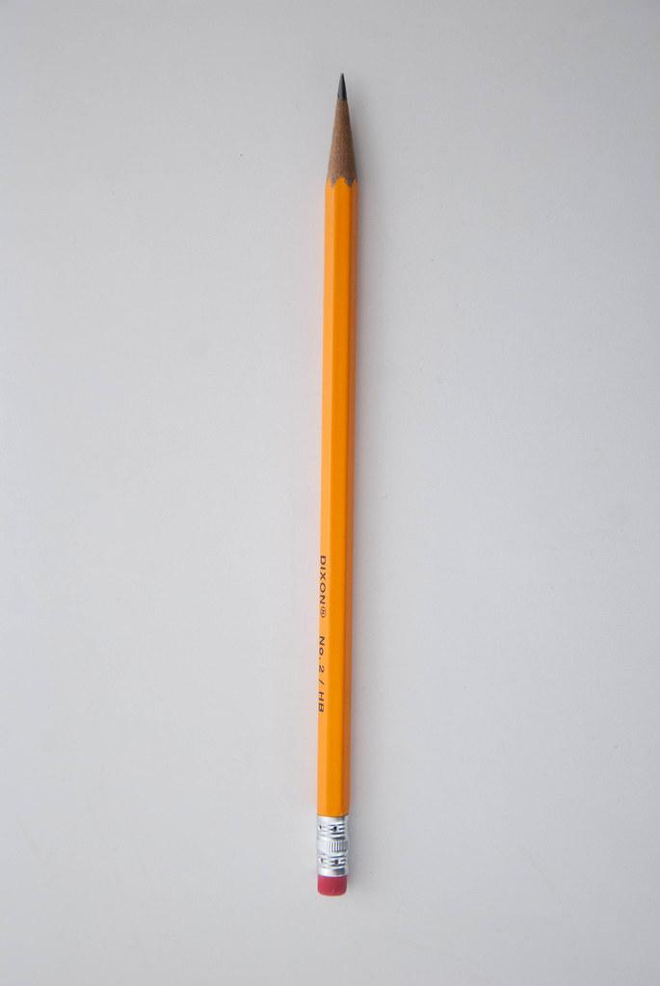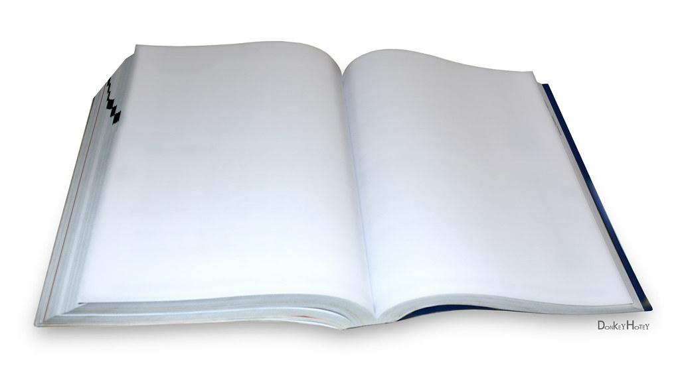 | Comparing the weight of various objects.  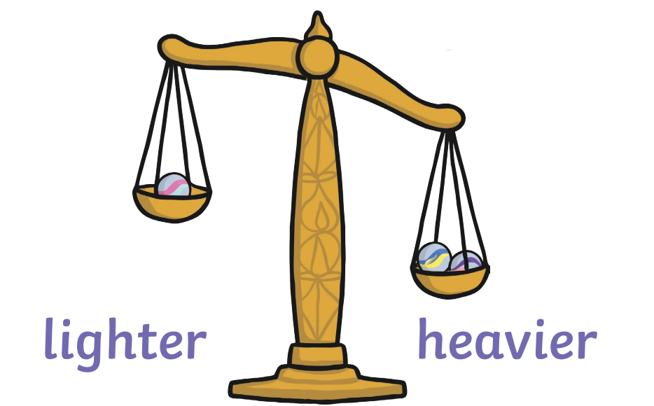 | Comparing how much a container holds. 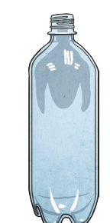 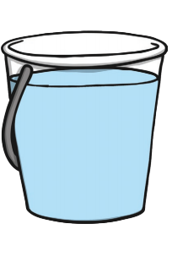
Measuring using non- standard units.  The pencil is __________ cubes long. | Measuring using non-standard units.  The books weigh the same as _________cubes. | Measuring using non-standard units.  The bowl holds __________ cups of water.  