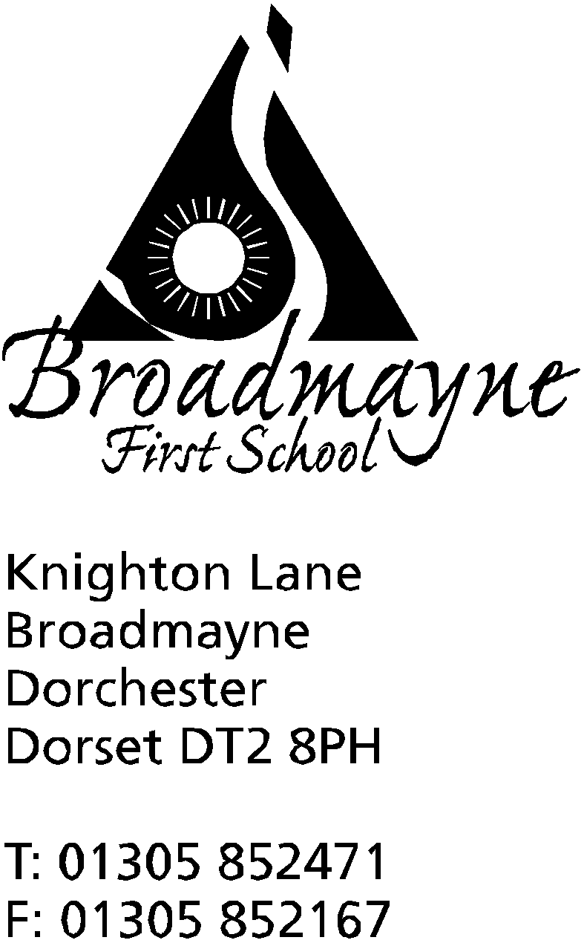

In Dorset

Headteacher
Helen Collings

Wednesday 9th October 2019

Autumn 2019: Newsletter No. 4

Things to remember!
- non school uniform this Friday 11th October - please bring a bottle for the FABS Bottle Bingo!
- parent consultations Monday 14th and Tuesday 15th
- The Reception Class photograph will be published in the Echo on Tuesday 15th October
- Y2, 3 and 4 - have you returned recent permission slips for trips?

Dear Parents and Carers,

There are so many things happening in and around school that I find myself writing another newsletter close on the heels of the previous one! You may have noticed that the area on the field where we previously had our activity area has changed recently. The old equipment has been removed - many thanks to Rosie and Simon Crumbleholme, and Jamie Wilson for their help with this - and the new equipment has just been delivered. This is the first stage in our revamp of this area, and once further funding is received we will add extra items.

Read with a Friend or Relative
We were really pleased to welcome so many parents, carers, grandparents and friends of our children to school this morning for one of our regular Read with a Friend or Relative sessions. The children loved seeing you all, and everyone had the opportunity to start the morning enjoying a book or two. You can find lots of photos of this event on the school website, and we look forward to holding another session next half term.

Harvest Festival
Please remember we are happy to accept donations for our Harvest Festival collection for the Dorchester Food Bank from Monday 14th October. The list of items particularly needed is in the previous newsletter, but all in-date food and toiletries are gratefully received.

The Book Bus
By now you will have received flyers about our visit from the Book Bus on Tuesday 15th October. The bus will be parked in the school playground, and will be available for parents and children to visit in the morning before school and after school until around 4pm.
Each class will have a chance to visit the Book Bus throughout the day. If you would like your child to have the opportunity to purchase a book please send them into school on the day with their money in a sealed envelope with their name, their year group and the amount written on the front. If you would like your child to specifically buy a reading book, please also write that on the front of the envelope. Books can be bought from around £4 - £5 upwards.

Defibrillator Update
Many thanks to the parents in Year 1 who have so generously been providing cakes for our weekly fundraising sales, and to Mrs Bevis and the children of Year 1 who have made delicious cookies each week. Thanks to everyone’s hard work, and our families’ generosity, we currently have just over £830 raised towards the defibrillator. We have calculated we need £1,200 to pay for the defibrillator, the unit it needs to be kept in, and whole school training - we are planning to organise training for the school (including the children) very soon.
Mrs Bassindale asks if there are any parents who are electricians who could advise us on the fitting of the unit she would be very grateful!
School Car Park
Please could parents not use the school car park when dropping off or picking up their children. The car park is not designed for anything other than staff cars and other authorised vehicles who we have risk assessed for - it is not safe for any other users.
Picking Up at the End of the School Day
The school understands that there are times when parents have an unexpected difficulty which means they are unable to pick their child up at the end of the day at 3.15 pm exactly. At these times we are happy to hold on to your child for a few minutes until an authorised adult can collect them. However, we cannot provide after-school child care for longer than this. If you know you are going to be late to collect your child, please arrange for another trusted adult to collect them, and please let the school office know in time. If there is no one to collect a child at the end of the day, please arrange for your child to attend the after-school club.
Splash Lottery
The FABS run a Splash Lottery to raise funds for the swimming pool. You can join for as little as £1 a week by going to https://www.yourschoollottery.co.uk/lottery/school/broadmayne-first-school or typing ‘Broadmayne’ into the www.yourschoollottery.co.uk website.
For £1 you get entered into TWO draws; one for Local Supporters with a guaranteed winner every week and a second entry into the jackpot draw where you could win an amazing £25,000.
Sign up by the 2nd November and you will also be entered into a prize draw to win one of three extra £100 prizes! 40% of all monies come directly to the school and will help fund some of the much needed refurbishment for the pool ahead of the summer term.
Broadmayne Players
The Broadmayne Players are looking for children to join their next panto, Little Bo-Peep, which will be performed in the village hall next year. They are looking for dancers, villagers and, of course, sheep!
If your child is interested in getting involved with what is always a popular community event, please contact Luke at getinvolvedbroadmayne@outlook.com
Teacher Training Information Evening

A drop-in information evening for those interested in training to teach in Dorset.
Are you thinking about kick-starting an exciting new career in teaching? If so, our drop in evening is a great way to find out about teacher training opportunities in Dorset for both primary and secondary School Direct routes into teaching. You can find out about the training offered by 2 teaching alliances in Dorset - the Teaching Alliance of Dorset Special Schools and Dorset Teaching School Alliance. Both alliances have a good track record of success in teacher training.
You will be able to:
· discuss the different teacher training options available, to help you decide which would best suit you
· meet representatives from our alliances that deliver teacher training in this area, and find out about our courses and entry requirements
· receive advice on submitting a successful UCAS application
Date: 17 October 2019, 4:30pm - 6:30pm
Location: Thomas Hardye School, Queens Avenue, Dorchester, South West, DT1 2ET

Yours faithfully,

Mrs Collings

Date | Time | Event
OCTOBER
Wed 18th | 7pm | FABS AGM in the school hall - Everyone welcome
Fri 11th |  | Non school uniform -bringa donation for the Bottle Bingo.
Mon 14th  Tues 15th | 3.30 - 5.30pm | Parents Evenings
Tues 15th | all day | Book Bus in school
Mon 21st | all day | Year 4 trip to Nothe Fort
Fri 18th | 9.15am | Harvest festival (in school)
Fri 25th | AM | Individual Photos  Whole school and Pre-School Pizza Day  FABS Bottle Bingo 6-8pm  Break up for half term
Mon 28th-Fri 1st Nov | HALF TERM | Monday 28th October - Ogg ‘n’ Ugg ‘n’ Dogg- play in village hall at 3pm-tickets available from the school office.
NOVEMBER
Mon 4th | All Day | INSET
Tues 5th |  | Children return to school
Mon 4th - Fri 8th |  | Safe and Healthy Me Week
Thursday 7th | 8.45 am | School nurse drop in
Mon 11th-Fri 15th |  | Remembrance Week
Thurs 14th |  | Y2 trip to Safewise  Y3 trip to Bovington Tank Museum
Fri 15th |  | Children in Need Day - more details to follow from the School Council
Mon 18th | 2.30pm | Family photos
Tuesday 26th |  | Optional flu inoculations
DECEMBER
Mon 16th | 2pm | Christmas play
Tues 17th | 9.30 am  5.00 pm | Christmas play  “ “
Weds 18th |  | Year 1 trip to the Shire Hall
Fri 20th |  | Last day of term; Christmas party lunch- school finishes at 2.30 pm
Mon 6th Jan 2020 |  | Back to school - First day of Spring Term

