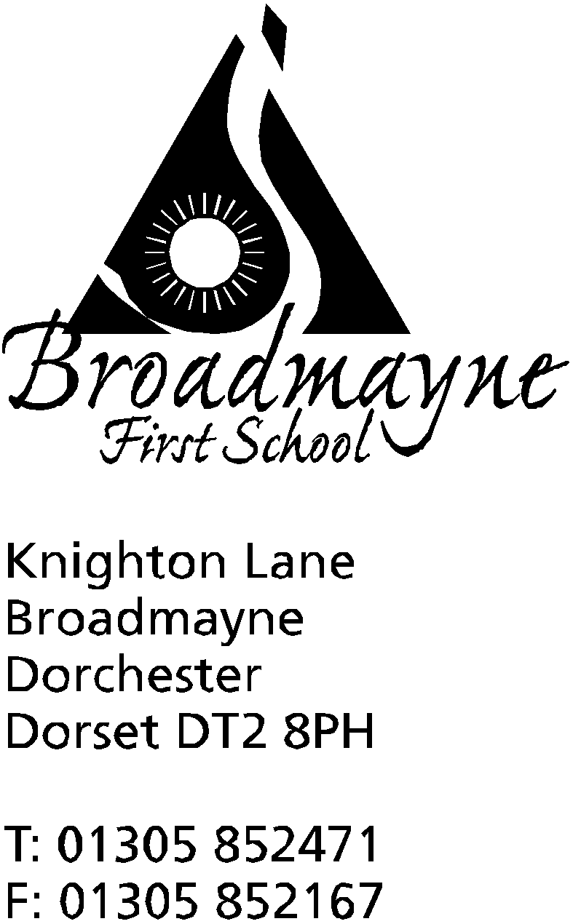

In Dorset

Headteacher
Helen Collings

6th September 2019
Autumn 2019: Newsletter No. 1

Dear Parents and Carers,

A warm welcome to the new academic year. It has been lovely to see the children coming into school eager to share their news of different things that have happened over the holidays, and to admire new haircuts and uniform! The staff at Broadmayne are looking forward to working with their new classes, and we are all very pleased to welcome our new children and parents to the school. We are expecting some exciting developments within the school this year, some of which are outlined below.

Training
The school is currently taking part in attachment training, and all staff (including lunch staff and several Governors) have taken part in training looking at how as a school we can develop our practice when working with vulnerable children. We are also about to embark on further developing our maths teaching with the Jurassic Coast Maths Hub, and we are working with the Centre for Literacy in Primary Education to plan English lessons linked to quality children’s books. We are also looking at our wider curriculum, and you will see some developments linked to this later this term.
Class and Curriculum Information
Teachers will be sending out letters over the next week to inform you of some of the things that will be happening within your child’s class this term. We would also like to invite you to a Curriculum Meeting for your child’s class. Staff will use this time to provide you with an overview of the year’s curriculum and any special information for the class. The dates for these are on the attached calendar. Please don’t worry if you cannot attend these meetings as all information will be sent out as necessary.
Changes for the coming year
You will notice that there will be changes in the coming year to some of our procedures and routines. One of these is that the long written reports will be sent out at Easter instead of the end of the Summer Term. This is to ensure that any targets within the reports can be worked on in the following term; you will be invited to a parents evening in the Summer Term to discuss your child’s progress before they move on to their new class in September. After very positive parental feedback we will be continuing with the short Snapshots each half term - these however will now report on attendance and once a term will include information about your child’s progress.
Another change is to our traditional Christmas play. We will still have a nativity, but this year it will be lead by the Year 1 children, with support from the other year groups. We will be performing our nativity in school rather than the village hall. We will then have a summer production lead by Year 4 in the village hall at the end of the summer term. More details will follow nearer the time, but Year 1 parents please don’t worry about costumes, as Mrs Bassindale senior is busy creating them for us!
Play Area
With the help of a grant from the WPA Benevolent Foundation we are planning to replace our adventure play area with new equipment. We are hoping to start the project in October, when the old equipment will be removed and a clamber stack will be installed. The next part of the project will be to add a traverse wall. We are all very excited about this, and hope it will give the children in our school new ways to play and be active.
Year 1 Cloakroom
You may have noticed that over the Summer holidays we have had a small extension built on to the Year 1 classroom. This is a cloakroom for the children to use - we are so pleased that they no longer need to keep their things in the hall! The building work was something of a last minute thing, as we received funding towards it right at the end of term which enabled us to go ahead with the work. The flooring has to dry before carpet can be laid - we are expecting this to happen over the October half term.
Parking
This academic year we are asking all parents and carers to be mindful of where they park when dropping children off or picking them up. We want to keep our good relationships with our neighbours, and as part of this we are asking all parents to ensure they park carefully when coming to school. Please do not block access to driveways, and please be especially careful that you do not make the exit and entrance to nearby roads dangerous, in particular Oakwood and Spring Gardens.
Nut Allergies
We will continue to be a ‘nut-free’ school and ask that lunchboxes do not include any products containing nuts. Thank you so much for your co-operation with this; our priority is always the safety of our children.
Music Lessons
Music lessons will continue this term. The starting dates are as follows: Mrs McCourtie (piano) and Mr Rushbrook (guitars and ukelele) will begin on Monday 16th September. Mrs Hubble (keyboard|) will begin on Tuesday 17th September, and Mr Fisher (violins) and Mr Page (drums) will begin lessons on Thursday 19th September. Mrs Hubble has a few spaces available for keyboard lessons for children in Year 2 and up; if you are interested please contact the school office or Mrs Hubble directly.
Clubs
Information about clubs this term will be sent out in a separate letter.

We look forward to a busy and exciting new academic year!

Yours faithfully,

Mrs Collings

Please find diary dates below; we will inform you of further dates as we receive them.

Date | Time | Event
SEPTEMBER
Thursday 12th | 8.45pm | School nurse drop in
Mon 16th | 2.45 pm | Y2 Parents Curriculum Meeting
Tues 17th | 9 am  2.45pm | YR Parents Curriculum Meeting  Y4 Parents Curriculum Meeting
Thurs 19th | 2.45pm | Y1 Parents Curriculum Meeting
Fri 20th | 2.45pm | Y3 Parents Curriculum Meeting
Sat 21st |  | Art Exhibition Broadmayne Village Hall
OCTOBER
Weds 9th | 9am | Read with a Friend or Relative
Mon 14th  Tues 15th | 3.30 - 5.30 | Parents Evenings
Tues 15th | all day | Book Bus in school
Fri 18th | 9.15am | Harvest festival (in school)
Fri 25th | AM | Individual Photos  Whole school and Pre-School Pizza Day  Break up for half term
Mon 28th-Fri 1st Nov | HALF TERM
NOVEMBER
Mon 4th | All Day | INSET
Mon 4th - Fri 8th |  | Safe and Healthy Me Week
Thursday 7th | 8.45 am | School nurse drop in
Mon 11th-Fri 15th |  | Remembrance Week
Mon 18th | 2.30pm | Family photos
Tuesday 26th |  | Optional flu innoculations
DECEMBER
Mon 16th | Christmas play | 2pm
Tues 17th | Christmas play  “ | 9.30 am  5.00 pm
Fri 20th |  | Last day of term; Christmas party lunch
Mon 6th Jan 2020 |  | Back to school - First day of Spring Term

