Safe and Healthy Me Week 2019
The first week back after October half term will be our first Special Theme Week of the year (Tues 5 Nov - Fri 8 Nov). During this week, we will be “off timetable” but will be delivering lessons around the theme of Safe and Healthy Me.
We have lots of exciting things planned….

The aim of the week is to raise awareness of all the ways children can keep themselves safe and healthy. We will be having visits from some key organisations to share what they do and teach some important life skills.
We will also be teaching age appropriate information around sleep, mental health, eating and nutrition, safety in the home, staying safe when out and about, making a 999 call and bike/scooter safety.

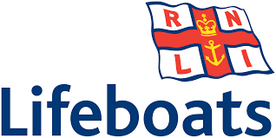  Amy from the RNLI will be coming in on Tues 5 Nov to deliver a whole school assembly on the important work of the RNLI.  Living near the sea, water safety is an essential life skill for our children.  We will also find out the other roles the RNLI do in the community and abroad. | 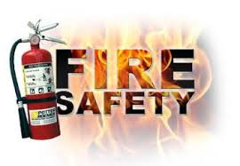  Reception and Year 2 will be meeting the Fire Safety Team to find out about the ways in which they can keep themselves safe, and what to do in an emergency. The children will also have the opportunity to find out more about the work undertaken by the fire service.  Other classes will also be considering fire safety as part of their learning. | 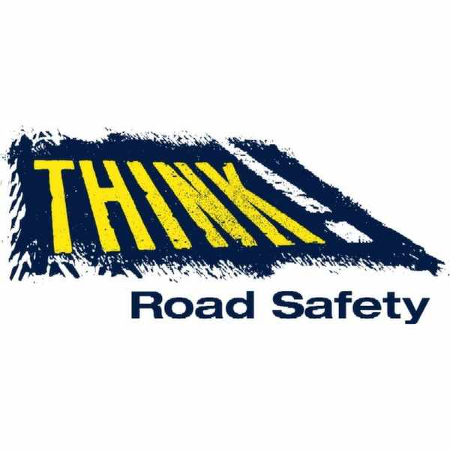All children will be meeting the Road Safety team on Fri 8 Nov. Each Key Stage will have a session, focusing on road safety skills and the ways in which we can all be safe road users.  We are hoping to share resources from the Wessex FM campaign “Be Bright Be Seen” during this week. Watch out for the visibility stickers coming home soon! | 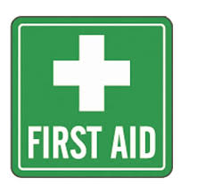  As part of our “Defibrillator” campaign, we will be giving all children in the school basic First Aid training. This is an amazing opportunity and a life skill that could potentially save a life in the future.  Over the coming year, we will also be visited by Chesil First Aid who will be “officially” training all children

HEALTHY EATING! Our hot meal service, Local Food Links, provides our children with a range of homemade nutritious lunches. These are available to all Rec and Key Stage 1 children for FREE! If you haven’t signed up yet, why not try a meal during this week? Contact the school office for further info. If your child brings a packed lunch, we will also be exploring healthy options that provide good nutrition and keep energy levels going for the afternoons!
DID YOU KNOW? - By the time you realise you are thirsty (dehydrated), your brain has already lost 20% of its thinking capacity! Have you had enough to drink today?

E-Safety in the modern world is extremely important. We cannot get away from the fact that our children are growing up in a technology era. We teach E-Safety throughout the year but will be placing special emphasis on this during Safe and Healthy Me week. |  | 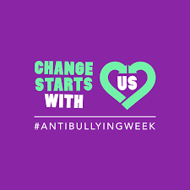  National Anti Bullying Week 2019 takes place the following week but we will start introducing the national theme of “Change Starts With Us”. Broadmayne School takes preventing bullying very seriously and we want to make sure the whole school community understands the parts we can all play in making a positive change and keeping us all safe. |  | 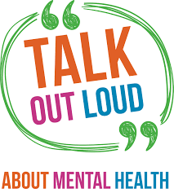  We will be focusing on the importance of good mental health as well as good physical health.  We will be looking at the brain science behind mental wellbeing and the importance of talking to others when you feel something is wrong.

All Rec and KS1 children will be receiving a FREE Bright Smiles, Bright Future kit supplied by Colgate. All classes will learn about the importance of dental hygiene and how to look after our teeth so that we can be happy and smiley! |  | We are hoping to have a visit from a local PCSO to explain the role that they play in our community and answer some of the children’s questions about the Police Service.

This year, Broadmayne School is working towards “Attachment Friendly Schools” status. We will be offering a parent information session on supporting positive mental health in children on Wed 6th Nov @ 2.15pm and again on Thurs 7 Nov at 6pm. We hope that lots of parents will be able to attend! The 1 hour session will cover a basic overview of how the brain and emotion are linked, identifying and responding to emotions in young children, positive tips on managing emotions at home and techniques for building strong, lasting connections from the start. (In association with calmfamily.org)
Final Thought…
Although we are focusing on safe and healthy practice during this special school week, Broadmayne School make an ongoing commitment to teaching this content over the entire academic year. We are always willing to engage with parents and members of the community to support the children in developing their safety knowledge so if you can help in anyway, or have contacts with safety organisations in the community, please let us know!

If you have concerns about a child’s safety or wellbeing, please contact our Designated Safeguarding Lead Helen Collings or Deputy DSL Natasha Bostock on 01305852471.

