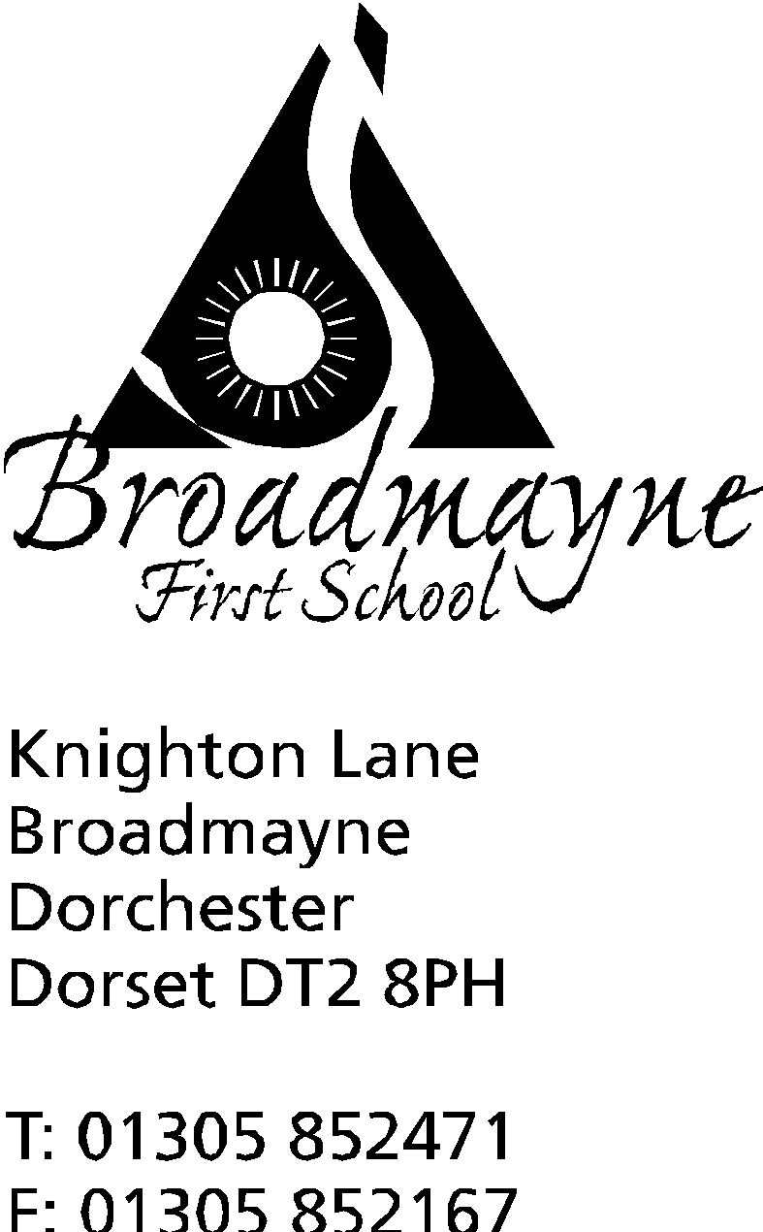

In Dorset

Monday 9th September

Dear Parents,

What an exciting time we have ahead of us in Year 4! Lots of things on the horizon as we begin the children’s final year at Broadmayne

This letter is to let you know about some of the things that are happening during the Autumn term in Oak Class.

Reading Books
By Year 4, the children are expected to take more responsibility for changing their individual reading book.Children are welcome to change their books as frequently as they need to and adults will help them as required. Reading books, and the Yellow Reading Record, should be brought to school EVERYDAY even if they are not being changed. Reading books do not have to be school books but should be appropriate to the level of the child. We will also be having guided reading sessions every week and these will be recorded in the Yellow Reading Record. Even if you child is a “free reader”, it is vital that they are reading regularly, and discussing this with an adult, as this underpins so many classroom skills. 5 to 10 minutes a day is often more effective than 30mins once a week!

PE
PE will take place on a Friday with Trevor Senior who will be running Rugby sessions. The children will also continue to take part in Action Van on a Wednesday as well as other sporting events over the term. Therefore, PE kits need to stay in school all the time. For safety reasons hair needs to be worn back out of their eyes and jewellery removed (including earrings), in line with school policy. As PE will be taught outside, children will need some trainers or plimsolls for this. As the weather gets colder a tracksuit or hoodie/ joggers may also be useful.

Topic work (Humanities)
Mr Oxlee teaches our topic work on a Friday. We are proposing the following topics for Year 4 over the year:
World War 2 - What was it like to be a child in WW2? | Anglo Saxons - Why did the Anglo Saxons settle in Britain? | Dorset and the Jurassic Coast - Why is the Jurassic Coast a UNESCO World Heritage Site?
A separate curriculum overview for the term will be sent home shortly.

Autumn Term Home Learning
Our new home learning policy was shared with you before the Summer holidays. As stated, the children will continue to receive a weekly SPAG homework and are being given the option to complete a longer project that links to their topic work (see below). In addition, times tables are the key to most mathematical learning and these should be practised frequently. All children will be given a TTRS log in that will be stuck in front of their home learning book. We always love to hear that children have been inspired by their learning. We have a home learning wall in the classroom that children can use to bring in and show any work they have completed independently. This could include posters, written work, visits to places linked to the topic, or research or experiments they have done in their own time.

WW2 Project
The WW2 project for this term could be a more in-depth look at something we are covering within school time that has captured the interest of your child, or could be something that we have not had time to cover in lessons. The project can be presented as either:
- A written project (typed or handwritten)
- A piece of art work (painting, drawing/sketches, comic)
- A 3D model
- A Powerpoint
- An information poster (A3 or larger)
Previous topics for projects have included Women in the War, Rationing, Aircraft in WW2, The use of horses in the war, Tanks, Dig for Victory and other campaigns, RAF Warmwell (local history link), My family in the War, Nurses and Medics, Air Raid Shelters, Local landmarks that were significant in WW2….the choice is yours! We look forward to receiving projects in school week commencing Monday 14th October 2019 and all projects will be displayed in an after school gallery for parents to view the following week. Any question, please ask the Year 4 staff.

Please refer to the Autumn Curriculum statement for further information on our learning objectives and themes for the coming term.
Water bottles and pencil cases: We encourage the children to bring in a water bottle for use during the day. If this is not possible, the school will provide cups that the children can access freely in the classroom. Year 4 are welcome to bring in a pencil case with basic equipment, although school will provide all necessary materials. Handwriting pens must be BLUE ink and not a gel pen or biro. Felt tip pens and highlighters are not required.

Show and Tell / Toys:
We do not have a designated show and tell time in Year 4 but always welcome interesting items linked to our topic or achievements out of school (such as gymnastics awards, music certificates, competition wins). Please remind your children that toys, however small, are not permitted in Year 4, unless pre arranged with the class teacher. However, children are welcome to bring in a football or basketball for use at playtimes, but do so at their own risk.

PLEASE NOTE:
THE YEAR 4 CURRICULUM MEETING WILL TAKE PLACE ON TUESDAY 17TH SEPTEMBER AT 2:45PM.

Yours sincerely,

Miss Carter-Grogan and Mr Oxlee

