BFS Art Knowledge Organiser Autumn 1
Printing  Printing is using objects or shapes to transfer paint and create patterns.  A pattern can be lines or shapes that are repeated in a sequence. They are uniform in size and colour.  -Choosing 2 or 3 shapes to be the core of the repeating pattern.  -Using paint to print.  -Ensure there is not too much paint on the sponge.  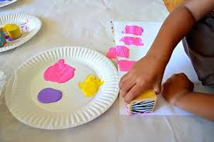  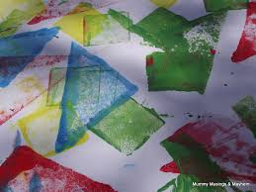  Overlaying one shape on top of another. | Colour mixing  There are 3 primary colours that cannot be mixed from other colours.  Primary colours - red, yellow, blue  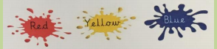  One of these primary colours and be mixed with another to make a secondary colour.  Secondary colours - orange, green, purple.  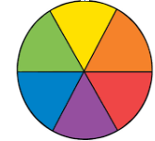
Rubbing  Using crayons to make rubbings of natural objects to study patterns in nature.  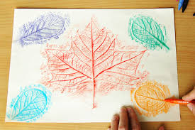 | Shades and tints  Shades of a colour can be made by adding white or black a small amount at a time to a primary or secondary colour.  White - colour becomes lighter  Black - colour becomes darker
Vocabulary
colour
print
rubbing
shade
tint
primary colour
secondary colour

