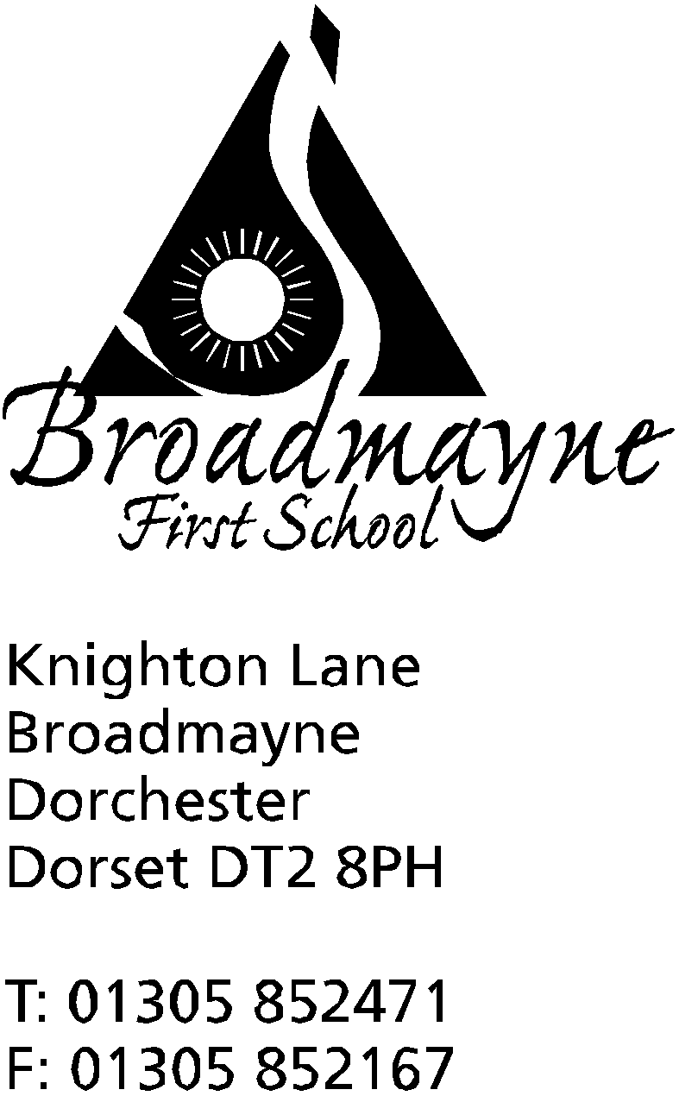

In Dorset

Headteacher
Helen Collings
Thursday 7th November 2019

Autumn 2019: Newsletter No. 6

Things to remember!
- School trips - have you returned permission slips/paid via School Money?

Dear Parents and Carers,
I hope everyone had a happy and relaxing half term. As we return to school the weather is finally becoming colder - please ensure children have a warm, clearly labelled coat at playtimes, and something warm to wear if they are likely to be outside for PE.

Poppies and Remembrance Week
The school will be running Remembrance related activities over the week beginning the 11th November. On Monday 11th November we will be observing the 2-minute silence together in respect for those who have lost their lives or suffered as a result of war. Following this we will go to post our messages of peace into the Peace Pole, which was donated to us by one of our families. Year 3 will be visiting the war memorial in Broadmayne village. Poppies and bands etc. are on sale in the school office.
Children in Need
Broadmayne School Council will be holding a Countryside Ramble on Monday 18th November to support Children in Need this year. Our plan (weather permitting) is for children to arrive at school at the usual time, with wellies and warm coats ready for a walk to the Wash Ponds and back again, leaving school once we are all registered. Parents and carers are warmly invited to come along too, although if you have very young children the path is difficult for pushchairs to navigate. We are inviting families to make a donation to Children in Need on the day. Children are welcome to wear Pudsey ears etc on Friday 15th, and again on the Monday, although we will be making ears for all the children to wear on their ramble. We hope you will be able to join us for what should be a lovely way to start our week, whilst also helping such a worthwhile cause.
FABS Christmas Fair
A letter should have reached you by now informing you of the Christmas Fair which this year will be held on Friday 29th November. There are tables available to hire, and FABS are asking for volunteers to give up a small amount of time to help out on the evening - details in the letter or from the school office.
School Photos
The school photographer will be visiting us on Monday 18th November to take family photos from 2.30 pm. If you would like a family photo (an ideal present!) please use the form at the end of the newsletter to book.
Middle School Open Days
St Osmunds will be holding an open day for parents of Year 4 children on Tuesday 12th November at 8.50 am and again at 5 pm on the same day. Dorchester Middle School will be open to visit on Tuesday 19th November from 9.15 am - 11 am.
Annual Flu Immunisation
There have been some changes to the optional flu immunisation that takes place at school each year. This year you will be able to provide consent for your child online. You will have already received information about this via email or as a paper copy - if you have not, please contact the school office.
Sports News
A huge well done to our Year 4 basketball team, who recently won the DASP First Schools’ basketball tournament. As always, a big thank you to Mr Gibbons for all his work with our children developing their love of sport - another trophy for the shelf!

Yours faithfully,

Mrs Collings

Date | Time | Event
NOVEMBER
Mon 4th - Fri 8th |  | Safe and Healthy Me Week
Tues 5th |  | Children return to school
Weds 6th | 2.15 pm | Supporting your child’s mental health workshop
Thursday 7th | 8.45 am  6pm | School nurse drop in  Supporting your child’s mental health workshop
Mon 11th-Fri 15th |  | Remembrance Week
Thurs 14th |  | Y2 trip to Safewise  Y3 trip to Bovington Tank Museum
Fri 15th |  | Children in Need Day
Mon 18th | 9.10 am  2.30pm | Broadmayne’s Countryside Ramble for Children in Need - please come along and join us!  Family photos
Tuesday 26th |  | Optional flu inoculations
Friday 29th | 5.30pm-7.30pm | Christmas Fair
DECEMBER
Mon 16th | 2pm | Christmas play
Tues 17th | 9.30 am  5.00 pm | Christmas play  “ “
Weds 18th |  | Year 1 trip to the Shire Hall
Fri 20th |  | Last day of term; Christmas party lunch- school finishes at 2.30 pm
Mon 6th Jan 2020 |  | Back to school - First day of Spring Term

-------------------------------------------------------------------------------------------------------------------------------------------------
To: The School Office - Family Photo Request
(Please tick as appropriate)

Child’s Name: ………………………………………………………………………………..

Class:……………………………….

- I would like an appointment to have a family photo taken on Monday 18th November. (Photographer starts 2.30 pm - we will inform you as soon as possible of your time slot)

Signed:...............................................................................................

Please print name:...............................................................................

Please return slip by Wednesday 13th November.

