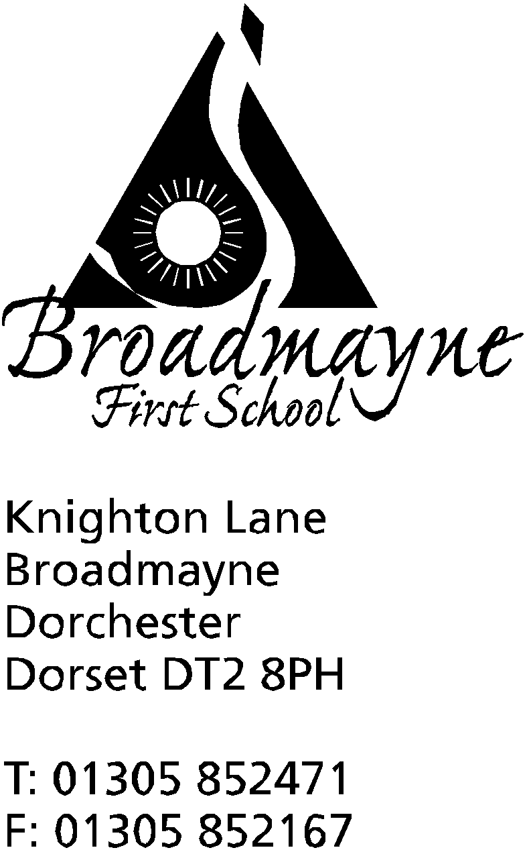

In Dorset

Headteacher
Helen Collings

5th November 2018

Autumn 2018: Newsletter No.4

Things to remember:
- Vote for our school swimming project! And encourage everyone you know to help too!
- check that school lunches are ordered

Dear Parents and Carers,

I hope everyone had a happy and relaxing half term. As we return to school the weather is finally becoming colder - please ensure children have a warm, clearly labelled coat at playtimes, and something warm to wear if they are likely to be outside for PE.

Learn Alongside Your Child
On Tuesday 6th November we will be holding one of our Learn Alongside Your Child sessions. The purpose of these sessions is for children and teachers to be able to share with you an aspect of learning from their curriculum-this term we are looking at maths. The sessions are informal and fun, and we would love to see as many people coming in as possible - it’s a great way to learn how we approach maths teaching and learning! Please meet in the hall at 9 am to give children time to settle into classes and take registers beforehand. Sessions will finish at around 10 am.

Poppies and Remembrance Week
To commemorate 100 years since the end of WW1, the school will be running different Remembrance related activities over the week. On Friday 9th November we will be observing the 2-minute silence together in respect for those who have lost their lives or suffered as a result of war. Following this we will go to post our messages of peace into the Peace Pole, which was donated to us by one of our families. Year 3 will be visiting the war memorial in Broadmayne village. Poppies and bands etc. are on sale in the school office.

Swimming Pool
You may have seen the advertising campaign that has been launched by the FABs to try and gain some funding for our swimming pool. As some of you may know, the pool was originally built through parental help in the seventies, and has been well used since then by many Broadmayne children. We want to ensure future generations of children can use this wonderful resource, but as you can imagine, after all this time the pool needs quite a lot of work. Thanks to the hard work of Jude Baker, one of our FABs, we are through to the voting round of the Aviva Community Fund, which gives us the chance of being awarded £25,000 - this would go a long way to solving our problems! Please vote for us at https://community-fund.aviva.co.uk/voting/project/view/4-2061
And encourage everyone you know to vote too!

Tag Rugby
A huge well done to our tag rugby team, who won the DASP First School’s tournament just before half term. A big thank you to Mr Gibbons for all his hard work in ensuring our children have the skills needed to do so well in sport.

DASP Music
Would you like your child to learn an instrument or take part in musical activities? Have a look what DASP Music could offer you....
Colourstrings (general musicianship class for KS1 children) Weds 3.45 – 4.30 pm @ Damers First School, £40 per term
Beginner Uke Troupe (for complete beginner players – no previous experience needed) Weds 4-4.30pm or 5-5.30pm @ Thomas Hardye School, £30 per term
Training Windband (for those already learning a wind/brass instrument who would like to play with others, from beginners to approx grade 2). Weds 4-5pm @ Thomas Hardye School, £30 per term
Stringalings (for those already learning an orchestral string instrument who would like to play with others, from beginners to approx grade 2). Weds 4-5pm @ Thomas Hardye School, £30 per term
Skylarks Choir Thurs 3.45 – 4.30pm @ Damers First School, £30 per term
In addition, did you know that your child can take individual and small group lessons on piano, recorder, flute, clarinet, trumpet, violin, cello, piano, guitar and ukulele at school, through DASP Music? Group lessons available from £4 per lesson.
Please contact www.daspmusic.co.uk to find out how to sign your child up.
Anti-bullying week – 12th November
The theme for Anti-bullying week this year is ‘Choose Respect’, a really important theme for us as it reflects one of school values. The children will be taking part in different activities across the week to highlight and promote respect, friendship, and the importance of thinking of others.

Christmas cards
Children have been bringing home information about how to order Christmas cards. The children need to design the cards at home, then attach the designs to the sheet provided. If you would then like to have the design made into a card or gift cards, you can order online and send the sheet into school and we will send it to the printing company.

Books needed for reading shed
A huge thank you to everyone who donated cushions, a rug and even a bookcase for the reading shed! It looks lovely inside the shed now, apart from one thing… books! Do you have some old children’s books hanging around at home that you could donate to us? This could be your chance to clear some space before Christmas! All donations will be happily received at the office.

School Lunches
There have been several children recently who have not had hot school meals ordered for them, despite parents thinking they had. This poses a real problem for the school, as the food we have delivered is the exact amount for the children who have ordered, and we do not have anything to spare. On investigation, one of the reasons for this appears to be people forgetting to click the ‘Confirm’ button after making their selections, and there appears to be some issues if you make orders using a tablet. Local Food Links suggest that parents go back in and check orders after making them, to ensure they have been recorded. You can also sign up for notification from the company - they will then send a reminder email out about ordering, if the problem is simply a case of being a little forgetful!

School Photos
The photographer from Cardwells visited the school on Friday to take individual photos of the children. The proofs will be coming home for you to order from if you wish, but there is no obligation to buy. The photographer is returning on Monday 19th November to take family photos from 3.30pm. If you would like a family photo (an ideal present!) please use the form at the end of the newsletter to book.

Children in Need / Wellbeing morning
On Friday Nov 16th, we are taking part in the BBC Children in Need day. The School Council have already sent out a letter about this - they are inviting everyone to wear home clothes on the day - with something spotty if you can. Please bring in a donation for the charity on the day.
We will also be running a Well Being morning on that day, as this is a focus for the school this year. We would love for you to come and join us for the morning to take part in some fun activities with the children in their classes. We will start with a brief introduction in the hall, followed by time in classes, before rounding off with an assembly.

Cool Kids
There will not be any Cool Kids After School Club on the last Thursday before we break up for Christmas. The last session will therefore be on Thursday 13^{h} December.

Breakfast Club
There will be no Breakfast Club on the morning of Tuesday 18th December due to the performance of the Christmas play at the village hall – more information will follow nearer the time.

Yours faithfully,

Mrs Collings

Date | Event | Time
NOVEMBER
Monday 5th | Remembrance week activities begin
Tuesday 6th | Learn Alongside Your Child | 9am
Mon 12th | Anti-bullying week begins
Weds 14th | Flu immunisations (optional)
Weds 15th | Read with a relative or friend | 9.05
Friday 16th | Children in Need (non- uniform day)  Wellbeing morning-all parents and carers invited | 9.00am
Monday 19th | Family Photos | From 3.30 pm
Tuesday 27th | Y3 trip to Tank Museum
Friday 30th | School Christmas Fayre | 5.30pm  -7.30 pm
DECEMBER
Fri 13th | Dress rehearsal of Christmas play- filmed
Mon 17th | Christmas play in school hall | 1.45pm
Tues 18th | Christmas play in Broadmayne Village hall  “ | 9.30 am  6.00 pm
Fri 21st | Last day of term; Christmas party lunch
Monday 7th Jan 2019 | First day of Spring Term

To: The School Office - Family Photo Request
(Please tick as appropriate)

Child’s Name: ………………………………………………………………………………..

Class:……………………………….

- I would like an appointment to have a family photo taken on Monday 19th November. (Photographer starts mid afternoon- we will inform you as soon as possible of your time slot)

- I would like a photo taken with brother/sister in another class on Monday 19th November during the school day

Signed:...............................................................................................

Please print name:...............................................................................

Please return slip by Friday 9th November.

