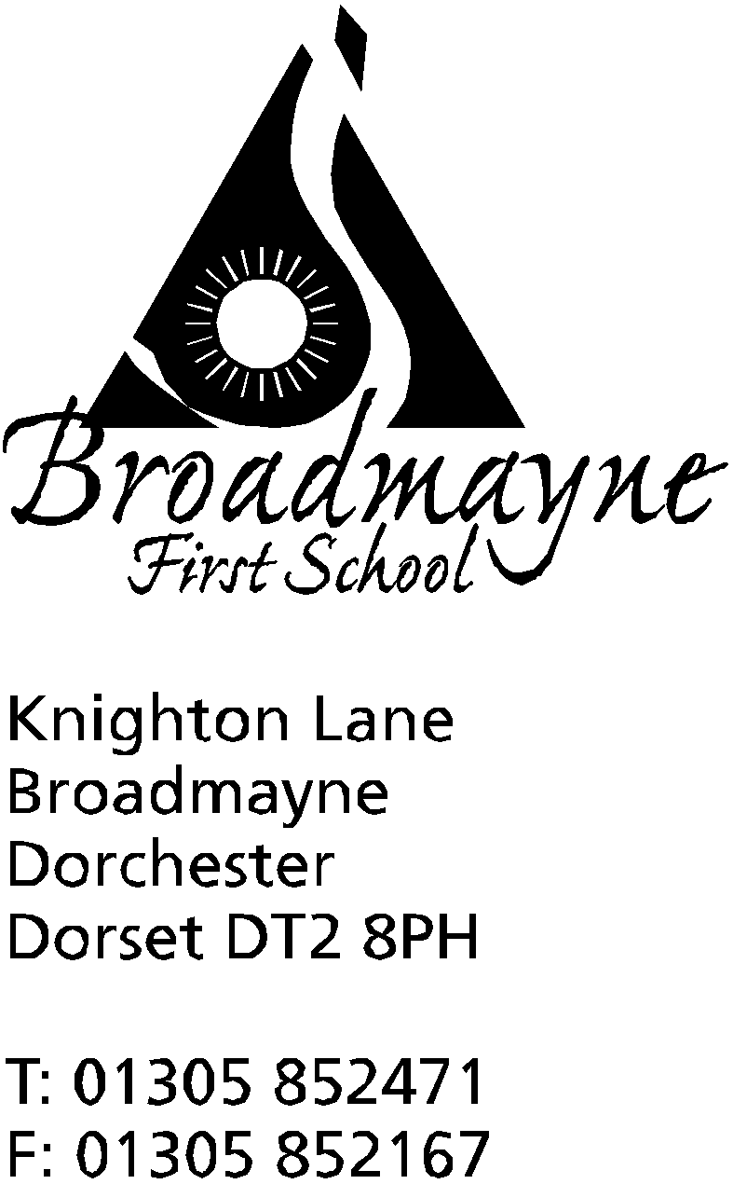

In Dorset

Headteacher
Helen Collings

Thursday 19th September 2019

Autumn 2019: Newsletter No. 2

Things to remember!
- Art Exhibition including some of our children’s work at Broadmayne Village Hall Saturday 21st September
- The Iron Man race on Sunday 22nd will mean several road closures in the area

Dear Parents and Carers,

Welcome to the second newsletter of the new academic year. We are all so pleased with how well the children have settled to the routines of their new classes, and our Reception class are making great strides in their learning already! The recent good weather has enabled us to make full use of our outdoor area, and the children have been taking part in lots of activities outside.

Whole School Phonics Lessons
This year the school has moved to whole school phonics lessons. These take place at the same time every day, and all staff and children are involved. This allows us to very carefully target our phonics teaching to the precise area your child currently needs to work on. All the children are in mixed groups for this, with each staff member targeting a different area, so it could be that your child is in Year 4 but is working with a Year 1 member of staff - this will be because that staff member has a particular focus for the half term that will benefit your child - not that they are working at a particular level. Children are regularly assessed and will move between different groups as necessary.

Family play at Broadmayne Village Hall - Ogg n Ugg n Dogg
We have great pleasure in announcing a wonderful family play that will be performing at the village during half term. Details as follows:

A long time ago there were no dogs – there were wolves, but we didn’t like them and they didn’t like us. But then along came Yorkshire hunter gatherers Ogg ’n’ Ugg to pal up with the wolves, invent our best friend, and save us all from a life of doglessness! Audiences can expect flying meat bones, sabre-toothed tigers, slug tastings, time travelling sticks, loads of scary howls and (if they’re lucky) even a chance to pat Dogg! Using Fideri Fidera’s characteristic rich mix of theatrical forms including physical comedy, clowning, puppetry, music and song, Ogg ‘n’ Ugg ‘n’ Dogg is for families and dog lovers of all ages. Touring Dorset with Artsreach, the counties touring arts charity following a sell out tour last spring with ‘Oskar’s Amazing Adventure’.
*Post show arts & crafts workshop available for ages 4+. 40min workshop, places limited. £3 each.
www.artsreach.co.uk
You can also use this link to see a trailer for the show: https://youtu.be/jmpAeGqIfq8

The performance takes place from 3pm, with the workshop beginning at 4 pm. Tickets are available from the Artsreach website www.artsreach.co.uk (with a small booking fee), or from the school office. Tickets are £6 for adults, £5 for under 18s and £20 for a family (2 adults and 2 children). The workshop is £3 per child.
The after show workshop has strictly limited numbers, so if you are interested in booking it is advisable to do so quickly.

School nurse
Karen Caines, our school nurse, comes in regularly across each term for a ‘drop in’ session. She is able to advise about various aspects of child care and has helped many of our families over the years. No appointment is needed and the dates for her visits are on the school calendar and displayed on the noticeboard in the office.

Children who are ill
As we move into the winter, it is inevitable that at times children will fall ill. Can I remind you of the procedure when this happens. School needs to be informed before 9 am on the day of any absence. If your child is likely to be away for several days, the school needs to be kept informed. Our safeguarding procedure means that we need to know the reason for any absence, and we will contact parents if necessary, as per our Attendance Policy.

Children being picked up at the end of the day
Please also remember that it is school policy not to allow children to be picked up by anyone other than their named adults unless we have been contacted beforehand. The school needs to be informed by you that a different person will be collecting your child - if it is a regular occurrence let us know and we will make a note of this. We do understand that in an emergency this might be a last minute arrangement, and we are happy to accept a phone call to inform us.

Read With A Friend or Relative
We would like to hold one of our popular reading events on Wednesday 9th October. Everyone is invited to come into school for 9 am for half an hour, to enjoy reading with the children. Whether you are a parent, grandparent, aunt, cousin - we would like as many adults to come in and spend some time enjoying books with the children as possible!

Waste Free Wednesday
As part of our continued drive towards becoming a more eco friendly school, every Wednesday will once again be ‘Waste Free Wednesday’. This means that we will try and minimise the amount of waste we produce at school during the day. As part of this, we will have a waste free lunch for staff and children. We ask that if your child has a packed lunch on a Wednesday that you include items that are not wrapped in single-use packaging, so that nothing need be thrown away, but instead can be brought home and reused. There will be no bins for rubbish in the hall on these days!

Class Assemblies
Please note the dates below for class assemblies throughout the year.
YR Tuesday 19th May
Y1 Thursday 13th February
Y2 Wednesday 1st April
Y3 Thursday 12th march
Y4 Friday 17th July

These will usually be at 9.15 am - more details will follow nearer the time.

Please find an updated list of diary dates for the term below. Thank you for all your continued support, and I look forward to a happy and productive Autumn term,

Mrs Collings

Date | Time | Event
SEPTEMBER
Thurs 19th | 2.45pm | Y1 Parents Curriculum Meeting
Fri 20th | 2.45pm | Y3 Parents Curriculum Meeting
Sat 21st |  | Art Exhibition Broadmayne Village Hall
OCTOBER
Weds 9th | 9am | Read with a Friend or Relative
Mon 14th  Tues 15th | 3.30 - 5.30 | Parents Evenings-more details to follow
Tues 15th | all day | Book Bus in school
Mon 21st | all day | Year 4 trip to Nothe Fort
Fri 18th | 9.15am | Harvest festival (in school)
Fri 25th | AM | Individual Photos  Whole school and Pre-School Pizza Day  Break up for half term
Mon 28th-Fri 1st Nov | HALF TERM
NOVEMBER
Mon 4th | All Day | INSET
Mon 4th - Fri 8th |  | Safe and Healthy Me Week
Thursday 7th | 8.45 am | School nurse drop in
Mon 11th-Fri 15th |  | Remembrance Week
Fri 15th |  | Children in Need Day - more details to follow from the School Council
Mon 18th | 2.30pm | Family photos
Tuesday 26th |  | Optional flu inoculations
DECEMBER
Mon 16th | Christmas play | 2pm
Tues 17th | Christmas play  “ | 9.30 am  5.00 pm
Fri 20th |  | Last day of term; Christmas party lunch
Mon 6th Jan 2020 |  | Back to school - First day of Spring Term

