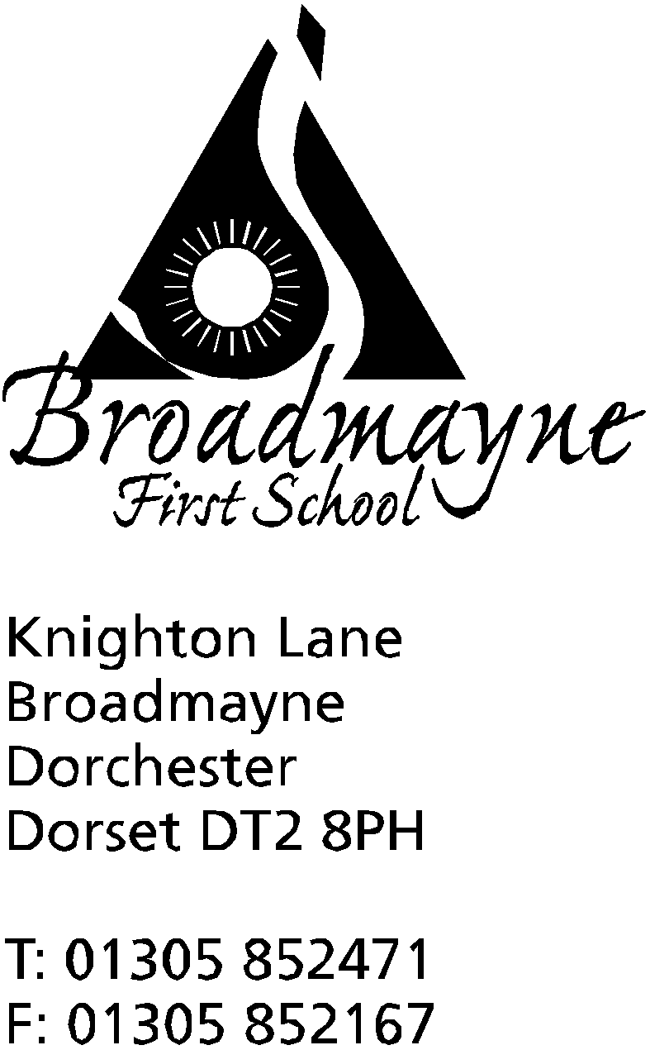

In Dorset

Headteacher
Helen Collings
Monday 30th March 2020

Dear Parents and Carers,

A week into lockdown, and the school remains open to provide care for our key worker families. The staff and children have enjoyed being able to get outside and make the most of the good weather last week, and I hope you all were able to take advantage of this too.

As we are approaching the Easter holidays, I thought it would be a good time to make contact with you all, and share our plans for the coming few weeks.

This week will continue in a similar way to the previous week - children can continue to use the ideas that were sent home initially to work on, and they will be provided with links and ideas for learning via Tapestry and Google Classroom. There are also now links available on the school website (via the Parents tab) to online learning which you and your children might enjoy. There are a growing number of websites which are providing opportunities for learning, and I’m sure you have all found some of your own.

As it is the Easter holidays starting next week, staff will not be expected to set or share work with you. Our staff are doing a fantastic job, going above and beyond with their work looking after our vulnerable and key worker children, keeping in touch with our families, planning and preparing work, and I want them all to feel they have the opportunity to have a break too. Sometimes we forget that they too have families and loved ones they are worried about and need to care for, and we must remember to allow them time to be able to do this.

After the Easter holidays you will find that ideas and links for learning will be provided online, through Tapestry or Google Classroom. Can I reiterate that you do not have to take part in any of this - I really want you all as families to find the best way to manage for you. Please don’t worry about children ‘falling behind’. As a school we are ensuring the work we provide and the links we send out will not disadvantage any child who does not take part. Please remember this is a crisis situation, and is not home schooling in any normal sense of the words - you are your child’s teacher in whatever form you choose - there is no right or wrong way! If you are having to work from home, it will not be possible to also be ‘teaching’ your child - believe me, I know this from first hand experience in my own home! Whatever choices you make for you and your family are absolutely the best ones at this moment. If nothing else, please use Tapestry or Google Classroom as a way of keeping in touch with everyone in school - we love hearing from you!

Please continue to contact staff via the dedicated email addresses, but I would ask you to use these carefully, so as not to overload staff. They can be used to ask questions, have a chat, or raise concerns, but please do not use them to complain or criticise - this is a difficult time for everyone and our staff are not immune to the stress and worry that many families are feeling right now. If you do feel the need to raise an issue, please use the headteacher@broadmayne.dorset.sch.uk email, and equally please use this contact for any questions - I’m happy to respond to any queries or concerns you might have.
At a time like this, our school values - be kind, be safe, be respectful - are more important than ever. Look after each other, keep in touch with the school, and know that we are all thinking of you.
Please look out for a PDF of a lovely self care booklet that we will email out to you which has been produced by NHS Sheffield that you and your children might enjoy sharing over the coming weeks.

Yours faithfully,

Mrs Collings

