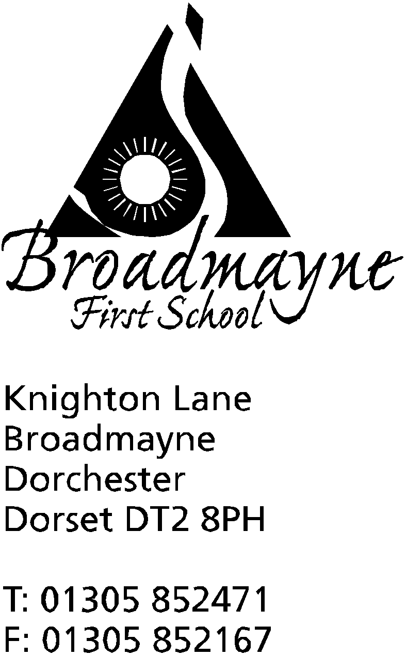

In Dorset

Headteacher
Helen Collings
23rd October 2019

Autumn 2019: Newsletter No. 5

Things to remember!
- FABS Bottle Bingo - this Friday at 6pm
- School photos on Friday - these will be individual portraits
- Pizza Day on Friday - weather permitting - please bring a pound to cover the cost of ingredients
- Wessex FM - some of our children are currently sharing their views on Wessex FM - tune in around 7.30 am to hear them, or listen again on catch up!

Dear Parents and Carers,

It seems like only two or three short weeks since the beginning of the new academic year in September, yet here we are at the end of the first half term already! It has been a busy time, with children settling in to new classes, and getting to know their new teachers.

Knowledge Organisers and Home Learning
Following on from our work to improve Home Learning last term, the school is now introducing Knowledge Organisers. Knowledge Organisers are short sheets linked to different areas of the curriculum which summarise the learning that will take place during the next half term. Currently each class has designed Knowledge Organisers for Maths, English (including a whole school phonics overview), History and/or Geography and Science. Other subjects will be included at a later date. Each Knowledge Organiser contains similar areas of information to others, but no two will be the same as the topics covered are different.
Knowledge Organisers will be sent out each half term, ready for the following half term, and will be used in several ways. In the classroom they will be used for children to check and consolidate their knowledge, whilst at home you can use them to see what your child will be learning next - you can then support them in any way which works best for you and your child. This will now be the basis for Home Learning.
The Knowledge Organisers are intended to help both teachers, children and parents, and will give you much more understanding of what your child is learning in class. They are not meant as an in depth plan of learning, but as an overview of key facts and information. We will not be sending out printed copies of these, instead they can be found on our website here: http://www.broadmayne.dorset.sch.uk/web/knowledge_organisers/430708
You can print these out if you wish; alternatively if you would like a printed copy please ask your child’s teacher or at the school office.
Pizza Day
On Friday 25th this week, we will be holding one of our regular pizza days. We will light up the cob oven early in the morning, and all children (and staff!) will have the opportunity to make their own pizzas and then cook them in the oven, before enjoying eating them. We ask for a small £1 donation towards the costs of ingredients - please hand in to the school office or to class teachers.

Harvest Festival
We were pleased to welcome so many parents and carers into school on Friday 18th to join with our Harvest Festival celebration. The children enjoyed sharing some of their favourite songs with you all, and a special well done to our Reception children, who joined in wonderfully! Many thanks to everyone who brought in contributions for the Food Bank - these will be delivered this week.
Safe and Healthy Me Week
The week straight after half term is the first of our newly introduced theme weeks. The focus for this week is ‘Safe and Healthy Me’ - further details will be sent out in a separate letter.
Open Morning
The school will be holding an Open Morning for prospective new parents on Wednesday 19th November. From 9.30 am until 11.30am we would like to invite all parents and carers who are hoping to send their children to us in the near future, or who are interested in what goes on within school, to come along to find out more about the school, and to see us at work. Please pass this information on to anyone who think this might be of interest to.
Plastic Bottles
Thank you to everyone who has passed the 2 litre plastic bottles over to us for our greenhouse. We are currently suspending the collection of these whilst we count up how many we have - we have run out of space to store them!
Other Faiths
We are very aware that whilst preparing our children for life in a multicultural world, we live in an area of the UK where children do not often get the opportunity to find out about a range of different cultures, faiths and countries. We would love to work with our community to widen our children’s opportunities to learn about other faiths and cultures. If you know of someone who would be happy to come in to talk to our children (it needn’t be scary - small groups or classes!) about their experiences of their faith or culture, or who could share objects or artefacts with us, we would love to work with them! Please see Sally or Kerry at the school office or contact me directly.
Parents “Supporting Your Child’s Mental Health” Workshop
This year the whole school is working towards Attachment Friendly School status and we are currently looking at how we can further support our children. During Safe and Healthy Me week, we will be running our first workshop sharing information to support parents in promoting positive mental health with their children. The sessions will run on Wed 6 Nov @ 2.15 pm and Thursday 7 Nov @ 6 pm and will last about an hour. Please see the slip below for content details and a reply slip. These sessions will only run if we have a minimum attendance.
School Admissions
We have been asked to inform you that Dorset Council are running the annual consultation on the School Admission Arrangements for 2021/2022 with effect from Monday 14th October 2019 to Friday 22ndNovember 2019. Details of the consultation will be available to view at https://www.dorsetcouncil.gov.uk/your-council/consultations/find-a-consultation.aspx.Responses must be submitted either in writing to School Admissions Team, Dorset Council, County Hall, Dorchester, DT1 1XJ or by email to schoolorganisation@dorsetcouncil.gov.uk by Friday 22nd November 2019. Upon the conclusion of the consultation period all responses will be considered carefully and a report will be presented to The People Scrutiny Committee prior to the determination deadline on 28th February 2020

We wish you all a happy and relaxed half term holiday, and look forward to seeing you all on Tuesday 5th November,after the INSET day on Monday 4th,

Yours faithfully,

Mrs Collings

Date | Time | Event
OCTOBER
Fri 25th | AM | Individual Photos  Whole school and Pre-School Pizza Day  FABS Bottle Bingo 6-8pm  Break up for half term
Mon 28th-Fri 1st Nov | HALF TERM | Monday 28th October - Ogg ‘n’ Ugg ‘n’ Dogg- play in village hall at 3pm-tickets available from the school office.
NOVEMBER
Mon 4th | All Day | INSET
Mon 4th - Fri 8th |  | Safe and Healthy Me Week
Tues 5th |  | Children return to school
Weds 6th | 2.15 pm | Supporting your child’s mental health workshop
Thursday 7th | 8.45 am  7pm | School nurse drop in  Supporting your child’s mental health workshop
Mon 11th-Fri 15th |  | Remembrance Week
Thurs 14th |  | Y2 trip to Safewise  Y3 trip to Bovington Tank Museum
Fri 15th |  | Children in Need Day - more details to follow from the School Council
Mon 18th | 2.30pm | Family photos
Tuesday 26th |  | Optional flu inoculations
DECEMBER
Mon 16th | 2pm | Christmas play
Tues 17th | 9.30 am  5.00 pm | Christmas play  “ “
Weds 18th |  | Year 1 trip to the Shire Hall
Fri 20th |  | Last day of term; Christmas party lunch- school finishes at 2.30 pm
Mon 6th Jan 2020 |  | Back to school - First day of Spring Term

-----------------------------------------------------------------------------------------------------------------------------------------------
Parent Workshop - Supporting Your Child’s Mental Health

Contents includes:
- Basic overview of the brain and how this links to mental wellbeing.
- Recognising and responding to emotion and why how we respond is so important.
- The "leaky cup" child and the importance of containment.
- Common parenting strategies to support mental wellbeing.
- The 5 love languages for positive connection.

Name of person/s attending: __________________________________

Ages of children _________________

- I would like to attend the workshop on Wed 6 Nov @ 2.15pm
- I would like to attend the workshop on Thurs 7 Nov @ 6pm

Signed: __________________________________________________

------------------------------------------------------------------------------------------------------------------------------------------------

