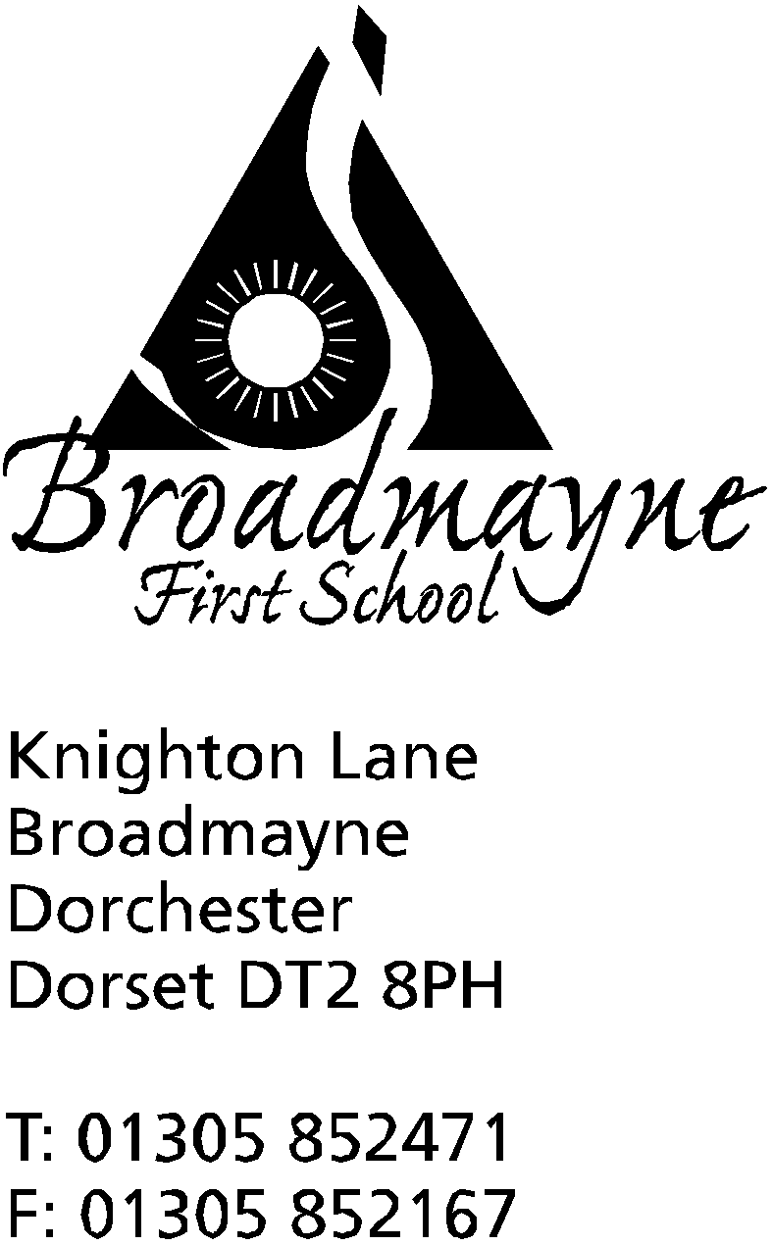

In Dorset

Headteacher
Helen Collings
25th April 2019

Summer 2019 - Newsletter 1

Things to remember: Year 4 parents - please return slips for Kingston Maurwood sports trip.

Dear Parents and Carers,

I hope you all had a restful holiday and had the opportunity to enjoy the good weather over the bank holiday weekend. This newsletter is mainly for the purposes of sharing important dates for the Summer term - we will share more dates as they are decided upon. Please note that on the last day of term, Tuesday 23rd July, the school will be closing earlier than usual, at 2pm.

Timing of the School Day
A reminder that the school doors open at 8.45 am every morning. If you arrive before that time, please wait in the appropriate playground with your child. The class teachers take registers at 8.55 am, so please ensure your child is in school by that time, or they will be registered as being ‘late’.

Visit by Oliver Letwin
On Friday 3rd May we are looking forward to welcoming Oliver Letwin, our local MP, to the school. He is tearing himself away from the Brexit negotiations to come and visit us, and to talk about our concerns around school funding.

Phonics Workshop
Mrs Bassindale would like to invite Year 1 parents in at 9am on the 2nd May to talk about the phonics screening that the Year 1 children will soon be taking part in. If you can’t make that date, she is planning a second meeting on the 14th, and will also send all relevant information home.

FABS Chocolate Bingo
The FABS will be holding their annual Chocolate Bingo at school this Friday, the 26th, at 6pm. This is always a well attended event - come along and see how much chocolate you can take home at the end of the evening - there is a lot to win!

Yours faithfully

Mrs Collings

Club update- please complete slips and return by Tuesday 30th

YOUNG ARCHITECTS CLUB for Years R, 1 and 2 with Mrs Bassindale. This will run every Thursday until half term from 3.15 - 4.15 pm and is free to attend. Children will have the opportunity to design and build using a range of materials, including Lego.Starts Thursday 2nd May.
ECO CLUB which was running before the holidays will continue, with the same children attending.
CRICKET CLUB will be on Tuesdays for Years 2, 3 and 4. We do not have details for exact timings or cost yet - this will depend on numbers, but is expected to be around £2 per child. Please indicate on the slip below if your child would be interested in attending, and we will send out details by the end of the week.
ACTION VAN is available for all year groups, and runs on Wednesdays after school from 3.15 - 4.20 pm The cost is £2.50 per child, and can be paid via SchoolMoney.

PERMISSION SLIPS FOR CLUBS
------------------------------------------------------------------------------------------------------------------
YOUNG ARCHITECT’S CLUB - Yr R, 1 and 2
I would like my child: …………………………………………. to take part in the Young Architect’s Club with Mrs Bassindale every Thursday until half term from 3.15-4.15pm.

My child will be collected by:...................................................................................................

Signed …………………………………………………………….. Parent/Carer
_________________________________________________________________________________

ACTION VAN
I would like my child…………………………………………….. to take part in Action Van on Wednesdays from 3.15 - 4.20 pm.

My child will be collected by………………………………………………………………………………….

Signed………………………………………………………….. parent/carer

-----------------------------------------------------------------------------------------------------------------------------------------
CRICKET CLUB
I am interested my child…………………………………………….. to take part in Cricket Club on Tuesdays after school.

My child would be collected by………………………………………………………………………………….

Signed………………………………………………………….. parent/carer

-----------------------------------------------------------------------------------------------------------------------------------------

Calendar Dates

Date | Time | Event
APRIL
Friday 26th | 6 pm | FABS Chocolate Bingo
Monday 29th |  | Class photos  Y4 trip to Kingston Maurwood
MAY
Thursday 2nd | 9am | Year 1 Phonics meeting for parents
Friday 3rd | 9am | Sir Oliver Letwin visiting the school
Monday 6th |  | BANK HOLIDAY
Thursday 9th | 9.10 am | Year 3 Class Assembly
Tuesday 14th May | 9am | Year 1 phonics meeting for parents
Tuesday 21st | 9.15 am  7 pm | Reception Class Assembly  New Reception parents meeting
Thursday 23rd |  | Last day of half term - Outdoor learning Day  School Pizza Day
JUNE
Monday 3rd |  | BACK TO SCHOOL
Tuesday 4th |  | Y4 visit to Nothe Fort
Tuesday 18th | 1.30 pm | Potted Sports
Tuesday 25th | 1.30 pm | Reserve afternoon for Potted Sports
Saturday 29th | AM | DASP Music Festival at Thomas Hardye School details to follow
JULY
Tuesday 2nd | 1.30 pm | Traditional Sports Afternoon
Thursday 9th | all day | Bikeability training
Friday 12th | PM | Reserve afternoon for Traditional Sports
Thursday 18th | AM | In House Football Tournament
Tuesday 23rd | 9.15 am | Year 4 Leavers Assembly  LAST DAY OF SUMMER TERM -school finishes at 2pm - return Wednesday 4th September

